**Applying through InfoReady Review**

## **Log in to InfoReady (NOTE: Use Chrome or Firefox – do *NOT* use IE)**

Perform the following steps:

1. Go to <https://ufresearch.infoready4.com>.
2. Click the blue UF Login button The Login for University of Florida Users page will appear. Enter your UFID and password. The Applications and Competitions for Grant Funding page will appear (Home page).

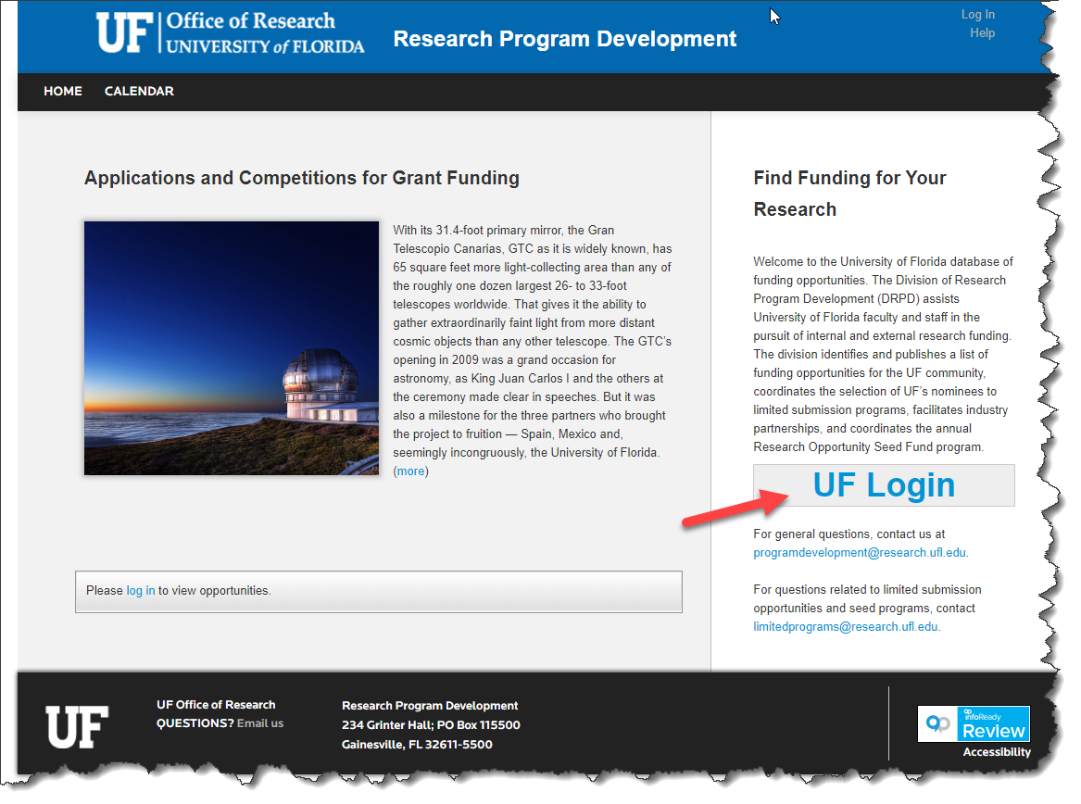

## **Searching for Open Opportunities on InfoReady Review Home Page**

You can view open funding opportunities listed by Due dates in the Table on the Home page. You can also search for an opportunity by typing the Title of the Funding Opportunity you are looking for in the search box (red arrow below).

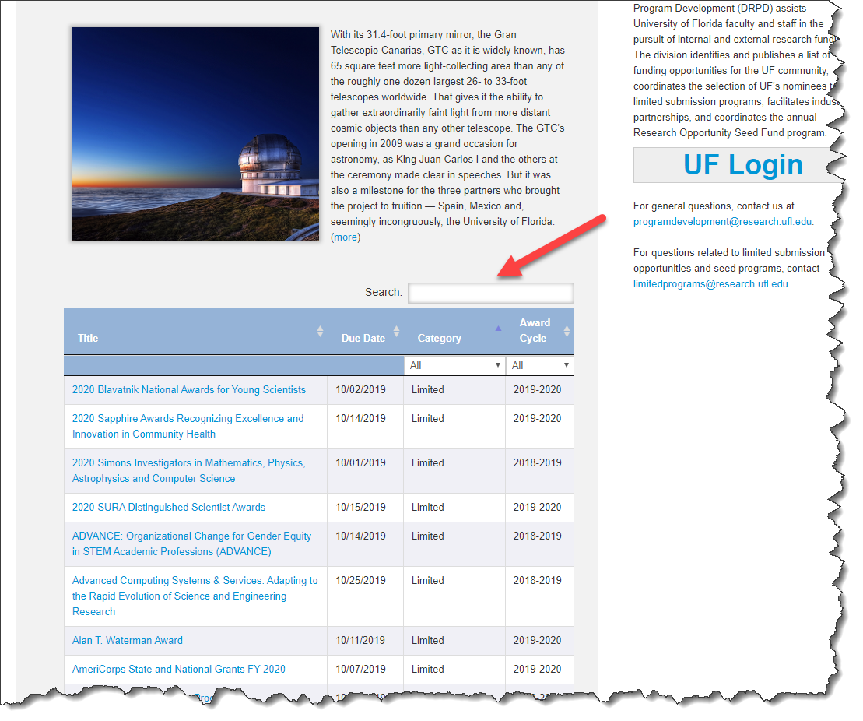

For grant opportunities with past deadlines please visit Opportunity Manager database at <http://my.research.ufl.edu/ProgramDevelopment/FundingOpportunities/OpportunitiesManager.aspx>

You may view the Opportunity Manager user guide at <https://research.ufl.edu/research-program-development/research_program_development_docs/OppManUserGuide.pdf>

**Viewing the details of a grant opportunity**

If you’re interested to know more about a grant opportunity, click on the Title of the particular grant opportunity either from the InfoReady or Opportunity Manager search page or from an email link. This will direct you to a details page which provides the link to the grant opportunity, lists the internal deadline as well as the Funding Agency deadline.

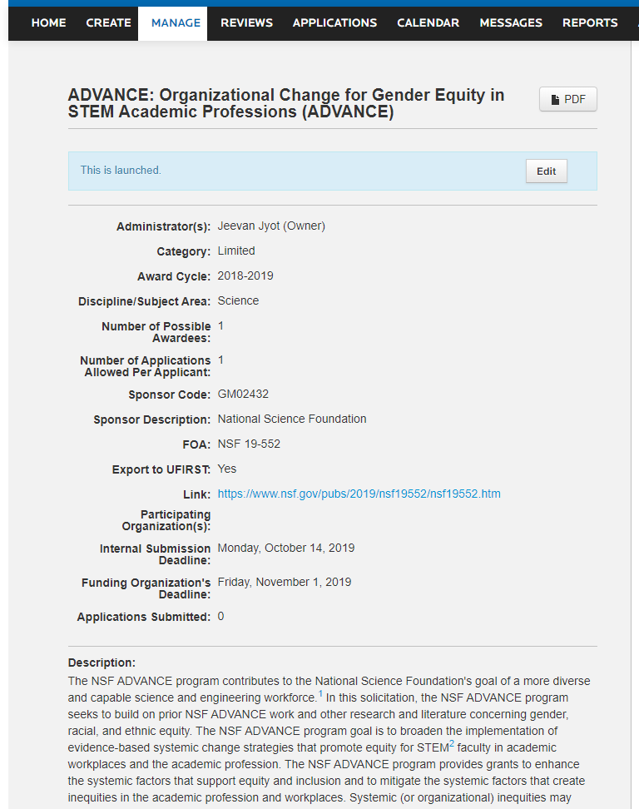

This indicates the Date internal concepts are due.

When **Category** indicates “Limited” this means the sponsor has limited the number of applications an institution may submit, therefore, there will be an internal selection process.

**Applying to the internal competition for a grant opportunity**

To the right of the internal announcement there will be an APPLY button.

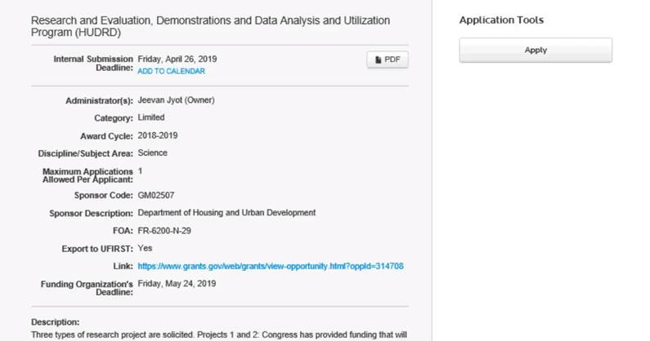

Clicking on the APPLY button will take you to a page similar to shown below. You will need to fill in your personal details in the system. This needs to be done only one time. 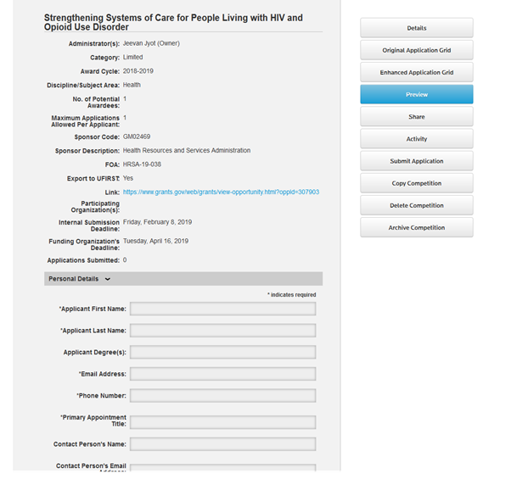

As you scroll down further, this page will display information about documents that you need to upload for the internal review/selection process. **The fields marked with an asterisk are required fields.**

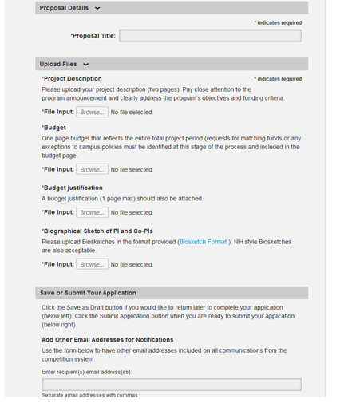

Click Submit when you are done. If any of the required fields are not filled the system will not allow you to submit.

Unless specified otherwise, the internal submission deadline is 11:59 PM on the date listed.

You will receive a confirmation from the system once you successfully submit your application.

After an internal review you will receive a notification through the InfoReady system as regards the outcomes of your application.

For any assistance or questions please contact: [limitedprograms@research.ufl.edu](mailto:limitedprograms@research.ufl.edu)

# **Using the Proxy Function of IRR**

In order for a user to submit an application by proxy for another, the PI would first have to designate that person as a proxy through their user profile. Perform the following:

## **Step 1: Assigning a Proxy**

Perform the following:

1. Go to your profile by clicking your name in the upper right corner of the page.
2. On your profile page, scroll down to the section titled "Designate an Applicant Proxy".
3. Enter the email address or name of the person who will be your proxy (the person will appear in a drop down menu if they already have an account in the system*).
4. Click 'Add'.
5. The person will appear in your list of proxies.
6. The system will send the proxy an email informing them that they are now a proxy for you.
7. Click 'Save Changes'.

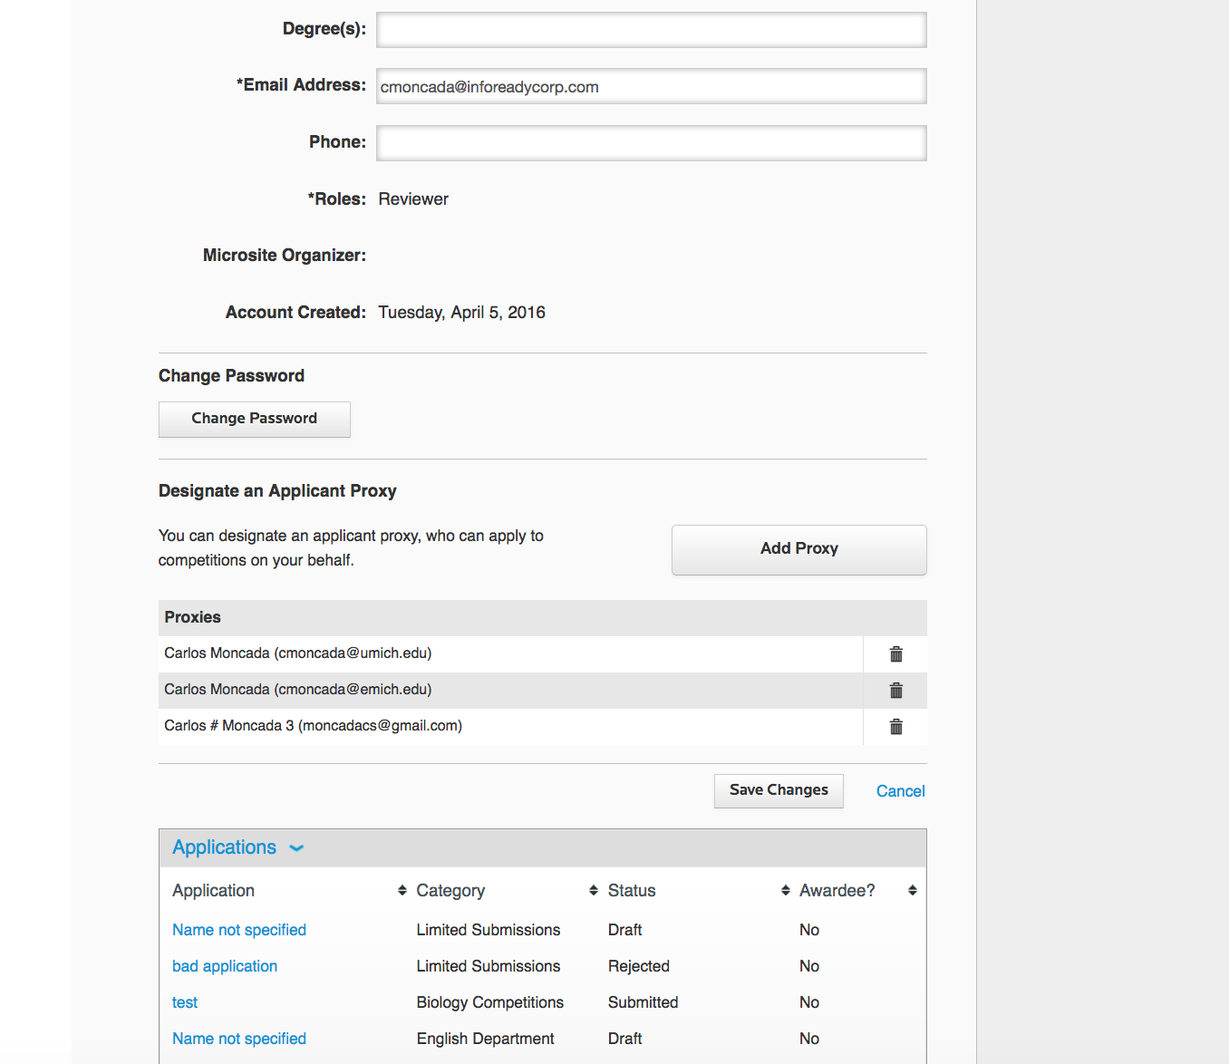

## **Step 2: Submitting as a Proxy**

You may have had another user designate you as a proxy applicant for them. Being a proxy gives you permission to submit applications on behalf of another user (only for applications and no other actions).

Perform the following:

1. Go to competition/opportunity.
2. Click the "Apply as Proxy" button from the local menu on the right side of the screen.
3. From the drop down in the proxy section, select the name of the applicant for whom you are submitting an application.
4. Fill out the application form as you normally would.
5. Save or submit the application as needed.
6. You will see confirmation of the submission on the screen and the applicant (the person you are applying on behalf of) will receive email confirmation of the submission.

[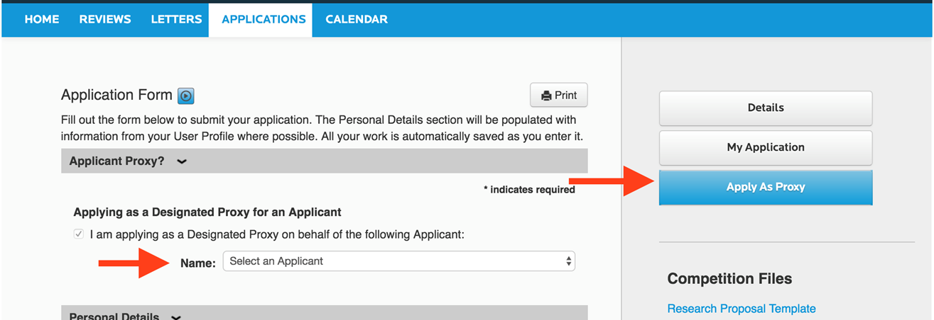](https://s3.amazonaws.com/cdn.freshdesk.com/data/helpdesk/attachments/production/14015200780/original/SiboY9I8yoOe-GaPAa4FWHAydjos87E-Ow.png?1493892783)