Boilerplate Text for Proposals

UF Research

Research Program Development

Contents

Contents
University of Florida 7
Advanced Magnetic Resonance Imaging and Spectroscopy (AMRIS) 10
Animal Care Services (ACS) 11
Aquatic Pathobiology Laboratory 12
Aquatic Toxicology Facility (ATF) 13
Artificial Intelligence & Data Science at the University of Florida 14
Brooks Rehabilitation Clinical Research Center 17
C. A. Pound Human Identification Laboratory (CAPHIL) 18
Cardiovascular Cell Therapy Research Network (CCTRN) 19
Cell & Tissue Analysis Core (CTAC) and 20
Cytometry Core at the Interdisciplinary Center for Biotechnology Research (ICBR) 20
Center for Entrepreneurship and Innovation (CEI) 21
Center for Environmental and Human Toxicology 22
Center for Exercise Science 23
Center for Movement Disorders & Neurorestoration – Norman Fixel Institute for Neurological Disease at UF Health 24
Center for Neurogenetics 26
Center for Perinatal Outcomes Research 27
Center for Pharmacogenomics and Precision Medicine 28
Center for Precollegiate Education and Training (CPET) 29
Center for Safety, Simulation & Advanced Learning Technologies (CSSALT) 31
Center for Spirituality and Health 32
Center for Structural Biology 33
Center for 33
Center for Vision Research 34
Center of Excellence for Regenerative Health Biotechnology (CERHB) 35
Clinical and Translational Science Institute (CTSI) 36
Collaboratory for Woman Innovators 38
College of Medicine 39
College of Pharmacy 40
College of Public Health and Health Professions 41
Craniofacial Center 42
CTSI Biorepository 43
Dental Clinical Research Unit (DCRU) 44
Department of Epidemiology 45
Department of Health Outcomes and Biomedical Informatics (HOBI) 46
Department of Pharmaceutical Outcomes and Policy 47
Department of Statistics 49
Combined program: The Department offers a bachelor’s/master’s degree program. 49
Diabetes Institute 50
Division of Sponsored Programs (DSP) 51
Electron Microscopy Core Facility 52
Emerging Pathogens Institute 53
Florida Climate Institute (FCI) 54
Florida Energy System Consortium 55
Florida Neonatal Neurologic Network 56
Global Pathogen Discovery Laboratory 57
Harrell Medical Education Building 58
Health Science Center 59
Health Science Center Libraries 61
HealthStreet 63
Human Imaging Core 65
Inclusion, Diversity, Equity and Access at the University of Florida 66
Institute for Child Health Policy (ICHP) 69
Institute of Food and Agricultural Sciences (UF/IFAS) 70
Institute on Aging 72
Interdisciplinary Center for Biotechnology Research (ICBR) 73
Interdisciplinary Center for Musculoskeletal Training and Research (ICMTR) 74
Interdisciplinary Program in Biomedical Sciences (IDP) 75
JDRF Network for Pancreatic Organ Donors with Diabetes (NPOD) 76
McKnight Brain Institute (MBI) 77
Medical Doctor/Doctor of Philosophy (MD/PhD) Program 79
Medical Honors Program 80
Metabolism and Translational Science Core 81
Molecular Pathology Core 82
Nanoscience Institute for Medical and Engineering Technology (NIMET) 83
Neuro ICU Research Lab 84
OneFlorida Clinical Research Consortium 85
OneFlorida Data Trust 85
Pain Research and Intervention Center of Excellence (PRICE) 86
Pediatrics – Jacksonville 88
Powell Gene Therapy Center (PGTC) 89
Prostate Disease Center 90
Proton Therapy Institute 91
Research Computing, High Performance Computing (HPC) 92
Southeast Center for Research to Reduce Disparities in Oral Health (SCRRDOH) 93
Southeastern National Tuberculosis Center (SNTC) 94
Stereotactic RadioSurgery Lab (RSB) 95
Structure Based Drug Design Lab 96
UF Research 97
UF Center for Experiential Learning and Simulation (UFCELS) 98
UF Center for HIV/AIDS Research, Education & Service (UF CARES) – Jacksonville 99
UF Center for Smell & Taste (UFCST) 100
UF Health 101
UF Health Cancer Center (UFHCC) 102
UF Health Communications 103
UF Health Hospitals 104
UF Health Integrated Data Repository (IDR) 105
UF Health Pathology Laboratories Genetic Laboratories, Molecular Pathology 106
UF Health—Jacksonville 107
UF Innovate 108
UF Innovate’s Pathways 110
UF IT Training 111
UF Research and Academic Center at Lake Nona 112
UF Undergraduate Research 113
VA Geriatric, Research, Education, Clinical Center (GRECC) 114
VA Medical Center 115
Vector Core Laboratory 116
Water Institute 117
Whitney Laboratory for Marine Bioscience 118

University of Florida

https://www.ufl.edu/

The University of Florida (UF) is an American public land-grant, sea-grant, and space-grant research university located on a 2,000-acre campus in Gainesville, Florida. UF has more than 900 buildings, including the first Leadership in Energy and Environmental Design (LEED) Platinum-certified building in the state of Florida. Now UF has more LEED-certified buildings than any other American university.
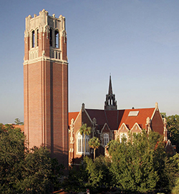
UF traces its beginnings to a small seminary in 1853. It opened its doors in Gainesville in 1906 with 102 students. Today, it is one of the most comprehensive and academically diverse universities in the nation, with an enrollment over 56,000 students annually. UF is home to 16 colleges and more than 200 research, service and education centers, bureaus and institutes. It offers nearly 300 graduate degree programs, 123 master’s degree programs and 76 doctoral degree programs in eighty-seven schools and departments. Only five other universities nationwide have as many programs of study on one campus as the University of Florida.

UF has a long history of established programs in international education, research and service. It is one of only 17 public, land-grant universities that belong to the Association of American Universities, the higher-education organization comprising the top 66 public and private institutions in North America. UF is consistently ranked among the nation’s top universities. After five consecutive years of ascension, the University of Florida’s performance has positioned UF among the nation’s top five ranked public universities, according to the 2022 U.S. News & World Report Best Colleges rankings. UF is within the top 100 universities worldwide (CWUR World University Rankings 2018-2019). It is considered a "Public Ivy," a designation reserved for the top public universities in the United States.

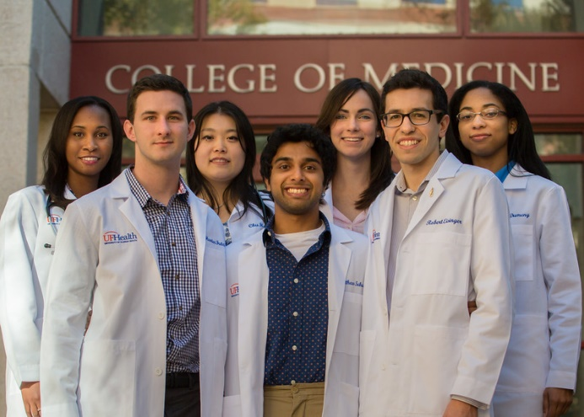
UF has nearly 5,000 faculty members with distinguished records in teaching, research, and service, including 37 Eminent Scholar chairs and 45 faculty elections to the National Academy of Sciences, Engineering, the Institute of Medicine, or the American Academy of Arts and Sciences. Awards include a Fields Medal, two Pulitzer Prizes, NASA’s top award for research, and Smithsonian Institution’s conservation award.

UF’s students are accomplished. Over 96 percent of incoming freshmen score above the national average on standardized exams. The freshman retention rate of 96 percent is among the highest in the country and 67 percent of UF freshmen graduate in four years; 87 percent graduate in six years. UF has a focus on a diverse student body. Among AAU public universities, UF ranks second in bachelor’s degrees and fifth in doctoral degrees awarded to African-American students in 2015.There are 56,567 (Fall 2019 total; 52,770 on campus and 3,797 online) students including 37,874 undergraduate and rest graduate students at University of Florida for academic year 2019-2020.

The UF residence halls have a total capacity of some 7,500 students and the five family housing villages house more than 1,000 married and graduate students. The university’s current facilities have a book value of more than $1 billion and a replacement value of $2 billion.

UF is a leader in research and discoveries which improve the lives of individuals throughout the state, nation and world. UF’s research funding totaled a record $900.7 million in research funding in fiscal year 2020. The total is a 16% increase over last year and surpasses the previous record of $837 million set two years ago by more than $63 million. Over the past 10 years, research awards to the university have increased 45% from $619 million in 2011.

Funding to the College of Medicine accounted for 35% of UF’s total with a record $310.9 million, up 9.5% over last year. The College of Engineering was up 27% to a record $114.1; the Institute of Food and Agricultural Sciences (IFAS) received $141.3 million; and the College of Liberal Arts and Sciences received $40.9 million. The total for the rest of UF’s 16 colleges was $293.5 million. UF had more than 100 awards of over $1 million.

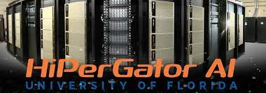
UF conducts over $20 million of industrial/company-sponsored research annually. The University of Florida is the most productive large university in the country at leveraging its research funding into new companies, new jobs and new ideas (2020 report released by the George W. Bush Institute and the Opus Faveo Innovation Development consulting firm). Research collaborations occur across the entire campus, in diverse fields that include engineering, life sciences, pharmaceuticals, and medicine, as well as the physical and social sciences. Research into improving education techniques and learning outcomes has also been sponsored by a variety of companies, particularly in areas pertaining to improving the education of students from under-represented and low-income demographic groups. Industrial funding for UF research comes from Global 1000 companies as well as local and regional start-ups and corporate entrepreneurs, all of which seek to leverage the expertise of UF’s world-class faculty to promote discoveries that will benefit the health and overall well-being of people worldwide.

UF generated an average of 123 issued patents and 15 startups per year between 2013 and 2017 placing it among the top-performing U.S. universities on those metrics. It was a strong performer in license income, earning an average of $36 million per year, equal to 6.4% of research dollars. The university has created an entire innovation ecosystem – which includes tech transfer, business incubators, a venture fund, corporate engagement and more – to support the translational research generated by UF faculty. The university has spun off more than 60 companies in biotech alone, and more than 20% of them have been acquired by major pharmaceutical, food, agricultural biotech and energy enterprises.

Since 1985, UF has been a member of the Association of American Universities, the higher-education organization comprising the top 62 public and private institutions in North America. It is one of three "research flagship universities" within the State University System of Florida, as designated by the Florida Legislature.

Overall, UF and related entities contributed $16.91 billion to the state’s economy in fiscal year 2017-2018, according to a study on UF’s economic contributions. These activities contributed $10.4 billion, or 1.1%, to the Gross State Product of Florida and supported 134,609 full- and part-time jobs, which amounts to 1.1% of the workforce in the state (https://news.ufl.edu/2019/10/economic-contributions/). Technology developed and patented by UF researchers brought in an estimated annual sales revenue of $1.34 billion for companies around the state. This technology spans from surgical appliances and supplies to botanical manufacturing. All this puts UF’s impact on par with the state’s trucking industry, its grocery store sector – that includes Publix and Winn-Dixie – or the total of all home construction activities in Florida.

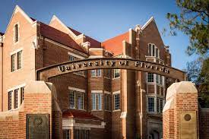

Advanced Magnetic Resonance Imaging and Spectroscopy (AMRIS)

https://amris.mbi.ufl.edu/ and https://biochem.med.ufl.edu/about/facilities/

A National MagLab Facility

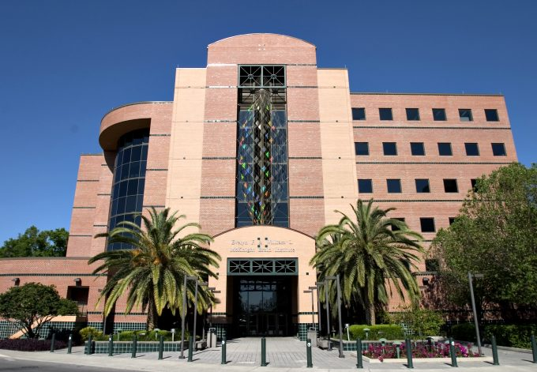
The Advanced Magnetic Resonance Imaging and Spectroscopy (AMRIS) Facility, located in the Evelyn F. & William L. McKnight Brain Institute, is a state-of-the-art NMR facility for high-resolution solution NMR, solid-state NMR, microimaging, animal imaging, and human imaging. There are currently nine spectrometer systems, including a 750 MHz wide bore, an 11 T/40 cm bore horizontal animal imaging magnet, and two 3T human systems. Five NMR magnet systems (500 and 600 MHz NMR spectrometers, 750 MHz wide bore spectrometer, and 4.7T/200 MHz and 11T/500 MHz MRI spectrometers) are available for high-resolution molecular structure determination and in vivo imaging and spectroscopy applications. The X-ray facility has a Rigaku generator, R-AXIS IV++ imaging plate system, osmic mirrors and an Oxford cryosystem cryostream.
Evelyn F. & William L. McKnight Brain Institute

AMRIS supports UF research groups and operates an international user facility for the NSF-funded National High Magnetic Field Laboratory (N HMFL). Equipment in the facility was acquired through support from the NIH, NSF, and Department of Defense.

Access for users external to UF and technology development time are available through the NHMFL Users Program.

ALL publications containing data collected at AMRIS must acknowledge the National Science Foundation Cooperative Agreement. Also, several instruments were purchased with NIH equipment funds; data collected using these instruments should acknowledge the appropriate NIH grants.

Animal Care Services (ACS)
https://acs.ufl.edu/

It is the mission of Animal Care Services to provide a humane and high quality animal care and use program to facilitate research and teaching at the University of Florida.

Proper care and use, with emphasis on the avoidance or minimization of discomfort, distress and pain, are essentials in ACS’s mission. ACS’s goal is to offer high quality service, expertise and guidance in all matters related to the care and use of animals. ACS has a team of Laboratory Animal Veterinarians and Veterinary Technicians that are available to provide expert clinical, diagnostic support and research troubleshooting.

myACS provides Animal Care Services with an enterprise management system to manage facility operations. Laboratory staff can utilize features that include:

- Real-Time census is available online
- Full cage card histories available
- Detailed invoicing displaying cage detail.
- Online Animal Ordering
- Protocol Animal Number Tracking
- Breeding Colony Data
- Detailed fee schedule

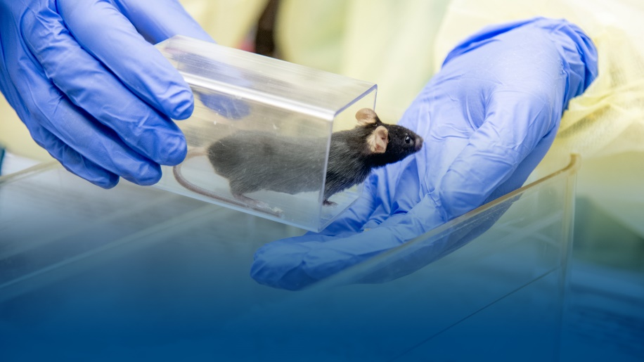
Please visit https://acs.ufl.edu/services/ for details of services provided.

Aquatic Pathobiology Laboratory

https://aquaticpath.phhp.ufl.edu/

The Aquatic Pathobiology Laboratory is a unique, state of the art research and teaching facility at the University of Florida. The Laboratory provides research space for interdisciplinary research activities on the UF campus related to environmental and aquatic animal health. Faculty with interests in these areas maintain a breadth of expertise and represent multiple academic units including Emerging Pathogens Institute, Water Institute, Institute for Food and Agricultural Sciences (Fisheries and Aquatic Sciences Program and Food Science & Human Nutrition), College of Veterinary Medicine (Departments of Large Animal Clinical Sciences, Small Animal Clinical Sciences, Infectious Diseases and Pathology and Physiological Sciences), College of Public Health & Health Professions (Environmental Health Program), and College of Pharmacy (Department of Medicinal Chemistry). A key element of the laboratory's program will be training of graduate students, visiting scientists and veterinary specialists.

Areas for collaborative research include cell injury, carcinogenesis, endocrine disruption, environmental and comparative pathology, molecular biology, immunology, behavioral toxicology, and fisheries and aquaculture sciences. The laboratory programatically partners with the Center for Environmental and Human Toxicology and the University-wide Aquatic Animal Health Program to support multidisciplinary collaborations throughout the UF community.

The UF Aquatic Pathobiolology Laboratory was designed in 2007 and a certificate of occupancy issued in May 2009. Since then, over 850 boxes, along with numerous aquatic animal tanks, racks, pumps and husbandy systems have been unpacked and put in place.

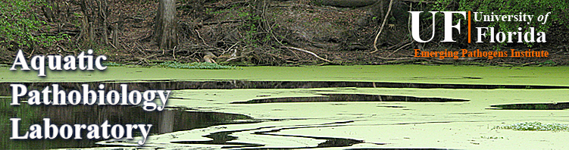

Aquatic Toxicology Facility (ATF)

https://toxicology.vetmed.ufl.edu/aquatic-tox/aquatic-toxicology-core-laboratory/

The aquatic toxicology facility (ATF) is a 1,700sq-foot multi-purpose laboratory designed to hold and maintain aquatic organisms for biological studies. Located within the Center for Environmental and Human Toxicology compound, under the direction of Dr. David Barber, the facility is primarily setup to perform toxicological studies using fish as animal models, it is also capable of housing a wide range of aquatic species for a variety of purposes. Together the facility contains approximately 40 tanks consisting of more than 4,400 gallons of fresh water and thus comprises the largest such facility on the University of Florida’s main campus.

The facility is designed for flexibility allowing a wide range of experiments to be performed simultaneously. Presently, 500 square feet has been allocated for short term holding of animals. This area is isolated from the rest of the facility in order to minimize possible contamination. The dosing areas contain our research tanks and are organized into systems or groups of tanks for recirculation or flow-through operation. Multiple or individual tanks may be run through effluent filters to remove toxicants or chemicals used during experiments. Alternative space is also available to setup any additional facilities or special environmental controls to fit investigator’s needs.

In addition, the ATF provides services to aid investigators and help ensure successful experiments. These include water quality testing kit, access to compound and dissecting microscope, conventional refrigerator and freezer space for food and specimen storage along with basic tools and a shop area for fabrication. ATF staff is also available to lend assistance with culture procedures, disease diagnosis and treatments, fish location, transport and handling, and routine aspects of experiments such as feeding.

A user application form is required along with a short review process for new experiments to be performed within the ATF. This enables the ATF to determine if the proposed experiment(s) are within the scope and capabilities of the facility.

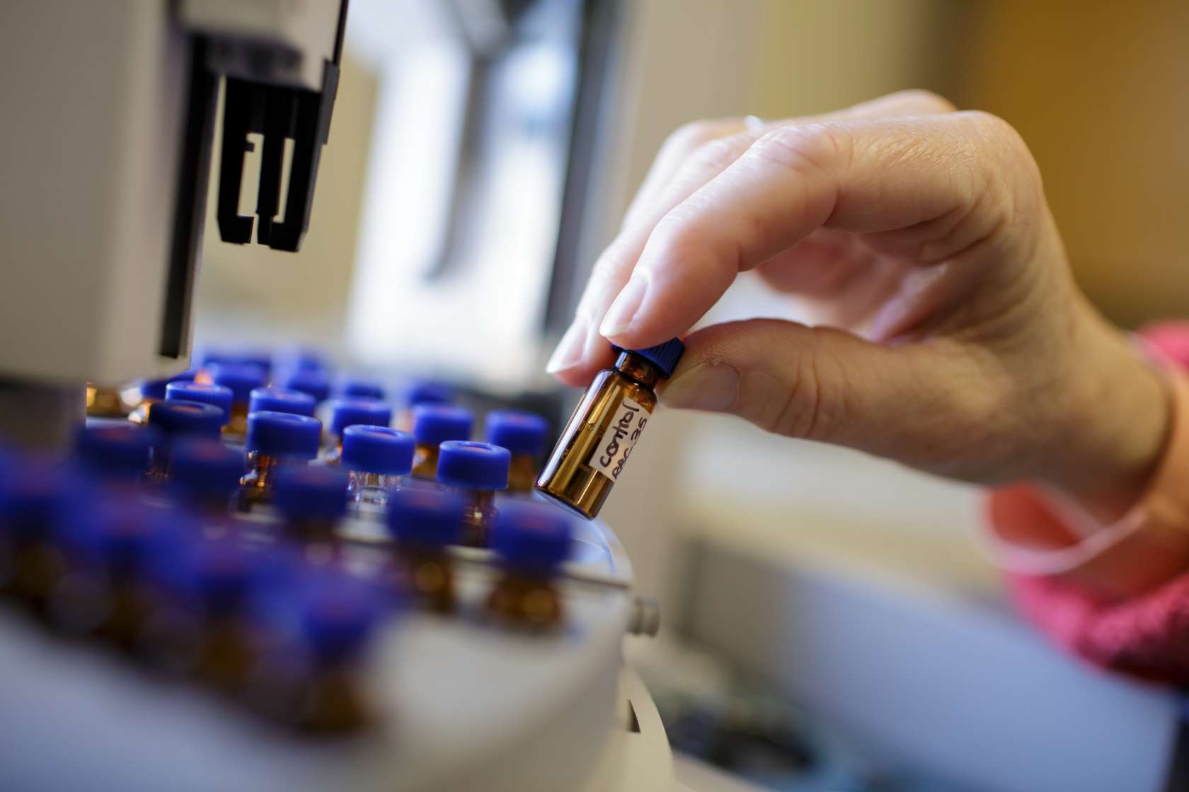

Artificial Intelligence & Data Science at the University of Florida

https://ai.ufl.edu/

Artificial intelligence is more than just the next wave of high-tech. It is transforming nearly every sector of the economy. Using AI to analyze massive amounts of data has dramatically affected communications, accounting, finance, transportation, medicine, agriculture, and more.

The University of Florida is making artificial intelligence the centerpiece of a major, long-term initiative that is combining world-class research infrastructure, cutting-edge research, and a transformational approach to curriculum. Its depth is making the university a leader in AI research and development; its breadth will make sure every UF student develops a basic competency in AI regardless of their field of study.

Committed to driving growth across the state, UF is hiring 100 new faculty members in AI. UF is leading the way by harnessing the power of AI to solve some of the world’s most formidable challenges.

UF-NVIDIA AI Partnership
In July 2020, the University of Florida announced a public-private partnership with NVIDIA to address some of the world’s most formidable challenges through UF’s research strength, create unprecedented access to AI training and tools for underrepresented communities, and build momentum for transforming the future of the workforce.

The initiative is anchored by a $50 million gift -- $25 million from UF alumnus Chris Malachowsky and $25 million in hardware, software, training and services from NVIDIA, the Silicon Valley-based technology company he cofounded and a world leader in AI and accelerated computing.

Along with an additional $20 million investment from UF, the initiative will create an AI-centric data center that houses the world’s fastest AI supercomputer in higher education. Working closely with NVIDIA, UF will boost the capabilities of its existing supercomputer, HiPerGator, with the recently announced NVIDIA DGX SuperPOD™ architecture. HiPerGator 3.0 and HiPerGator AI, the NVIDIA DGX SuperPOD, enable scalable artificial intelligence (AI) and high-performance data analytics. This will give faculty and students within and beyond UF the tools to apply AI across a multitude of areas to improve lives, bolster industry, and create economic growth across the state.

UF is the first institution of higher learning in the U.S. to receive DGX A100 systems, which are designed to accelerate diverse workloads, including AI training, inference, and data analytics.

NVIDIA will also contribute its AI expertise to UF through ongoing support and collaboration across the following initiatives:
- The NVIDIA Deep Learning Institute will collaborate with UF on developing new curriculum and coursework for both students and the community, including programing tuned to address the needs of young adults and teens to encourage their interest in STEM and AI, better preparing them for future educational and employment opportunities.
- UF will become the site of the latest NVIDIA AI Technology Center, where UF Graduate Fellows and NVIDIA employees will work together to advance AI.
- NVIDIA solution architects and product engineers will partner with UF on the installation, operation and optimization of the NVIDIA-based supercomputing resources on campus, including the latest AI software applications.
HiPerGator 3.0 & HiPerGator AI
HiPerGator and HiPerGator AI can be used by UF faculty and by faculty at universities in Florida for teaching and research using these options and procedures:
- For teaching a class, allocations are free and they last one semester. See https://www.rc.ufl.edu/services/teaching-support for detailed instructions.
- For research, allocations can be purchased for periods ranging from three months to several years. The rates are listed at https://www.rc.ufl.edu/services/rates/ with details at https://www.rc.ufl.edu/services/rates/service/
- A three month trial allocation at no cost may be requested for developing a course in advance of teaching the course and to explore the use of AI for research. Use the application form at https://www.rc.ufl.edu/access/request-trial-allocation/. After the trial ends, please work with UFIT Research Computing staff to find the best way forward for continuing use of HiPerGator and HiPerGator AI.
- To learn about AI and HiPerGator capabilities, colleges and departments can request a free 3-month trial allocation shared between all faculty in the unit to get easy access for learning about AI and preparing to include AI in their courses at no cost to individual faculty. The details of a basic “AI Starter” allocation that will cover a typical large department or small college are given below.
Note that the HiPerGator operation and infrastructure has been operating successfully on this model since 2013 with significant investment from the provost, the VP for research, and the CIO.
- AI Support: Numerous applications are supported, see https://help.rc.ufl.edu/doc/AI_Support.
- AI Consulting: Provide best practice guidance to get started on HiPerGator AI, conduct AI research in the most efficient way, and in-depth consultation on AI projects.
- Interdisciplinary collaboration: Connect you to the domain experts on UF campus and NVIDIA for advanced research and collaboration.
- AI training and education resources
  - https://help.rc.ufl.edu/doc/AI_Education_and_Training
    - NVIDIA Deep Learning Institute
      - Instructor led workshops
    - AI Courses in Coursera
  - UF AI courses
AI CONTACT HELP: IT-RC-AI@RC.UFL.EDU
Malachowsky Hall for Data Science & Information Technology
Currently under construction, the Malachowsky Hall for Data Science & Information Technology, will be a 263,000-square-foot academic building located in the heart of UF's main campus that will connect students and researchers from across disciplines and create a hub for advances in computing, communication and cyber-technologies with the potential for profound societal impact.
The building, made possible by a gift from UF alumnus Chris Malachowsky as well as funding from the state, will provide collaboration space and will focus on the application of computing, communication, and cyber technologies to a broad spectrum of areas including health care, pharmacology, security, technology development, and fundamental science. The building is slated for completion around April 2023.
The engineering spaces will serve as the headquarters for IT students in the National Society of Black Engineers, Society of Hispanic Professional Engineers, Women in Science and Engineering, and Women in Computer & Information Science & Engineering. Faculty and students will be able to expand on fields like human centered computing, intelligent healthcare, and informatics and data science.
The building will also house the coordinating center for the OneFlorida Clinical Research Consortium, a statewide research network and data trust established through the UF Clinical and Translational Science Institute in 2010 to help facilitate and accelerate health research in Florida. OneFlorida’s partners include four academic centers and eight health systems, which collectively have 22 hospitals, 1,240 practices/clinics and 4,100 providers. The OneFlorida partners provide care for about 74% of Floridians in all 67 counties. A hallmark of OneFlorida is its data trust, an integrated data repository that houses linked electronic health record, health care claims, death, environmental and other geospatial data for approximately 15 million Floridians. The clinical research network and data trust offer scientists data resources and improved tools for using real-world data to 1) identify and address health disparities, 2) develop and test innovative health care delivery strategies for underserved communities, and 3) ensure that people who historically have been excluded from health research are represented in clinical trials.

Brooks Rehabilitation Clinical Research Center

https://pt.phhp.ufl.edu/research/brooks-phhp-research-collaboration/

Some of the Brooks/UF-PHHP Research Collaboration goals are:
- Create a contemporary model for collaborative and interdisciplinary research between an academic center and a rehabilitation centric health care system
- Enhance the existing missions of UF PHHP and Brooks by providing opportunities for high quality rehabilitation research that positively impacts the delivery of clinical services

The Brooks Center will endeavor to create recommendations about "best practices" in this ever- changing and highly individual discipline of medicine. The hope is to advance the science and improve patient outcomes while reducing the costs of treatment. The Brooks Center will also utilize its research and studies to influence changes in public policy regarding medical rehabilitation and the treatment of disabling injuries and illness. Above all, the Center aims to foster a strong relationship between scientific medical research and the application of rehabilitation in order to restore hope and improve the quality of life for people with disabling injuries or illnesses.

The Brooks Rehabilitation Clinical Research Center was created in 1999 as a result of a collaboration between the College of Health Professions at the University of Florida and Brooks Rehabilitation. A donation of $2.5 million by Brooks was matched by the State of Florida funds for a total of $5 million to establish this clinical research enterprise with the mission of furthering knowledge in rehabilitation science, technology, clinical practice and health policy through excellence in research and training.

The Brooks Rehabilitation Clinical Research Center is committed to enhancing recovery and quality of life through research. We offer a platform of research that focuses on the investigation and development of:

- Accurate and informative rehabilitation assessment tools
- Innovative treatment protocols that utilize new technologies and evidence based practices
- Outcome measures that enable us to assess and track the recovery process while in rehabilitation programs and after discharge

Our research addresses the rehabilitation and human performance needs of individuals with disabling conditions resulting from birth, injury, or disease. These include individuals with many types of conditions such as: stroke, brain and spinal cord injuries, chronic pain, arthritis and various musculoskeletal conditions.

C. A. Pound Human Identification Laboratory (CAPHIL)

https://caphil.anthro.ufl.edu/

The primary mission of the C.A. Pound Human Identification Laboratory is to provide forensic anthropology services for medical examiners and coroners. The laboratory also provides anthropological, legal, and technical laboratory-based education and training to graduate students and professionals in the fields of anthropology, medicine, medico legal death investigation, and law enforcement. The laboratory and its faculty and graduate analysts serve as a resource for pathologists, scientists and technical experts practicing in communities and various jurisdictions in the state of Florida.

The C.A. Pound Human Identification Laboratory (CAPHIL) is located within the Department of Anthropology at the University of Florida. The CAPHIL is located on the ground floor of the Cancer & Genetics Research Complex on the corner of Mowry Road and Gale Lemerand Drive on the UF campus. The laboratory was endowed by the late C. Addison and Annie Pound. This endowment funds basic operating expenses in support of the laboratory’s mission. The CAPHIL provides consultation services for Medical Examiners, law enforcement agencies, and attorneys, assisting with determination of the identity of the decedent and cause and manner of death. CAPHIL recently celebrated the 45th anniversary of forensic anthropology at the University of Florida.

The CAPHIL is under the direction of Interim Director Dr. Phoebe Stubblefield. The CAPHIL is staffed with doctoral graduate analysts and a team of select volunteers. The faculty and staff conduct casework and perform research in biological anthropology, forensic identification, skeletal trauma analysis, and a diversity of topics within the field of Biological Anthropology. The CAPHIL, a component of the William R. Maples Center for Forensic Medicine, complies with ISO17020 and Supplemental Standards, as well as the best practice guidelines and minimum standards for the discipline as established by the SWGANTH and the NIST OSAC subcommittee on forensic anthropology

Cardiovascular Cell Therapy Research Network (CCTRN)

https://cardiology.med icine.ufl.edu/research/

Division of Cardiovascular Medicine, Department of Medicine, College of Medicine (COM) houses the UF Regional Clinical Center for the NHLBI-sponsored Cardiovascular Cell Therapy Research Network.

The University of Florida’s Division of Cardiovascular Medicine is the highest ranked program in Florida and is recognized as one of top 50 programs in the country by U.S. News & World Report. This team of physicians, healthcare specialists, and scientists work together to deliver excellent patient care, as well as perform research and education to enhance the quality of heart treatments in the future.

The mission of CCTRN is to advance stem cell research to enhance the efficacy and safety of clinical therapy in patients with cardiovascular disease. Our primary goal is to help patients through the advancement of clinical stem cell research. Our investigators are highly trained nurses, cardiologists, surgeons, and scientists coming together to identify and refine cell therapies to treat heart and vascular disease. These cell therapies have the potential to improve the structure and function of the heart and circulatory system after acute injury (heart attack) or repeated injuries (heart failure) or ischemia (angina or limb claudication).

CCTRN was established with $63M grant for 7 years from NIH. CCTRN, a national clinical trial consortium that, in addition to UF, includes the University of Miami, Indiana University, Stanford University, Texas Heart Institute, the University of Louisville and the Minneapolis Heart Institute. Originally funded in 2007, the network received the first federal funding for cooperative studies of so-called adult stem cells, in which patients are treated with cells taken from their own bodies. The UF-led team includes satellite study sites at UF College of Medicine-Jacksonville, Orlando Health and Pepin Heart Hospital in Tampa, FL (https://news.drgator.ufl.edu/2012/04/02/63-million-nih-grant-helps-uf-national-consortium-explore-cell-regeneration-therapies-for-heart-disease/)
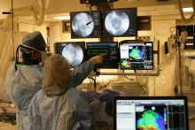
.

Cell & Tissue Analysis Core (CTAC) and

Cytometry Core at the Interdisciplinary Center for Biotechnology Research (ICBR)

https://mbi.ufl.edu/2018/10/05/icbrs-cytometry-core-merges-with-mbis-cell-tissue-analysis-core/

The MBI Cell & Tissue Analysis Core (CTAC) has been established to provide a centralized imaging and analysis resource for the UF/McKnight Brian Institute (MBI) research community. The CTAC maintains high- end instrumentation as well as standard microscopy systems for the acquisition and analysis of bright field, ultrasonic, intravital, fluorescent, and bioluminescent data from both in vitro and in vivo experimental models. The Histology Self-Serve Lab houses several Histology instruments for hands-on access, as well as the ability to process and paraffin-infiltrate your "fixed" tissues.

Cytometry Core at the Interdisciplinary Center for Biotechnology Research, or ICBR, acquired the McKnight Brain Institute’s Cell & Tissue Analysis Core, or CTAC in 2018.

Built on the tireless efforts of Ed Scott, Ph.D., a professor of molecular genetics and microbiology, and Doug Smith, CTAC manager, the MBI’s CTAC has grown from a small imaging start-up to a widely reputable core offering unique services for UF researchers. Smith will continue to serve as CTAC’s manager while ICBR will provide support for administrative and management functions. The transition represents the next evolution for CTAC, to offer services like online calendar scheduling through its integration with ICBR Cytometry.

Likewise, ICBR users will also benefit from the merger, with access to: additional imaging equipment, an additional live cell imaging system, additional animal in vivo imaging equipment, self-service usage for training requests, and a self-service histology lab complete with cryostats and microtomes for frozen and paraffin embedded tissue sectioning.

CTAC will remain in the MBI (Imaging Suite in LG-164 and, Histology Resource Lab in CTAC-HRL), located in close proximity to ICBR Cytometry’s secondary lab in the MBI (L3-160).

Directed by the UF Research, the acquisition will provide greater access to instrumentation and services, while making research approaches even more convenient.

Center for Entrepreneurship and Innovation (CEI)

https://warrington.ufl.edu/entrepreneurship-and-innovation-center/

The Center for Entrepreneurship and Innovation (CEI) was created to teach, coach and inspire students to be entrepreneurial in their lives. The Center provides students the tools and experiences necessary to creatively pursue new opportunities and innovations in the start-up, social, and corporate venture arenas.

Through courses, degree programs and complementary activities such as speakers and workshops, the Center currently serves more than 2,000 students per year. Partnering with other colleges at the University, the Center delivers introductory and specialized courses at both the graduate and undergraduate level, and offers every graduate student at the University of Florida the option to earn a graduate minor in entrepreneurship. In addition, the Jeff Gold Experiential Learning Laboratory which houses the GatorNest program, the Gator Hatchery student incubator and the IdeaGators Co-Working Space provides students the opportunity to experience real life entrepreneurship while still in school. Co-curricular programs that include consulting to disadvantaged entrepreneurs in South Africa and our community partnerships in Gainesville, FL, as well as the $40,000 Big Idea Competition, provide additional opportunities to “learn and do”, helping students create an innovative and entrepreneurial mindset.

In addition, the Center offers the nation’s most comprehensive specialized degree program focused on entrepreneurship, the Thomas S. Johnson Entrepreneurship Master’s Program.

Center for Environmental and Human Toxicology

https://toxicology.vetmed.ufl.edu/

The Center for Environmental and Human Toxicology serves as the focal point at the University of Florida for activities concerning the effects of chemicals on the environment, human and animal health.

The Center serves as an interface between basic research and its application for evaluation of human health and environmental risks. This interface includes an educational component to transfer this knowledge to producers, consumers, and regulators. The research and teaching activities of the Center provide a resource for the State of Florida to identify and reduce risks associated with environmental pollution, food contamination, and workplace hazards.

Development and improvement of risk assessment methods as well as toxicity testing and elucidation of mechanisms of action of chemical-induced adverse health effects are all activities of the Center that serve as resources for the State of Florida and the nation. The Center provides a forum for the discussion of specific and general problems concerning the potential adverse human health effects associated with chemical exposure. Using the interpretive skills of scientists and clinicians from various health disciplines, better decisions can be made for the protection of public health.

Center for Exercise Science

https://hhp.ufl.edu/faculty-r esearch/centers-institutes/ces/

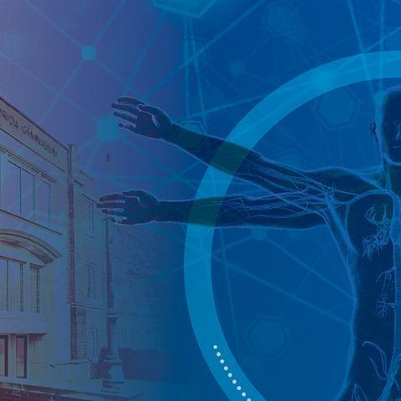
The University of Florida Center for Exercise Science (CES) is a multidisciplinary research center housed in the Department of Applied Physiology and Kinesiology. CES is dedicated to investigating the complex interactions between physical activity, muscle, heart, brain and age-related diseases. The primary goal of scientists in the CES is to improve human health by advancing knowledge through research. Moreover, the CES provides an outstanding laboratory environment to educate UF students and post-doctoral fellows who will become the next generation of health-related exercise scientists and clinicians.

CES LABORATORIES:
Applied Neuromechanics Lab (Hass)
Integrative Cardiovascular Physiology Lab (Christou, D.)
Integrative Muscle Biochemistry Lab (Powers)
Laboratoy for Neuromuscular Physiology Rehabilitation (Wei-LaPierre)
Laboratory for Rehabilitation Neuroscience (Coombes)
Laboratory of Basic and Clinical Muscle Biology (Ferreira)
Laboratory for Rehabilitation Neuroscience (Vaillancourt)
Locomotion Neuromechanics Lab (Choi)
Molecular Cardiology and Myology Laboratory (Smuder)
Molecular Physiology of Muscle Laboratory (Barton)
Molecular Metabolism Laboratory (Ryan)
Motor Behavior Lab (Cauraugh)
Muscle Stress Physiology Lab (Clanton)
Neurocognitive and Behavioral Development Laboratory (Wang)
Neuromotor Behavior Laboratory (Seidler)
Neuromuscular Physiology Lab (Christou, E.)
Performance Psychology Lab (Janelle)
Sensorimotor Plasticity Lab (Vahdat)
Sports Medicine Research Lab (Borsa)

Please see the above link for more information about CES labs.

Center for Movement Disorders & Neurorestoration – Norman Fixel Institute for Neurological Disease at UF Health
https://movementdisor ders.ufhealth.org/about/

https://fixel.ufhealth.org/about/

The University of Florida Center for Movement Disorders and Neurorestoration (UFCMDNR) was established in July 2002, to bring together UF doctors and researchers with special expertise in Parkinson’s disease and other movement disorders. The mission of the center is “To provide the highest level of medical and surgical care to patients with Parkinson’s disease, tremor, dystonia and other movement disorders. To perform research that will lead to better treatments, and ultimately cures for Parkinson’s disease and other movement disorders. The Center is founded on the philosophy that integrated, interdisciplinary care is the most effective approach for patients with movement disorders and disorders involving a group of circuits in the brain called the basal ganglia. The Center delivers motor, cognitive and behavioral diagnoses as well as various treatments all in one centralized location. Care is coordinated and provided by leading specialists from many advanced medical and surgical services.

The new name for the center is “Norman Fixel Institute for Neurological Diseases.

The Norman Fixel Institute for Neurological Diseases is home to scientists and clinicians at UF Health who are working on neurological disorders that afflict millions of people across the globe. These conditions include Parkinson’s, dystonia and other movement disorders, Alzheimer’s disease and dementias, concussion, traumatic brain injury, and neuromuscular disorders like amyotrophic lateral sclerosis, also known as ALS, or Lou Gehrig’s disease.

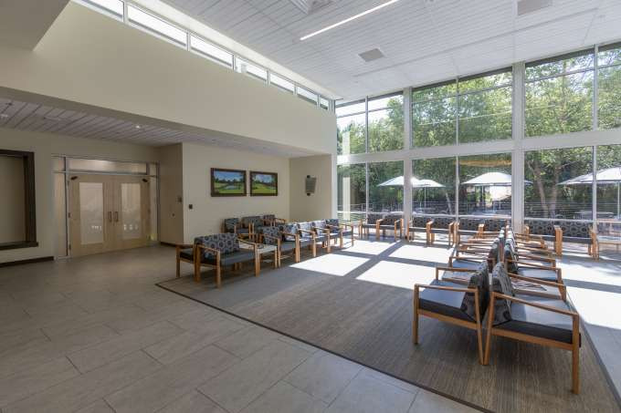
The Institute is a cornerstone of the university’s aspiration to help create history’s healthiest generation through precision health, the elimination of health disparities and the advancement of therapies related to the brain and neuromuscular and mental health.

UF Health physicians and researchers conduct leading-edge treatments, such as deep brain stimulation and gene therapy, that are transforming patient care. Under the umbrella of the Fixel Institute, they seek to revolutionize discoveries in Parkinson’s and other neurological diseases that will lead to new therapies and improve the quality of life for patients and forever change how these conditions are treated.

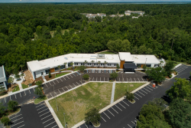
The Fixel Foundation previously gifted more than $25 million from 2017 to 2019 to establish the Norman Fixel Institute and to help build the UF Health Neuromedicine – Williston Road facility that houses UF Health’s neuromedicine specialty practice and a neurotechnology laboratory. The institute is a premier clinical care and research enterprise focused on advancing diagnosis and treatment for Parkinson’s disease and other neurological disorders, including Alzheimer’s, Lewy body dementia, ALS (also known as Lou Gehrig’s disease), dystonia and concussions. The institute was named in honor of Lee Fixel’s father, Norman, who graduated from UF with a bachelor’s degree in business in 1975. Lauren Fixel is also a UF graduate, with a 2007 bachelor’s degree in journalism.
Aerial view of the Norman Fixel Institute for Neurological Diseases at UF Health, which will soon expand thanks to a gift from the Lauren and Lee Fixel Family Foundation

Center for Neurogenetics

https://neurogenetics.med.ufl.edu/

The Center for NeuroGenetics (CNG) integrates molecular, genetic and clinical approaches to define the causes of neurodegenerative disease and develop effective treatment strategies. The goal is to advance our understanding of the causes of neurogenetic disease and develop opportunities for therapeutic intervention. To accomplish this we are using an integrated approach to understand the molecular mechanisms and common cellular pathways of neurological and neuromuscular disease. The Center combines valuable clinical and patient support with newly available tools for gene discovery with laboratory models that allow us to study of the effects of these mutations on the basic biology and function of neurons in the brain. Areas of research focus include:

  - Clinical Research
  - Human Gene Discovery
  - Mouse Behavior and Genetics
  - Neuronal Function
  - Neuroimaging

Center for NeuroGenetics housed in the Cancer Genetics Research Complex.

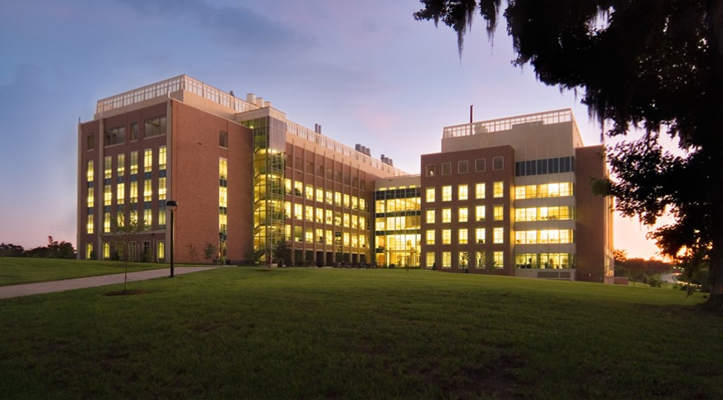

Center for Perinatal Outcomes Research

http://perinatal.ufl.edu/research/center-for-perinatal-outcomes-research/

The “Center”, originally called the Center for Research on Women’s Health, was founded at the University of Florida in the late 1990’s to foster interdisciplinary and inter-professional research collaborations in Women’s Health. It was the first Center at the University of Florida not housed in a particular College, but rather encompassed a University wide collection of researchers across many disciplines.

The Center was renamed the Center for Perinatal Outcomes Research and subsequently approved by the Florida Board of Governors. The change in Center name was intended to focus the vision of the Center on research that would lead to improved perinatal outcomes, although the original intent of interdisciplinary and inter-professional research collaborations across many fields of basic science, medicine, and social sciences was maintained. Collaborations for improving perinatal outcomes and subsequent child development, as well as increasing reproductive and lactational efficiency among large animals continues to include fundamental, translational and clinical research. Funding for the Center was initiated by the Dean of the College of Medicine and has subsequently continued through contributions of indirect cost allocations from grants of Principal Investigators in the Center.

The Center partners with the Reproductive and Perinatal Biology Research Program, which has been in existence for more than 40 years at the University of Florida. Together, they meet weekly during the academic year for a series of educational seminars, which includes participants from undergraduate programs, master level students and pre and postdoctoral students, as well as MDs, PhDs and DVMs from at UF and across the world.

Center for Pharmacogenomics and Precision Medicine

https://precisionmedicine.ufhealth.org/research/center-for-pharmacogenomics-and-precision-medicine/

The UF Center for Pharmacogenomics, with over $2 million in NIH, FDA, and other research awards, was established in 2001. The center strives to identify genetic variations that affect drug response, with the goal of enabling safer and more effective drug therapy. Research in the Center for Pharmacogenomics and Precision Medicine spans from mechanistic studies to multi-omic approaches to elucidate genetic contributions to drug response. Center investigators collaborate with investigators across the University of Florida and other institutions, both nationally and internationally, to ensure innovation in this cutting-edge science. The center also supports the UF Health Precision Medicine Program through the translation of pharmacogenomic research findings into patient care and examining outcomes with genotype-guided therapies.

It consists of 2033 sq. ft. of renovated laboratory space (five laboratories) in the UF Health Science Center. The laboratories are divided based on workflow and for reasons of quality control. The sample processing laboratory contains liquid handling/sample processing robot, a class I safety enclosure and electrophoresis units. The Pre-PCR laboratory contains three Laminar flow hoods, refrigerator, and freezer. The PCR laboratory contains a Purifier Filtered PCR Enclosure; five thermal cyclers, which can accept single tubes, 96-well plates or 384-well plates; QIAGEN QIAcube Automated RNA, DNA and Protein isolation instrument, 96- and 384-well plate centrifuge, and liquid handling/sample processing robots. The clinical sample processing and DNA isolation laboratory have a 96- and 384-well plate reader, NanoDrop Spectrophotometer, Protein Gel Systems and Blotter, Gel Documentation System, digital camera, Micro hybridization oven, UV lightbox, and Gel dryer. Another laboratory is an analytical laboratory which contains extensive analytical equipment including 2 Transilluminators, 3 Vertical Gel Electrophoresis Systems, 10 Horizontal Electrophoresis Systems, 2 autosamplers, 6 Multichannel Pipetters, and a pH Meter. General equipment shared between the labs includes a variable speed refrigerated centrifuges, variable and fixed speed microcentrifuges, one 96- and 384-well plate centrifuge, a liquid nitrogen system, a controlled water bath, microwave oven, and three computers. The analytical and genotyping laboratory is the largest laboratory and contains the major genotyping systems, including 2 LifeTechnologies QuantStudio TaqMan-Based OpenArray Multiplex Genotyping Systems, Pyrosequencing high-throughput genotyping system (PSQ HS 96), and a liquid handling/sample processing robot (Packard Multi Probe II HT Systems). Labs are equipped with refrigerators, centrifuges (Eppendorf Microcentrifuge 5418 R, 5415 R, and Eppendorf Benchtop 5810 R centrifuge, and DAMON-IEC CRU-500 centrifuge), and standard lab equipment such as pipettors, glassware, etc. Departmental shared space includes a freezer room, which contains additional freezers including four -80°C freezers and five -20°C freezers. The Center for Pharmacogenomics is supported by NIH grants U01 HG007269, R01NS073346, FDA grant U01-FD005235, and other foundation and institutional awards. The center is well-equipped to process, extract, and store DNA samples collected from study participants.

Center for Precollegiate Education and Training (CPET)

https://www.cpet.ufl.edu/

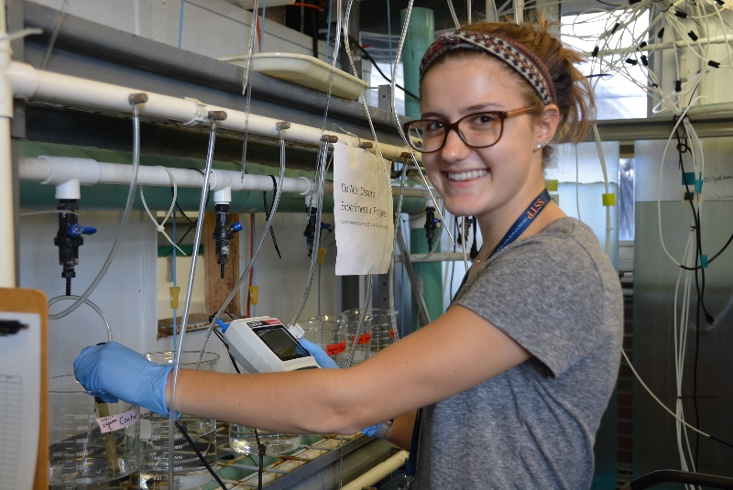
Since 1995, the center has involved hundreds of faculty in offering content-rich, laboratory- based, professional development programs for secondary school teachers coupled with school- year follow up. The Center for Precollegiate Education and Training collaborates annually with more than 300 faculty volunteers and hundreds of educators from around the state of Florida.

The center assists more than 30 researchers with the design and implementation of specific activities to broaden the impacts of their individual grants or pending proposals. Programs incorporate bridging activities that include teachers, researchers, and industry professionals in preparing and delivering effectual science education and career investigation from middle school through graduate school. Its instruction incorporates multiple research-based and novel teaching/learning strategies and is aligned with national and state education standards. The Center for Precollegiate Education and Training extensively interacts with graduate students across campus and actively solicits, coordinates, and oversees their voluntary or for-credit participation in precollege programs.

Center for Precollegiate Education and Training programs are designed to expand the content knowledge, skills, resources, networking, and enthusiasm of teachers and to reengage them with the university community. Newly generated and published curricular materials, methods and modules, and increased involvement of teachers and their students in school-site, inter-school, and university campus research and career-related activities are used to measure success.

Outcomes include rich curricula related to research and aligned with education standards that will be shared face-to-face and online as well as successful dissemination of UF research and recruitment of new “gators” and future STEM and health professionals. Outcomes also include increased funding and sustainability through leveraging for precollege education; broader impacts for research; exposure to STEM academic, health, and industrial careers (pipelines); and a growing culture of interest and experience in research teaching, outreach, and associated professional development in mentoring and science communication for graduate students and their research mentors.

UF CPET programs are developed and coordinated to promote:

- Excellence in science, technology, engineering and math; foster interdisciplinary science education throughout university research centers
- Forge partnerships among researchers, schools, communities, and industries
- Continually integrate research processes and product knowledge with national education goals and standards
- Foster the skills of research students, graduate students, and faculty to bring their work to the public

Center for Safety, Simulation & Advanced Learning Technologies (CSSALT)

https://simulation.health.ufl.edu/about-us/

CSSALT provides clinician training and support in developing simulation proposals and studies. In addition, it provides education, training and services to residents, faculty, clinical personnel and staff throughout the University of Florida Academic Health Center including the UF Health Healthcare system, to clinicians in the state of Florida, to UF medical, veterinary, dental, engineering and other health profession students, to local and regional emergency personnel and to industry executives and personnel worldwide.

CSSALT builds on the legacy of a continuous and sustained research and development effort in simulation that began in 1985 with the Bain group under the direction of Drs. J.S. Gravenstein and Jan Beneken and remains active today in the development and application of simulation technology.

In 1987, the former dean of UF College of Medicine, Dr. Michael Good, and the director of CSSALT, Dr. Samson Lampotang, developed the first prototype of the Human Patient Simulator (HPS) mannequin. This patient simulator technology is licensed to Medical Education Technologies, Inc. (METI), and used worldwide.

The Virtual Anesthesia Machine (VAM) team, affiliated with CSSALT, offers a portfolio of web-enabled simulations.

Center for Spirituality and Health

https://spiritualityandhealth.ufl.edu/

The Center for Spirituality and Health is to pursue research and provide curriculum at the interface of spirituality and the health sciences. It is designed to promote within UF the rigorous, interdisciplinary study of the human experience of faith, belief and spiritual knowledge in relation to health at the individual, community and global levels. The Center will foster free and creative communication about these issues. We are also committed to the academic exploration of the wider contexts of spirituality, religion and sciences as a whole, using the interface of spirituality and health sciences to bring Humanities, Natural and Social Sciences into relationship.

Research and Wisdom

Research in the area of meditation is normally interdisciplinary in nature. Meditation research encompasses many fields of research from religious studies to psychology to neuroscience. The following study was an interdisciplinary venture that brought together researchers from the fields of religious studies, psychology, sociology, and neuroscience.

Arts in Medicine

The goal of the proposed quantitative/qualitative study is to test (a) if creative arts/guided imagery interventions for patients with advanced cancer and their primary informal caregivers will promote spiritual transformation and psychosocial growth in both patients and caregivers;

- if a high intensity intervention is more effective than a low intensity intervention; and (c) if spiritual transformation and psychosocial growth will lead to better social relationships, enhanced subjective well-being, more accepting attitudes toward death and, ultimately, a better dying experience of the cancer patients.

The major activities of our Center include conducting and/or organizing:

- interdisciplinary “for credit” courses at the undergraduate, graduate and professional levels;
- certificate program;
- seminars about research and scholarship that are at the interface of spirituality, biomedical science and health;
- community-wide educational programs and workshops;
- research projects and programs that focus on the interface between religious traditions, spirituality and health;
- interdisciplinary discussion groups and journal club; and
- retreats and parallel activities led by students and student groups

Center for Structural Biology

https://biochem.med.ufl.edu/about/facilities/

The Center for Structural Biology is a University Center in the College of Medicine with a mission to provide a framework for collaborative research among faculty addressing structural studies of significant biological problems and to foster advanced training of students in structural biology.
The goal of the Center is to increase understanding of biological function through structural studies of large biological molecules, supra-molecular assemblies, and whole organisms. These studies are accomplished using advanced spectroscopic, diffraction, and imaging techniques (nuclear magnetic resonance, optical microscopy, electron microscopy, and X-ray crystallography). This information is related to cellular structure and function; then to the morphology and physiology of the whole organism.

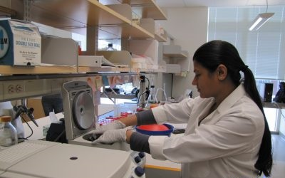

Center for

Center for Vision Research

https://com-ophthalmolo gy-cvr.sites.medinfo.ufl.edu/

Vision research at the University of Florida crosses the boundaries of nine departments in the College of Medicine and six colleges at the University of Florida. Because of this diversity, the Center for Vision Research was established in 1996 to help build a cohesive core of vision researchers. Specifically, the Mission of the Center for Vision Research is to:

  - Integrate a campus-wide, multi-college group of faculty interested in different aspects of vision research.

  - Promote communication, academic courses and other educational activity that will enhance vision-oriented research at the University of Florida.

  - Develop and coordinate multidisciplinary collaborative approaches to solve vision- related research problems.

  - Provide a focused unit to enhance collaborative research with external research labs, industry and other centers.

Center of Excellence for Regenerative Health Biotechnology (CERHB)

http://cerhb.ufl.edu/

The Center of Excellence for Regenerative Health Biotechnology (CERHB) was established in 2003 and located in Alachua's Progress Corporate Park. The mission is to stimulate promising research and facilitate commercialization of technologies that will provide treatments and cures for human diseases, as well as create new companies and high wage jobs for Florida. The activities encompass education, translational research, and biopharmaceutical manufacturing.

Discoveries in the basic health sciences have the potential to translate into new medical treatments. Currently, it costs nearly one billion dollars to turn a research discovery into a commercial medicine, due in large part to the expense of clinical trials, and drug manufacturing and testing that satisfy federal regulations. Of the products tested in Phase I human clinical trials, 45% graduate to Phase II, 10% move to Phase III, and only 5% are commercialized. Translational research is focused on transitioning the innovations discovered in the laboratory into the clinic, where safety and efficacy can be evaluated. The CERHB facilitates translational research by providing expertise and infrastructure to investigators at the University of Florida, local start-up companies, and other universities, research institutions, and companies in the Southeast. The CERHB plays an integral role in developing the biotechnology cluster in Florida by fostering new company formation, existing company expansion, and attracting outside companies to the region.

Biotility – Applied Biotech Training (https://biotility.research.ufl.edu/)

The mission of Biotility at UF CERHB is to provide high-quality education and training to individuals jumpstarting or advancing a career in the bioscience industry. As the education and training arm of CEHRB, the programs include industry-recognized credentials, industry short-course certificates, and customized training solutions.

Launched in 2006 to prepare emerging workforce talent and advance incumbent employees for success in the bioscience industry, UF Biotility functions at the intersection of academia and industry. Proximal to the cluster of biotechnology companies in the Gainesville/Alachua area, Biotility is committed to providing high-quality education and training to facilitate the professional growth of each participant, by partnering with industry leaders to identify current training requirements and develop course content. Short courses are attended by professionals and students preparing to enter industry careers, as well as researchers, all of whom seek to expand and deepen their knowledge in technical and regulatory details unique to biotechnology industries and translational research.

UF Biotility is also home to the Biotechnician Assistant Credentialing Exam (BACE). Designed to assess knowledge and skill sets identified by industry as valuable to technician-level positions, successful completion of the BACE leads to an industry-recognized credential. Originally vetted by the state of Florida industry organization, BioFlorida, which represents more than 3,000 companies and research organizations in the biotechnology, pharmaceuticals, medical devices, and bioagriculture sectors, the BACE is now assessed annually by our national advisory board, and is administered nationally.

Clinical and Translational Science Institute (CTSI)

https://www.ctsi.ufl.edu/

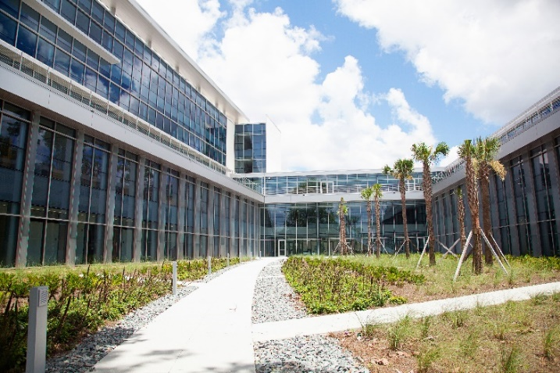
The University of Florida Clinical and Translational Science Institute (CTSI) was founded in 2008 to speed the translation of scientific discoveries into improved health by strengthening the university’s ability to conduct clinical and translational research.

The mission of the UF CTSI is to improve human health by accelerating the translation of scientific discoveries and the implementation of evidence-based best practices for the diagnosis, treatment, prevention and cure of human disease. It is geared to attract individual and team investigators to amplify their capabilities, and to help them more effectively and more quickly carry out their clinical and translational research. UF CTSI improvements include awarding of funding for pilot projects, changing the IRB submission process, creating new informatics resources, and introducing a common reimbursement price list for clinical research charges.

As a catalytic hub connecting resources, people and ideas, the CTSI expands collaboration and advances translational research across UF’s 16 colleges, the state and the national Clinical and Translational Science Award consortium.

The CTSI performs three central functions: 1) transforming the environment by developing new capabilities and providing novel infrastructure for research and translation to practice; 2) delivering high-quality and efficient research services and resources; and 3) cultivating a strong translational workforce.

The CTSI offers multidisciplinary training programs, undertakes transformational initiatives and provides services and resources to facilitate health research in any disease area and to advance knowledge across the translational spectrum – from laboratories to health-care settings to the public health and policy arenas, and back again.

The UF CTSI is supported by multiple NIH grants, most notably a Clinical and Translational Science Award (CTSA) from the National Center for Advancing Translational Sciences, and by significant institutional support from UF. As part of its second CTSA awarded in 2015, the UF CTSI expanded its collaboration with Florida State University as a partner in community-based research.

The Clinical and Translational Research Building (CTRB) serves as the headquarters for clinical and translational science at UF and in the state. The building houses patient-oriented research venues for the Institute on Aging and the Clinical and Translational Science Institute. The 120,000-square-foot facility features two main wings. Construction cost approximately $45 million, with $15 million coming from an NIH ARRA grant awarded to the Institute on Aging. Units in the new building include: Clinical and Translational Science Institute, Institute on Aging, Department of Biostatistics, Department of Epidemiology, Department of Health Outcomes and Bioinformatics

For further information, please visit CTSI Facilities – Resources: https://www.ctsi.ufl.edu/about/uf-ctsi-overview/citing-the-ctsi/#facilities
Download the comprehensive Facilities and Other Resources Word document (this version includes photos, figures, tables and graphics), or download the same Facilities and Other Resources (no graphics) Word document, without graphics, here.

CTSI REDCap
REDCap (Research Electronic Data Capture) is a secure, web-based application designed to
support traditional case report form data capture for research studies. Initial access to REDCap is offered at no cost, but annual maintenance fees will apply to projects that are not deleted from REDCap within one year of their creation date. If you need financial assistance to pay for this or other REDCap project maintenance, the CTSI is willing to support the REDCap annual project maintenance costs for research projects via its voucher program. For more information about CTSI vouchers, see https://www.ctsi.ufl.edu/research/voucher-request/. For those with funding, fee-based configuration services are also available to jump-start a given project. REDCap was originally developed at Vanderbilt University. The University of Florida and more than 2,000 other partners now comprise the REDCap Consortium that continues to develop and support the software. Using REDCap’s streamlined process for rapidly developing databases and/or surveys, users create a project, define and organize the data they wish to capture, build the related forms/surveys and associate them with study events. Other features include automated export procedures for seamless data downloads to Excel and common statistical packages (SPSS, SAS, Stata, R), as well as a built-in project calendar, a scheduling module, ad hoc reporting tools, and advanced features, such as branching logic, auto-validation, file uploading, survey stop actions, and calculated fields.

Collaboratory for Woman Innovators

https://innovate.research.ufl.edu/accelerate/the-hub/collaboratory-2/

The Collaboratory for Women Innovators seeks to inspire, educate, and empower women to attain leadership in all phases of the innovation lifecycle. Diversity is critical to the success of innovation in the U.S., and research shows that there is still a significant disparity in the numbers of women entrepreneurs and innovators. The Collaboratory seeks to bridge that gap by supporting participants at various stages of personal and professional development.
A portfolio of resources and training opportunities ranging from structured programming to informal networking, workshop and special topic speakers are offered, designed to address diverse goals and objectives. Programs and resources are designed to support women starting their own companies as well as increase participation of female inventors/researchers. Additional activities provide opportunities for women to learn more about innovation, entrepreneurship and leadership and connect with like-minded people and mentors.

While the Collaboratory has a focus on women, we also offer programming that is non-gender specific. View our available programs or contact us for more information.

College of Medicine

https://med.ufl.edu/

College of Medicine faculty are national leaders in fundamental, translational and clinical research in areas pertaining to diseases of the nervous system, human aging, cancer, diabetes, infectious disease, immunology and inflammation, addiction, population sciences, genetics and gene therapy. College researchers are involved in collaborative research in several research institutes and centers within the university, including the Evelyn F. and William L. McKnight Brain Institute, the Emerging Pathogens Institute, the Genetics Institute, the Institute on Aging, the UF Health Cancer Center, the Diabetes Institute, the Clinical and Translational Science Institute, the Institute for Child Health Policy, Center for Addiction Research and Education, and the Research and Academic Center at Lake Nona.

College of Medicine faculty and collaborative research teams continue to receive awards and honors that reflect their exceptional distinctions and contributions. College of Medicine researchers have achieved an increase in National Institutes of Health funding for each of the last eight consecutive years, totaling nearly a 50% increase in NIH funding. This increase in NIH funding is reflected in the impressive rise in national rankings in recent years to 40 (joining the upper third of United States medical schools), according to U.S. News & World Report. With lab spaces across UF in Gainesville and at the UF Research and Academic Center in Lake Nona, the college is home to more than 380,000 square feet of research space.

College faculty members practice at UF Health Hospital, the UF Health Children's Hospital, the UF Health Cancer Hospital, the Malcom Randall Veterans Affairs Medical Center, the UF Health Rehab Hospital and the UF Health Psychiatric Hospital. In addition, physicians practice throughout North Central Florida at more than 50 UF Health Physicians practices. College of Medicine physicians accounted for nearly 859,000 physician visits in North Central Florida at UF Health Physicians practices in Fiscal Year 2016. Within UF Health Shands Hospital, College of Medicine physicians accounted for more than 50,835 patient discharges in Fiscal Year 2016.

College of Pharmacy

https://pharmacy.ufl.edu/

The University of Florida College of Pharmacy was established in 1923 and is the oldest of six health science colleges at UF. Ranked by U.S. News & World Report as the No. 1 pharmacy college in Florida and in the Top 5 nationally, the University of Florida College of Pharmacy is training the next generation of pharmacists and pharmaceutical scientists through its masters, Pharm.D., and Ph.D. programs.
Faculty in the college are annually recognized among the elite educators in the country with recent awards from organizations such as the Institute of Medicine, the American College of Clinical Pharmacy and the American Association of Pharmaceutical Scientists. The Pharm.D. program annually enrolls 270 students across the college’s three campuses in Gainesville, Jacksonville, and Orlando.
The University of Florida College of Pharmacy received a record $28.3 million in research awards in 2019, which moved the college higher in the American Association of Colleges of Pharmacy, or AACP, research rankings released June 9, 2020. Faculty research in the college is highly collaborative and interdisciplinary, spanning across the entire life cycle of a drug — from drug discovery and development to precision medicine and post-marketing drug safety studies. The depth and breadth of research is evident by the 48 faculty members who secured funding as principal investigators or co-principle investigators on extramural grants during AACP’s reporting period from October 2018 to September 2019.
The college has extensive affiliations, partnerships and collaborations to support practice excellence. In addition to active practice sites maintained by clinical practice faculty, two Medication Therapy Management (MTM) Call Centers have been established in Gainesville and Orlando. To meet the continuing professional development of pharmacy practitioners, the college has five pharmacy residency programs and five clinical fellowship programs. As a UF Health college, the COP clinical faculty serve as a part of interprofessional teams in community health care clinics and at UF Health Shands Hospital for residents of Florida who travel to Gainesville and Jacksonville for specialized care. The college’s Center for Quality Medication Management operates a call center that serves more than 150K Medicare and other patients nationwide. The college is the home to one of only two accredited PGY2 residencies in pharmacogenetics, the only one based at a university.

College of Public Health and Health Professions

https://phhp.ufl.edu/

The College of Public Health and Health Professions (PHHP) is one of the largest and most diversified health education institutes in the nation. Today, PHHP is one of six colleges that comprise the UF Health Science Center. The college has eight departments: Biostatistics; Clinical and Health Psychology; Environmental and Global Health; Epidemiology; Health Services Research, Management and Policy; Occupational Therapy; Physical Therapy; and Speech, Language and Hearing Sciences.

The college offers 20 degree programs, including two bachelor’s, seven master’s programs, eight doctoral, and three professional degree programs, with 163 faculty teaching a total of 2,275 students. The college is also home to five NIH-funded T32 training grants, and eight research centers. Additionally, the college’s research funding has more than doubled during the last decade, with more than $42M in external grants and contracts for research per year. PHHP faculty work collaboratively with many investigators across UF and on research projects locally, nationally and globally on a diverse range of topics.

The PHHP's home is in the Health Professions, Nursing, and Pharmacy (HPNP) building, completed in 2003, and includes 11 classrooms, four lecture halls, one auditorium, and a distance learning room for a total of 7,783 square feet. The college also includes the PHHP Research Complex, which is located in the Dental Wing (Ground Floor) of UF Health and totals 15,690 square feet of dedicated research space.

PHHP has 452 affiliation agreements that allow students to participate in site visits and to be placed at various organizations to complete internships, clinical rotations, supervised research, and other practical experiences. The agreements include 147 with health departments, hospitals, health centers, and Veteran’s Administration facilities, 275 with clinics and private practitioners, and 30 with other universities/educational institutions.

Craniofacial Center

https://craniofacial. pediatrics.med.ufl.edu/

The University of Florida Craniofacial Center’s interdisciplinary team approach consists of many specialists working together to provide the best possible integrated care. Our team consists of health professionals from pediatrics, plastic/craniofacial surgery, clinical psychology, speech-language pathology, otolaryngology, audiology, nursing, pediatric dentistry, oral and maxillofacial surgery, orthodontics, social work, and genetics.

The Center provides a broad spectrum of interdisciplinary services to patients and families pertaining to cleft lip and palate, facial disfigurement and other malformations of the head. These disorders may be due to birth defects, developmental or acquired through disease or accident. Services available from the Center include corrective surgery, pediatric medical care, pediatric dentistry, orthodontics, prosthodontics, otology and audiology, speech- language pathology, psychology, and patient/parent education.
The Florida Cleft and Craniofacial Network (FCCN) is a leading cooperative group composed of members from the University of Florida, Children’s Medical Services (CMS) of the Florida Department of Health, regional and local family networks, and Florida healthcare providers. Its mission is to assist professionals and families who care for children with craniofacial differences and to educate and empower them with knowledge and understanding of the needs of children with cleft lip, cleft palate, and other craniofacial conditions.

CTSI Biorepository

https://www.ctsi.ufl.edu/research/laboratory-services/ctsi-biorepository-2/

The CTSI Biorepository provides a range of services to help clinical and basic science investigators to conduct research and generate publications in biobanking and improved patient care. A successful biorepository opens many doors of opportunity for investigators and patients, including the potential to acquire large-scale clinical trials, become leaders of research consortia, advance clinical research technologies and medical care, and develop educational opportunities for faculty and students.

Services and Facilities:

Biospecimen Library
More than 32,000 remnant specimens collected with informed consent and made available to anyone with appropriate IRB approval or materials transfer agreement.

- Fresh-frozen tissue samples: Tumor and matching normal from same patient, same organ
- Mirror-image FFPE blocks of fresh-frozen tissue samples
- Corresponding blood/blood derivatives: Plasma, serum, buffy coat
- Retrospective and prospective specimen procurement services

Secure Specimen Storage Facility
- Both -80C and LN2 freezers with capacity for more than 520,000 samples
- Equipped with multiple, independent temperature-monitoring systems
- All freezers are connected to backup generators in the event of a loss of electrical power
- CO₂ backup systems on all -80C freezers

Specimen Processing Services and Equipment
- Processing of tissue, blood and bodily fluids; peripheral blood mononuclear cell (PBMC) processing
- Nucleic acid extraction and quality-assessment equipment

Comprehensive Research Specimen Management
- Consultation on study-specific needs
- Custom kit creation (study specific)
- Multi-site management and support
- Sample receipt, reconciliation, and storage
- Sample distribution and shipping
- Electronic biospecimen tracking in OnCore Biospecimen Management database (complete cradle-to-grave sample tracking. including chain-of-custody, aliquoting, freeze-thaw cycles, etc.)

Dental Clinical Research Unit (DCRU)

https://research.dental.ufl.edu/resources/ufcd-clinical-research-2/f/

The University of Florida’s Health Science Center, with the College of Dentistry is committed to developing and expanding clinical research in areas such as patient care, disease prevention, oral/microbiology, biomaterials, and immunology. The intent of the clinical research is to explore the effectiveness and safety of medication, devices, diagnostic products, and treatment regimens that can lead to improved oral health care. To facilitate clinical research the college established the Dental Clinical Research Unit (DCRU). The DCRU provides space and resources for dental investigators including faculty, students, and external sponsors.

Services include: assistance with in-vitro studies, pharmacology, microbiology, diagnostic methodology and data collection/management. The DCRU is staffed with study coordinators and dental assistants that provide expertise in clinical study development and implementation.

The college requires that all sponsored and resident clinical research is vetted through the DCRU staff. The staff ensures IRB documents are accurate, and confirms that the principal investigator has access to the necessary resources to complete the study. The college also requires that clinical research projects are entered into in the AxiUm clinical management system. In addition to meeting compliance requirements, research projects established in AxiUm give a research team the ability to collect data involving participants and treatments.

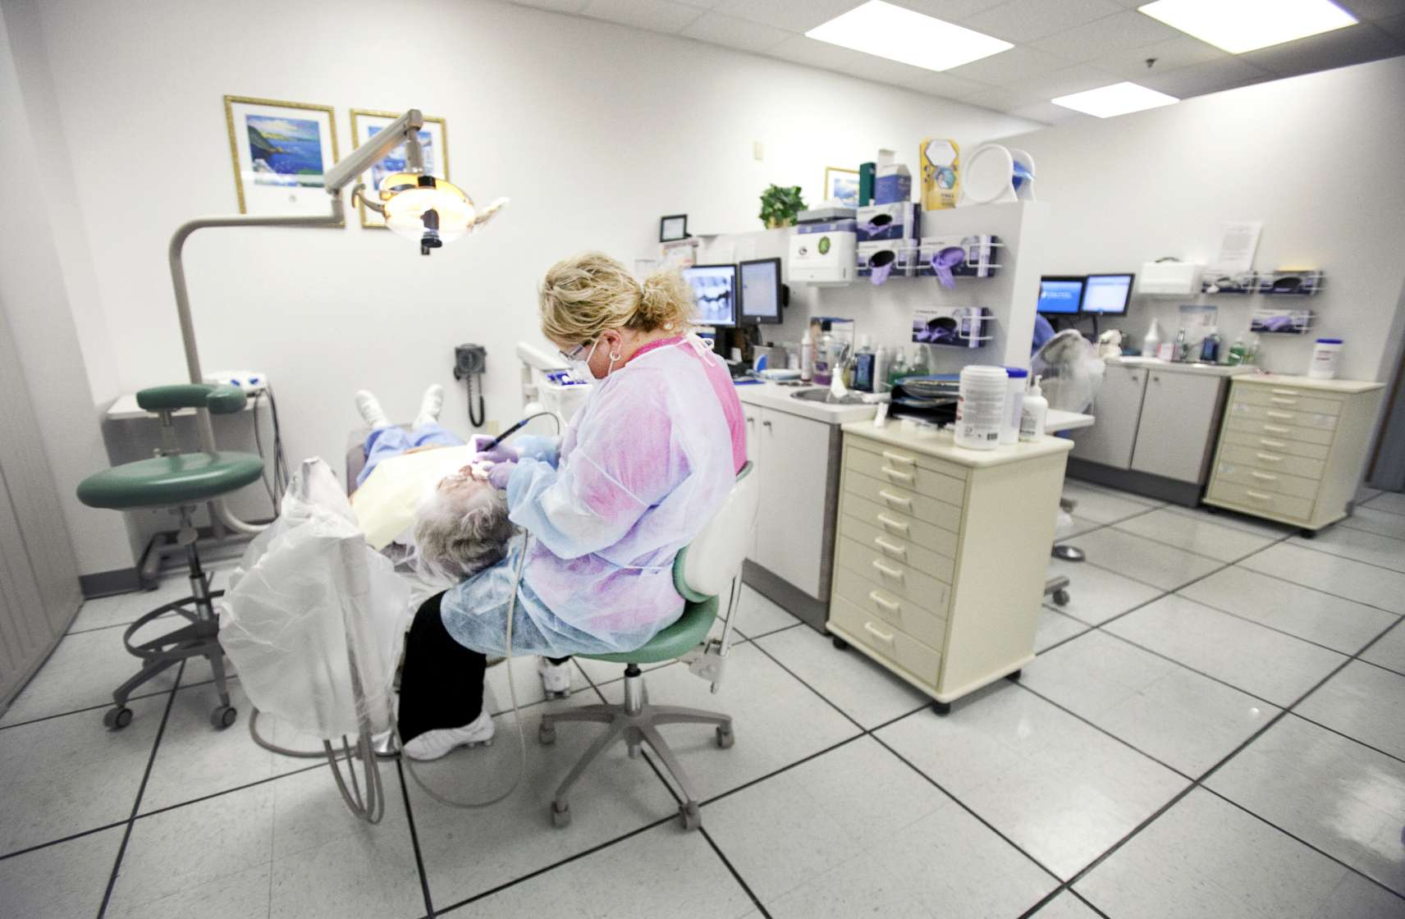

Department of Epidemiology

https://epidemiology.phhp.ufl.edu/about/

The Department of Epidemiology is dually-governed by the colleges of Public Health and Health Professions and Medicine. Six full-time staff members provide the academic and departmental functions alongside 17 full-time, 3 part-time and 19 graduate faculty. Located in the Clinical and Translational Research Building, the department occupies 6,700 square feet of the fourth floor. HealthStreet, the community engagement arm of the CTSI is also part of the Department of Epidemiology.

Training: The Department offers four academic programs, including the PhD in Epidemiology Program which entered its first student in 2009 and now with 25 graduates, the Master of Science in Epidemiology, a Certificate in Psychiatric Epidemiology and the epidemiology concentration in the Master of Public Health program. The Department is home to two NIH T32 training grants that each support multiple pre- and postdoctoral fellows each year. Individuals with one of these prestigious, federally-funded fellowships are appointed for two to three years with a stipend, tuition and fee waiver, travel funding, and funding for training-related expenses such as textbooks or computers. The department is also home to the Southern HIV and Alcohol Research Consortium, approved as the UF SHARC Center for Translational HIV Research, which provides research infrastructure, training, and mentoring to improve health outcomes and reduce HIV transmission among the diverse range of populations affected by alcohol and HIV infection in the Southeastern United States.

Research: Faculty have garnered over $8M in extramural funding. Fields of expertise include community engaged research, public health surveillance, global health, methodology, healthcare safety and quality, violence and victimization, and areas within epidemiology such as psychiatric, behavioral, cancer, cardiovascular, environmental, genetic, and infectious disease. Epidemiology faculty members engage in numerous collaborations throughout UF, the State, the country and world.

Department of Health Outcomes and Biomedical Informatics (HOBI)

https://hobi.med.ufl.edu/

The Department of Health Outcomes and Biomedical Informatics (HOBI) is located in within the UF Health Science Center and organizationally within the College of Medicine. The physicians in the College of Medicine frequently provide consultation services at no charge to HOBI. The department has two major research divisions:

Health outcomes and implementation science: Health outcomes researchers use medical records, insurance databases, patient questionnaires and other data to evaluate the overall effectiveness of medical treatments or health interventions, including clinical outcomes, financial impact and patient-reported quality-of-life and satisfaction. Implementation science involves the study of methods to promote the successful integration of research findings and evidence into health care policy and practice. When developing these methods, researchers often engage patients and providers to ensure that their needs and preferences are considered. Stakeholder engagement improves compliance with treatment regimens and prevention interventions.

Biomedical informatics: Defined as “the study of information at the intersection of computer science, biology and health,” biomedical informatics is the new frontier of health research. The biomedical informatics team at HOBI asks critical questions about the very nature of data and its integrity in an effort to leverage the ever-increasing amount of health data available today to improve health outcomes, health care delivery and health policy.

HOBI is located in the Clinical and Translational Research Building (CTRB). The CTRB serves as the headquarters for the Clinical and Translational Science Institute (CTSI) at UF and in the state. The building houses patient-oriented research venues for the CTSI, as well as a range of clinical and health services research faculty, many of whom have extensive expertise in the areas of implementation science, quality of care and health outcomes. Adequate office space for study personnel and space for storage have been allocated.

HOBI has 24 full-time faculty who provide leadership in implementation science, health promotion, health disparities, and health outcomes studies. Areas of focus include health care outcomes and preventive interventions for low-income children and adolescents, risk behavior reduction, biomedical informatics, community intervention trials, community-engaged research, and health care quality and outcomes for disadvantaged populations. There are more than 100 professional and support staff.

The extramural funding portfolio in HOBI is diverse and includes current funding from the National Institutes of Health, Pfizer, the Robert Wood Johnson Foundation, Health Resources and Services Administration—Maternal and Child Health Bureau, State of Florida, State of Texas, and the Patient Centered Outcomes Research Institute. The current annual extramural funding is approximately $33.5M annually. The department, HOBI, offers six graduate degrees: a M.S., Ph.D., and graduate certificate in health outcomes and policy and a M.S., Ph.D., and graduate certificate in biomedical informatics.

Department of Pharmaceutical Outcomes and Policy

https://pop.pharmacy.ufl.edu/

The Department of Pharmaceutical Outcomes and Policy’s focus on research and graduate training is centered on the evaluation of drugs and related medical technology. This focus includes classic pharmacoepidemiologic work in drug safety and comparative effectiveness, pharmacoeconomics, as well as patient safety and program evaluation as related to medication use.

Training: The department contributes to the college’s teaching mission professional education (PharmD program) and has one of the oldest graduate program in pharmaceutical outcomes research, with an average of 25 enrolled Ph.D. students, a small number of residential and more than 150 online MS students. The department offers a weekly seminar series and journal club as well as more than 20 graduate courses in the department specialty areas.

Research facilities: The Department has excellent research facilities that support studies involving big data and statistical modeling. Core facilities include a large conference-style room dedicated to ongoing research studies and a research office that allows hardwired access to the department’s research server. The department also provides an array of hardware, software, and personnel resources to support quantitative research including access to Truven MarketScan data for 12 years (~160 million lives), Medicaid Extract (MAX) files for 29 states covering 12 years (~80 million lives), and Medicare national 5% sample data for 5 years (15 million lives) and the UF Health Clinical research data warehouse.

The department is staffed by 2.5 Statistical Research Coordinators who serve as both database query specialists and statistical consultants. The Department of Pharmaceutical Outcomes and Policy’s high-speed research server is physically located in a secure and environmentally controlled server farm at the UF Health Science Center in Gainesville, FL. The server, 45Tb high-speed disk storage system, network hardware, and backup and disaster recovery infrastructure are maintained by the UF Academic Health Center IT Department and overseen by the Office of the Assistant VP for Information Services. System administration of the server, including maintenance and updating of the operating system and software applications, security compliance and monitoring, user account and user group management, system performance, and disk storage backup and DR, is managed by UF College of Pharmacy IT staff. Requests pertaining to user support, user security issues, user account setup, user group membership, software applications, and system performance are first triaged and appropriately elaborated by the Department’s Statistical Research Coordinators and then submitted to COP IT staff for handling. The server is accessed through secure desktop PC terminals in the P.A. Foote Health Outcomes Laboratory, through authorized Foote Lab staff office desktop PC's, and through a highly secure Virtual Desktop Interface (VDI) system that can be installed on any notebook or desktop PC. The VDI system enables authorized users to access the research server from any remote location, allowing them to work flexibly within the server’s computing environment while at the same time completely preventing any uploading of malware/viruses or downloading of sensitive data between the remote PC and the server. The server, associated supporting equipment, and all desktop and notebook PC's used to access the server comply with federal data security requirements involving storage of personal health information and SSN and those formulated by several states including Florida, Texas, California, and New Jersey.

Department of Statistics

https://catalog.ufl.edu/graduate/colleges-departments/liberal-arts-sciences/statistics/

The Department of Statistics at the University of Florida, under the College of Liberal Arts and Sciences, has its purpose: (i) to provide excellent education in statistics, (ii) to prepare departmental majors for successful careers in academia, industry and government, (iii) to extend the frontiers of statistics through basic and applied research, (iv) to collaborate with researchers in other disciplines to investigate important scientific issues and (v) to provide leadership within the University and the profession. The Department seeks to be comprehensive, balanced and to conduct itself with openness, enthusiasm, integrity and respect for the diversity of the contributions made by its members.

The Undergraduate Program in Statistics offers a B.S. or B.A. for students looking to major in statistics as well as two minors. The Graduate Program in Statistics offers both Master’s and PhD degrees. Graduate degrees are offered through the Graduate School.

Interdisciplinary programs: The Department offers a co-major program in conjunction with the Fisher School of Accounting leading to the Doctor of Philosophy degree in statistics and business administration accounting. The Department is also a partner in the interdisciplinary concentration in quantitative finance, along with the Departments of Mathematics; Industrial and Systems Engineering; and Finance, Insurance, and Real Estate. For information on these programs, consult the departmental graduate coordinator.

Combined program: The Department offers a bachelor’s/master’s degree program.

Diabetes Institute

https://diabetes.ufl.edu/

The University of Florida Diabetes Institute was founded in 2015 with a commitment to advance patient care and ultimately find a cure through pioneering research, innovative treatment and education.

The Diabetes Institute serves as the umbrella organization under which research, treatment and education are coordinated at UF and UF Health, the university academic health center. Researchers and physicians affiliated with the Diabetes Institute are working to prevent, diagnose and treat diabetes in a wide array of areas, including immunology, genetics, endocrinology, metabolism, pediatrics and social sciences.

As the primary coordinating center for the JDRF Network for Pancreatic Organ Donors with Diabetes, or nPOD, the UF Diabetes Institute leads a global network of more than 150 researchers where pancreas tissue is available for the first time to address how diabetes forms. UF is part of an international effort to solve that mystery, tracking about 8,000 newborns with increased genetic risk for type 1 diabetes in four countries to determine what triggers it in some children but not others. These are just a few of the many contributions UF has made as an international research leader in the treatment and management of the disease.

UF faculty have been awarded competitive grants from the National Institutes of Health/NIDDK, JDRF, the American Diabetes Association, the Leona M. and Harry B. Helmsley Charitable Trust, and other private and public funding agencies. Current total annual research funding exceeds $15 million. Cumulative scholarship produced by University of Florida faculty well exceeds 1100 papers, chapters and books.

Division of Sponsored Programs (DSP)

https://research.ufl.edu/dsp.html

The Division of Sponsored Programs (DSP) facilitates institutional approval for all proposal submissions, accepts and administers grant awards, and negotiates contracts and other research-related agreements on behalf of the University of Florida. The Division of Sponsored Programs is responsible for the following areas:

Proposal Preparation & Submission
DSP reviews, approves and facilitates submission of all proposals; provides UF Authorized Official signature on proposal submissions; and offers guidance on budgeting and other proposal just-in-time and post-submission questions.

Outgoing Subawards
DSP’s Outgoing Subaward Team works closely with Principal Investigators and their staff to prepare and execute outgoing subawards or subcontracts.

Agreement Negotiation & Signature
DSP staff review, negotiate and facilitate the acceptance of all grants, contracts, awards, non-disclosure and data use agreements. They are the only official signatory for these documents at UF

Award Management
DSP facilitates the initial set-up and supports ongoing management of all sponsored awards. DSP reviews and approves all required prior approvals and award modifications.

Grant Accounting
Learn about the Division of Contracts & Grants and see what services it provides.

Award Closeout
The last step in a grant or contract’s life cycle, whether cost reimbursable or fixed price, is project closeout.

DSP’s main office is located in Grinter Hall.

Electron Microscopy Core Facility

https://emcore.m edicine.ufl.edu/

The UF College of Medicine Electron Microscopy (CoM EM) Core is based in the Division of Nephrology, Hypertension, and Renal Transplantation and has been in operation since 1998. We provide support for researchers from the University of Florida at large, as well as investigators outside of UF, who need ultrastructural methods for their projects, including access to equipment, consultation, training, and technical services. The Director, Jill W.Verlander, DVM, and staff have decades of experience using ultrastructural methods in biomedical research. All equipment and technical expertise needed for conventional transmission electron microscopy are available in the CoM EM Core. In addition to electron microscopy, we offer services related to the use of polyester wax embedding medium for immunohistochemistry. Fees for services and equipment use are based on cost-recovery in accordance with federal guidelines.

Services include:
- Fixative preparation
- Tissue processing in epoxy resin, acrylic resin or polyester wax
- Sectioning
- Immunoperoxidase and immunogold labeling
- Counterstaining
- Imaging
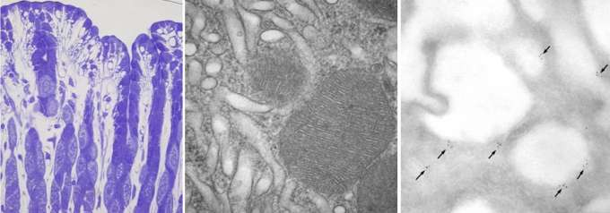
- Quantitative Methods

Emerging Pathogens Institute

https://www.epi.ufl.edu/

Since 2006, the Emerging Pathogens Institute has committed itself to interdisciplinary studies of the emergence and prevention control of human, animal and plant pathogens of concern to Florida, the nation and the world. Working with locally and globally, EPI faculty oversee ongoing research in more than 30 countries. With more than 200 distinguished faculty members from 11 University of Florida colleges, EPI supports the best minds in order to better understand how novel infectious diseases affect our world. Biologists, epidemiologists, geographers, biostatisticians, mathematicians, physicians, veterinarians, and other scientist create the strong collaborative spirit of EPI.

EPI fuses key disciplines to develop research, education, and outreach capabilities designed to preserve Florida and the world’s health and economy, and to prevent or contain new and re-emerging diseases

Major areas of research include vector-borne diseases, influenza, other viral pathogens, tuberculosis /drug-resistant TB/non-TB mycobacterial disease, enteric and foodborne illnesses, plant pathogens and antibiotic resistance /hospital infection control. The Emerging Pathogens Institute is housed in an 88K square foot research building dedicated for institute use. The building includes 16 BSL3 laboratory modules as well as extensive BSL2 space and space for biomathematics; it has 50 faculty offices, 150 spaces for graduate students and post-doctoral fellows, and multiple conference rooms (including a 70-seat seminar room), and a large administrative suite.

Link to EPI Brochure: https://epi.ufl.edu/media/epiufledu/EPI-Brochure-Online.pdf

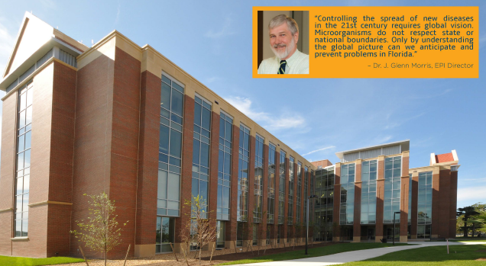

Florida Climate Institute (FCI)

https://florid aclimateinstitute.org/about

The Florida Climate Institute (FCI) is a multi-disciplinary network of national and international research and public organizations, scientists, and individuals concerned with achieving a better understanding of climate variability and change.

The FCI has ten member universities – Florida A&M University (FAMU); Florida Atlantic University (FAU); the Florida Institute of Technology (FIT); Florida International University (FIU); Florida State University (FSU); Nova Southeastern University (NSU); the University of Central Florida (UCF); the University of Florida (UF); the University of Miami (UM); and the University of South Florida (USF) – and is supported by relevant colleges, centers, and programs at these universities. UF and FSU initiated the FCI in 2010; FAU, UCF, UM, and USF formally joined in 2012; FIU formally joined in 2013; FAMU formally joined in 2014; FIT formally joined in 2015; and NSU formally joined in 2017.

The FCI is led by an executive board consisting of two faculty from each member university. The two faculty at each university include a university FCI branch director and an additional person selected by the university. Leadership of the executive board consists of a chair and an associate chair. UF currently serves as the FCI host institution and, as such, coordinates the central operational duties. As branch director of the host institution, Dr. James W. Jones currently serves as the FCI chair. The host institution rotates among member universities and is reconsidered every three years. Each member university also has support staff to assist the executive board in developing, executing, and evaluating FCI programs and activities.

Over 400 individual affiliates, including university researchers and representatives from government and industry, have joined the FCI. Anyone in Florida who works in climate research, teaching or outreach is welcome to become an affiliate.

In September 2014, the FCI and the Southeast Florida Regional Climate Change Compact signed a Preliminary Partnership Agreement to (1) seek better alignment between public sector information/management needs and ongoing university research and (2) improve coordination between the Compact and FCI universities in pursuing competitive research funding opportunities.

Florida Energy System Consortium

http://flori daenergy.ufl.edu/

The Florida Energy Systems Consortium (FESC) was created by the Florida State government to promote collaboration among the energy experts at its 12 supported universities to share energy-related expertise. The consortium assists the state in the development and implementation of an environmentally compatible, sustainable, and efficient energy strategic plan. The Consortium was charged to ‘perform research and development on innovative energy systems that lead to alternative energy strategies, improved energy efficiencies, and expanded economic development for the state‘. The legislature appropriated funding for research at five of the universities as well as support for education, outreach, and technology commercialization. The Consortium reports to and provides guidance on an as needed basis to the Florida Legislature, Executive Office of the Governor, and the Florida’s Office of Energy housed in the Florida Department of Agriculture and Consumer Services.

Overarching to the Consortium’s research strategy is an energy systems approach to identify innovation opportunities, prepare an energy workforce, and guide economic development.

Through collaborative research and development across the State University System and the industry, the goal of the consortium is to become a world leader in energy research, education, technology, and energy systems analysis. In so doing, the consortium shall:

Coordinate and initiate increased collaborative interdisciplinary energy research among the universities and the energy industry.
Assist in the creation and development of a Florida-based energy technology industry through efforts that would expedite commercialization of innovative energy technologies by taking advantage of the energy expertise within the State University System, high-technology incubators, industrial parks, and industry-driven research centers.
Provide a state resource for objective energy systems analysis.
Develop education and outreach programs to prepare a qualified energy workforce and informed public.

The administration office is located at the University of Florida directed by Dr. David Norton. FESC can provide support letters to PIs for their energy related proposals if needed. Please contact Canan Balaban at cbalaban@ufl.edu for further information.

Florida Neonatal Neurologic Network

http://hopefn3.or g/

The Florida Neonatal Neurologic Network's (FN3) mission is to provide state-of-the-art care for newborn babies with brain injuries and to collect research and develop future therapies to improve long-term outcomes. FN3 aims to create innovative new therapies for babies with brain injuries.
FN3’s values include:

- Provide state-of-the-art clinical care across the state of Florida;
- Provide educational resources to parents;
- Develop future treatments to improve the outcome of babies with brain injuries.

This will be accomplished by combining the excellence found in the top hospitals and research institutes in the state of Florida. FN3 shall further:

- Observe ethical and professional standards;
- Maintain communication and positive relationships between hospitals and the general public;
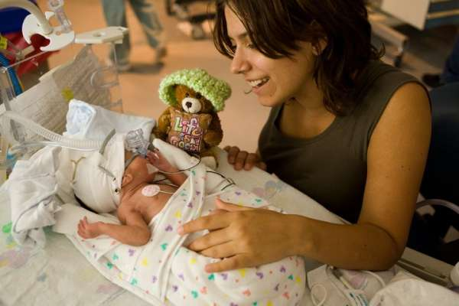
- Strengthen research databases by maintaining an updated registry

Global Pathogen Discovery Laboratory

https://egh.phhp.ufl.edu/services/global-patho gen-discovery-lab/

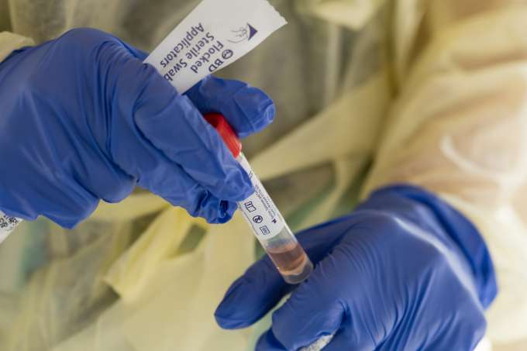
The Global Pathogens Discovery Laboratory works collaboratively on projects that need microbiology surveillance, identification and discovery. The laboratory was created in response to the need for high quality molecular and culture-based assays to detect, identify, and quantify pathogens, with a particular emphasis on analysis of environmental and animal samples. The founding director, Dr. John Lednicky, has more than 20 years of academic research and industry experience in developing assays to quantify pathogens and identify unknown viruses in environmental, wildlife, and human samples. In response to the current COVID-19 pandemic, we have developed an in-house rtRT-PCR-based assay to detect SARS-CoV-2 in water, air, and human specimens for research purposes. The Laboratory has dedicated BSL2 space and access to BSL3 suites.

Harrell Medical Education Building

https://med.ufl.edu/about/harrell-medical-education-building/

The George T. Harrell, M.D., Medical Education Building opened in Fall 2015 and serves as a home for medical education at UF, accommodating advanced simulation training and meeting the educational needs of the next generation of UF physicians and physician assistants.

The Harrell Medical Education Building is a 95K-square-foot, four-story facility that is located in close proximity to UF Health Shands Hospital. Its design facilitates the collaborative education of health sciences students at the UF College of Medicine. It features a state-of-the-art experiential learning center to teach complicated, high-risk skills, including an experiential learning theater with retractable walls and concealed grid to accommodate dozens of configurations and hundreds of health care scenarios, as well as one UF Health Shands Hospital mock operating room. It offers an expanded clinical skills learning and assessment center, with 18 standardized patient examination rooms equipped with video cameras and microphones; a control room with display screens to record student-patient encounters; spaces for review and evaluation of students’ skills; and two hospital rooms modeled after UF Health Shands Hospital patient rooms. It also has two circular learning studios – each of which can accommodate up to 160 students – with six oversized video screens, ceiling-mounted projectors and sound-absorbing acoustical wood paneling.
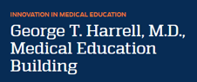
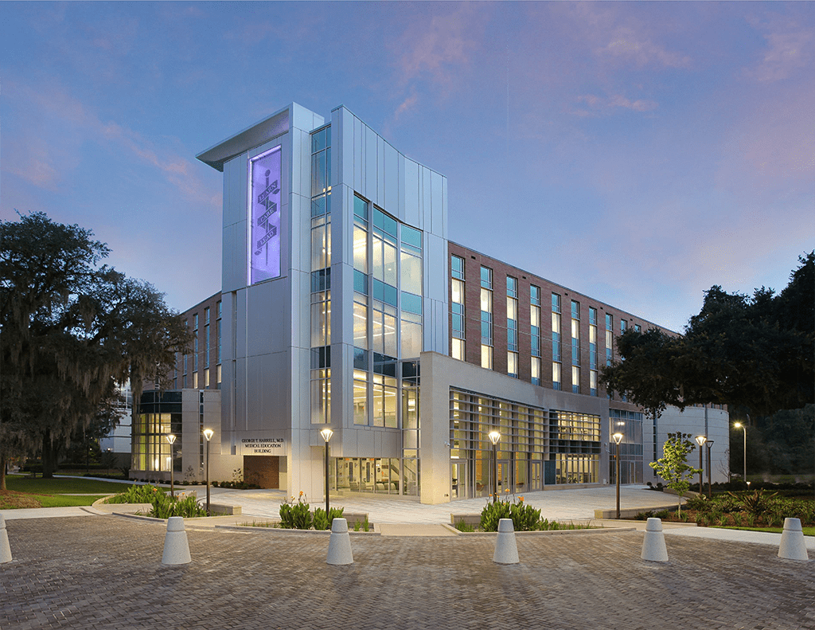

Health Science Center

https://ufhealth.org/a cademic-health-center/overview

The HSC is the country’s only academic health center with six health-related colleges located on a single, contiguous campus. Our colleges, major research centers and institutes and clinical enterprise focus on building collaborative specialized clinical services centered on quality and innovation.

Our vision as a preeminent academic health center is to optimize our collective expertise to improve patient care, education, discovery and the health of the community. Our success is predicated on research-based, multidisciplinary, cross-college programs. The colleges teach the full continuum of higher education from undergraduates to professional students to advanced post- doctoral students.

The academic health center is also a world leader in interdisciplinary research, generating 52 percent of UF’s total research awards. Seven major health-related research centers and institutes are designed to create synergies and collaborative research opportunities. Research activities reflect a depth of purpose by focusing on the translational nature of biomedical research, following the continuum from fundamental research to clinical research to patient care.

The Office of the Senior Vice President for Health Affairs includes several administrative units that provide leadership and support to all HSC colleges, centers and institutes. Among these are Academic and Administrative Affairs, Finance and Planning, HSC Libraries, Information Services & Technology and the Student Health Care Center. The HSC includes two primary campuses in Gainesville and Jacksonville as well as numerous educational, clinical and research affiliates across the state.

The Health Science Center also includes six major research institutes focused on health issues of importance to Floridians, more than 100 specialized centers of clinical expertise and a vibrant regional campus in Jacksonville.

From the time of the Health Science Center’s founding in 1956, an effort led by our namesake, UF President J. Hillis Miller, we have operated as a single academic enterprise. He and other leaders had the distinct belief they were creating something unique for its time — an integrated campus dedicated to training a variety of professionals side-by-side and to introducing new knowledge that will safeguard the health of Florida’s citizens.

The HSC is a world leader in interdisciplinary research. The Clinical and Translational Science Institute, McKnight Brain Institute, UF Health Cancer Center, UF Genetics Institute, UF Institute on Aging and the UF Emerging Pathogens Institute are designed to create synergies and collaborative research opportunities that focus on the translational nature of biomedical research, following the continuum from fundamental research to clinical research to patient care. In the summer of 2009, UF became the only university in Florida to receive the National Institutes of Health’s Clinical and Translational Science Award. This $26 million five-year grant is geared toward accelerating scientific discovery, enhancing medical care, producing highly skilled scientists and physicians and fostering partnerships with industry; it supports multidisciplinary research in a wide range of fields such as biomedical informatics, gene therapy, aging, nanotechnology and infectious diseases.

Select Initiatives
- The University of Florida Cancer and Genetics Research Building adds to Florida’s biotechnology efforts and is a prototype for interdisciplinary research. The 280,000-square-foot facility houses the UF Genetics Institute, the UF Health Shands Cancer Center, the Interdisciplinary Center for Biotechnology Research and the C.A. Pound Human Identification Laboratory.
- The UF Health Proton Therapy Institute (UFHPTI), located at UF Health Jacksonville, opened and treated its first patient in August 2006. UFHPTI is a 98,000-square-foot facility providing conventional radiation cancer treatment and proton therapy. UFHPTI includes clinics for the pre- and post-therapy and on-treatment evaluation of cancer patients, planning suites, an infusion and anesthesia suite, psychosocial and dietary services, a research office and faculty offices. At capacity, the facility can treat up to 200 patients.
- The UF Health Shands Cancer Hospital opened November 1, 2009, and supports the academic medical services offered by Shands and UF. The hospital houses 192 private inpatient beds for a variety of patients, including those receiving diagnostic and therapeutic oncology services. In addition, the UF Health emergency department and trauma unit and a critical care center for emergency- and trauma-related services are located there.
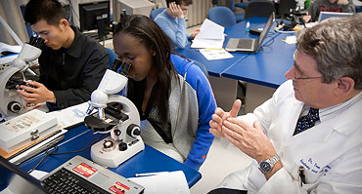
- The University of Florida Biomedical Sciences Building serves as a center for animal research into genetics and cancer. The $85 million facility opened in September 2009.

Health Science Center Libraries

https://library.health.ufl.edu/

The University of Florida Health Science Center (HSC) Libraries are active partners in the education, research, training and clinical needs of the HSC colleges, centers and institutes, the University of Florida and the state.

HSC Libraries have 3 locations:
- HSC Library, UF Campus, Gainesville
- HSC Library – Borland, Jacksonville
- Veterinary Medicine Education Center, UF Campus, Gainesville

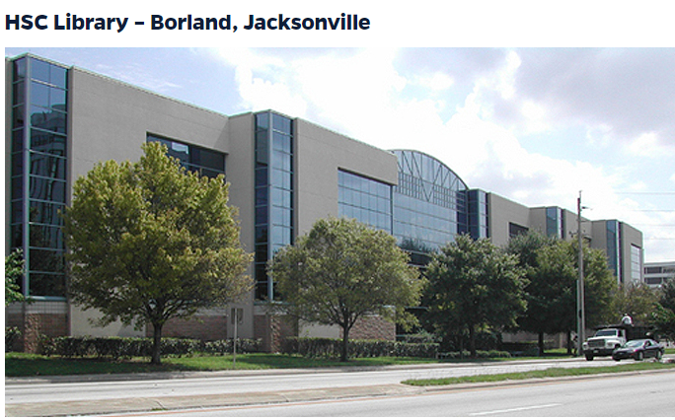
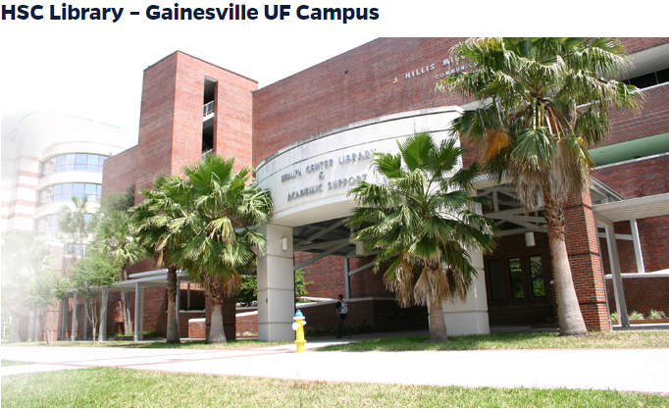
The Main Health Science Center Library in Gainesville, founded in 1956 along with the College of Medicine, is a 53K-square-foot, technology-enhanced facility whose users may access 162 publicly available computers on all three floors of the library, including 30 big-screen monitors. Free wireless access is available throughout the library, and patrons not affiliated with UF may request temporary access. In addition, seating and study space accommodating up to 870 patrons is available across three floors, including 32 study rooms for individuals and groups. The Health Science Center Library in Gainesville is typically open 95 hours per week and averages approximately 33,000 visitors per month. 24/7 access to the second floor is available to HSCL users who are UF students currently enrolled in any of the six Health Science Center colleges, UF Health/Shands Residents and Fellows. Reference assistance and search help are provided at the Information Desk.

Borland Library
Borland Library in Jacksonville is an 11,302 square feet facility, and has seating and study space for 196 patrons, including 4 group study rooms, 1 large presentation practice/large group study room, and 24 individual study carrels, and is also equipped with free wireless access. Patrons may use 24 public computers: 12 general stations, 10 in the electronic classroom, one scanning workstation and a large-screen monitor with specialized medical software. Borland’s combined circulation and reference desk is staffed an average of 48 hours per week.
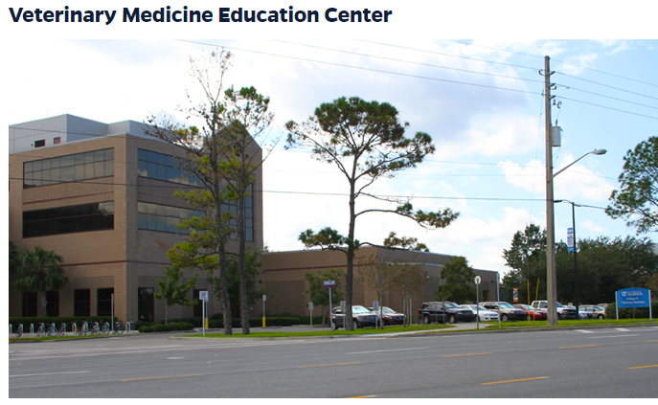
The HSC Libraries provide services and programs to support the six colleges of the UF Health Science Center (HSC): Dentistry, Medicine, Nursing, Pharmacy, Public Health and Health Professions, and Veterinary Medicine. The HSC also includes the Clinical and Translational Science Institute; Center for Pharmacodynamics; Diabetes Institute; Emerging Pathogens Institute; Genetics Institute; Institute on Aging; Institute for Child and Health Policy; Institute for Therapeutic Innovation; McKnight Brain Institute; and UF Health Cancer Center. The HSCL also support the broader clinical and research missions of UF Health, including: UF Health Shands Hospital in Gainesville, UF Health Jacksonville, UF Research and Academic Center at Lake Nona; and the Innovation Incubator at the Sid Martin campus in Alachua, as well as a variety of primary and specialty clinics. The primary clientele of the HSCL were responsible for over $393 million in research awards in 2019 (over 50% of the University’s total research awards). The HSCL supports these efforts by providing access to essential research content, as well as facilitating public access compliance and data management, and offering systematic reviews and other services, all in a technology-rich environment.

Library services include reference assistance, course-integrated library instruction, circulation, document delivery, Interlibrary loan, photocopy services, course reserves, lockers and study rooms. Computer access to electronic databases, journals and catalogs is available onsite and remotely to authorized users. Since 1999, the HSC Libraries have operated a Liaison Librarian program that facilitates partnerships with academic faculty, researchers, and clinicians by assigning one or more dedicated librarians to each HSC College or Department.

The HSC Libraries’ collection includes reference materials, journals, books, audiovisuals and electronic resources. As of July 2020, the Libraries’ collection totaled 292,319 volumes available for immediate access or housed in a remote storage facility. Additionally, we have 147,613 unique monograph titles (books) in all formats and 16,865 serial titles (journals) in all formats, and our users have access to 101 databases. Total expenditure for the collection in Fiscal Year 19-20 was $2,791,342.

Through the HSC Libraries’ website and via the UF Libraries’ Catalog, we offer access to several thousand electronic databases and journals that include broad and specific subject areas from Anesthesiology to Zoology. In addition to access from any on-campus university computer, with few exceptions the HSC Libraries also provide off-campus access to all electronic resources to UF faculty, staff, students. Off-site users may access electronic resources by installing VPN client software or by logging into the UF Libraries’ EZProxy server.

HealthStreet

https://healthstreet.program.ufl.edu/

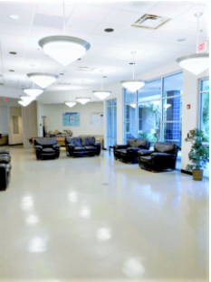
HealthStreet, a community engagement program at the University of Florida, employs evidence-based, community outreach practices to reduce disparities in healthcare and research. Community health workers (CHW) help bridge the gap between community members and resources available to them, including medical and social services and opportunities to participate in research. CHWs provide medical and social referrals and link community members to health research that is relevant to their health concerns and conditions.

HealthStreet is located in Gainesville, FL, but reaches people all across the State of Florida. It includes about 10,000 square feet of space for community engagement and offices for faculty, staff, students and volunteers. The HealthStreet suite also includes a lobby, a community center, a conference room, multiple meeting spaces, several interview rooms, four clinical rooms, and two kitchen facilities. In collaboration with the UF Libraries, a paper and electronic library of health information is provided. There are handicap-accessible restrooms and shower facilities. HealthStreet is easily accessible to the greater Gainesville student and non-student population with links to public transportation

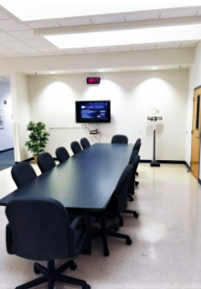
HealthStreet relies on Community Health Workers, who drive three seven-passenger vans drive to outreach locations and to provide transportation to community members for engagement.

Community Health Workers operating in 46 of 67 counties in Florida complement the Gainesville outreach efforts. Additionally, HealthStreet leads a national network of 18+ CTSA sites in conducting Our Community, Our Health events. These monthly forums promote bi-directional communication between researchers and the communities they serve, addressing relevant health topics and disseminating research findings. The events are streamed nationwide and are interactive using text messaging and social media.

Since opening in November 2011, HealthStreet has enrolled more than 10,000 people from the community; more than 2,050 of the 5,000 people navigated to studies have been enrolled in health research studies across the University. HealthStreet expanded operations to Jacksonville beginning in 2015, where HealthStreet Jacksonville facilities are housed within the Edward Waters College Center for the Prevention of Health Disparities close to the urban core of downtown Jacksonville.

HealthStreet is a one-stop portal of entry for linking and navigating underrepresented populations to opportunities to collaborate with the research community through town halls, focus groups, individual interviews, library use, individual health assessment, and navigation to appropriate research through a CHW-delivered, person-centered, health-literate process. The one-stop portal also offers referrals to social (food pantry, housing, criminal justice, etc.), medical and psychiatric (MDs, nurse practitioners, drug treatment, other health professionals) services and, in-house, offers vision and mental health treatment services as well as HIV testing provided through local health agencies. CHWs provide regular screening for blood pressure and blood sugar along with health education, including navigation to research opportunities. Quarterly, HealthStreet produces a Community Health Needs Assessment (CHNA) report that describes all conditions and concerns and is distributed through many media to the community. In addition, HealthStreet offers many opportunities for dissemination of research findings and community consultations in early research phases. These opportunities include: facilitated focus groups; targeted town hall meetings; poster presentations to appropriate audiences; community dissemination of fliers and other printed health information; and our flagship monthly town hall meetings routinely watched in 29 states through livestreaming, Our Community Our Health. HealthStreet is a CTSI-sponsored community engagement and recruiting program; Principal Investigators can contract for specific services through the CTSI infrastructure. HealthStreet is University of Florida IRB approved to recruit participants for appropriate studies.

Human Imaging Core

https://www.ctsi.ufl.edu/research/laboratory-services/human-imaging-core/

The University of Florida CTSI Human Imaging Core provides infrastructure and support to facilitate research and educational activities using magnetic resonance imaging (MRI) and magnetic resonance spectroscopy (MRS) technology, with particular emphasis on translational research in humans.
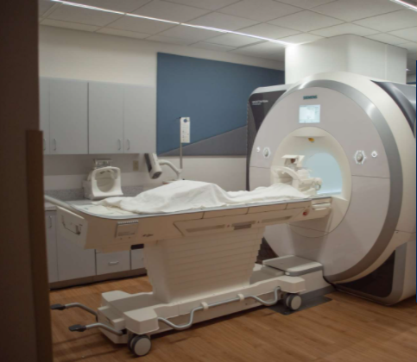
Located in the McKnight Brain Institute, the core houses two state-of-the-art 3.0 Tesla whole-body human MR scanners, Siemens and Philips, dedicated to research. Both scanners are equipped with the latest acquisition techniques for human MR research, including multinuclear capabilities, functional MRI (fMRI), advanced diffusion MRI techniques, MR elastography, musculoskeletal and cardiac studies, and MRS techniques.

The Siemens scanner is a 60 cm bore Prisma equipped with an unmatched 80 mT/m @ 200 T/m/s gradient system, parallel transmit capabilities, a series of MR coils and pulse sequence packages. The Philips scanner is a 70 cm bore Engenia Elition 3TX and provides the largest homogenous field-of-view, 55 cm, in a commercial 70 cm system, while still providing strong gradients. The Elition is equipped with Philips’ unique broadband digital MR architecture, the d-STREAM, which samples the signal directly at the coil and transmits the signal through fiber optics to reduce noise and increase signal-to-noise ratio.

On the same floor in the MBI, the Advanced Magnetic Resonance Imaging and Spectroscopy Facility houses three higher magnetic field magnets (4.7 T, 11.1 T and 17.6 T) for MRI and MRS of animals and/or tissue samples. This is a biological program of the NSF-funded National High Magnetic Field Laboratory, which together with the UF CTSI Human Imaging Core, provides a state-of-the-art facility for cutting-edge translational MR research in human health and diseases.
The CTSI Human Imaging Core capabilities include:
Structural and functional MRI; Methods and protocols for MRI data acquisition; Image quality assurance and quality control; Image acquisition and transfer support; Image archive, review, and access; Teaching investigators data acquisition and analysis techniques; Assisting researchers in designing experimental protocols; Development of advanced MR imaging and spectroscopy methodology.

Inclusion, Diversity, Equity and Access at the University of Florida

https://cdo.ufl.edu/

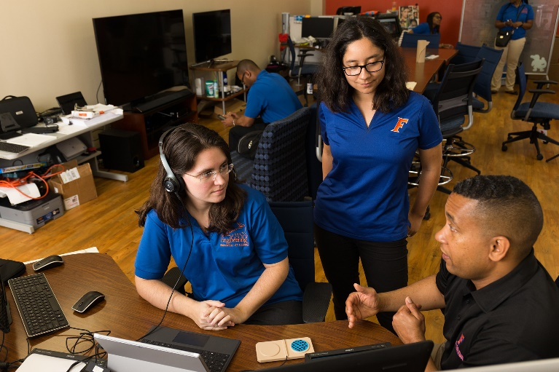
The University of Florida (UF) is home to a diverse group of faculty and students. UF seeks to foster inclusion and promote diversity at both the faculty and student level, through several university-wide resources. UF’s Chief Diversity Officer, Dr. Marsha McGriff, leads the university’s diversity and inclusion efforts by identifying areas for improvement and developing resources for faculty and students. In support of faculty, the university has joined the National Center for Faculty Development & Diversity (NCFDD). Institutional membership allows the UF academic community – faculty, postdocs, graduate students and administrators – access to online career development resources. Additionally, UF is home to several faculty organizations who work to promote inclusion and raise awareness of faculty needs and experiences, including the Association of Black Faculty and Staff, Asian Faculty and Staff Association, and Association of Academic Women.

Dedicated to increasing college access and providing opportunities for students from all backgrounds, the University of Florida strives to provide a supportive and accepting environment for the various identities that make up its student community. Consequently, UF promotes several programs and organizations for undergraduate and graduate students. Programs, such as the University Multicultural Mentoring Program (UMMP), support first-year students in their transition to the University of Florida campus community by pairing them with a faculty/staff mentor. The university supports first-generation students through programs such as the Florida Machen Opportunity Scholars Program, which recruits students from across Florida. For first-generation students moving closer to graduation, the First-Generation Academy provides a year-long program created to improve self-awareness, community building, and career planning. Student-led organizations, including the Pride Student Union and Black Graduate Student Organization, are also active on campus. These organizations can provide social support and useful resources for students as they learn and grow at UF.

Chief Diversity Officer and Campus Diversity Liaisons Network
The Chief Diversity Officer (CDO) is a cabinet level position that also serves as senior advisor to the President. The CDO provides leadership, expertise and vision for the university’s coordinated model for diversity and inclusion. A network of Campus Diversity Liaisons—faculty/staff members embedded within the leadership team of each college or business unit—work with the CDO to advance the university’s strategic initiative around IDEA and its anti-racism initiative.

Center for Teaching Excellence
The Center for Teaching Excellence supports excellence in teaching and learning across the university. CTE offers several trainings related to IDEA for faculty, teaching assistants, post-docs and graduate students, including: modules in cultural competence in the Passport to Great Teaching certificate program and Accessible Online Environments. They have also compiled comprehensive resources in their website related to inclusive teaching.

Crucial Conversations
The Office of the Chief Diversity Officer has taken more than 300 faculty and staff members through this intensive training developed by VitalSmarts in how to have conversations around high-stakes, emotional and risky topics. The trainings have included college-level senior leadership, the Campus Diversity Liaison network, and specific colleges’ management teams. The university has invested in a train-the trainer program and now has a group of trained, experienced trainers to deliver this content in a sustainable manner.

UF Racial Justice Research Fund
In FY 2021, UF committed nearly $1 million to faculty research projects focused on racial disparities in health care, diversity in professional programs, challenges in developing and teaching an inclusive curriculum, and strategies for creating a more inclusive campus environment. UF Research has awarded $970,000 to more than a dozen faculty teams across campus. The projects funded include one that addresses racial disparities in clinical trials of treatments for some of the nation’s most prevalent chronic diseases, like obesity, diabetes, hypertension, stroke, and heart and kidney disease. Another project, led by psychology Professor Emeritus Carolyn Tucker, is looking at why older Black individuals are reluctant to take advantage of traditional health care and whether they might be more likely to use telehealth options that have grown significantly during the pandemic. Dr. Duane Mitchell, professor of neurosurgery and director of UF’s Clinical and Translational Science Institute, is leading an effort to identify barriers to success for Blacks in the biomedical field and to develop strategies for them to thrive.

Managing Bias
In December 2020, UFHR introduced a new “Managing Bias” online training module as an initial step in our shared efforts to better understand and begin to dismantle the individual and collective forces that support racism. UF’s racial justice education initiative will also include training for students.

National Center for Faculty Development and Diversity Membership
The university has signed on as an institutional member of NCFDD, providing all faculty and staff access to the free career and professional development programming offered. Membership data indicates that faculty and staff are steadily becoming aware of and taking advantage of the resource and report high levels of satisfaction with the resource. In addition, the university has made a concerted push to fund faculty members, especially women and URM faculty, participation in the Faculty Success Program. This boot camp has been described by alumni of the program as transformative.

AAAS SEA Change Charter Membership
In October 2020, the University of Florida joined the first SEA Change charter members, along with Arizona State University; the University of California, Irvine; and Westfield State University. SEA Change is an initiative of the American Association for the Advancement of Science to support colleges and universities as they systematically transform themselves into diverse, equitable and inclusive institutions.

This national network is publicly committed to creating sustainable changes to recruit, retain and advance the full range of diverse talent in science, technology, engineering, mathematics and medicine.

For more information and resources, visit https://research.ufl.edu/finding-funding/large-grant-proposal-development-assistance/table-uf-resources-and-boilerplate-text.html

Institute for Child Health Policy (ICHP)

http://i chp.ufl.edu/

The institute brings together multidisciplinary faculty from UF to conduct innovative and rigorous science to promote the health of children, adolescents, and young adults. The institute, housed within the department of Health Outcomes and Biomedical Informatics in the College of Medicine at UF, has over 25-year history of collaborating with teams of researchers across the UF campus and with scientists nationally.

Child, adolescent, and young adult health, particularly among those who face health disparities, is vital to securing a positive future for Florida and the nation. Our goal is to be a catalyst for scientists to work together to advance scientific knowledge that will be used by policymakers to promote and protect child, adolescent, and young adult health. Our research programs include the use of rigorous scientific methods, which are transdisciplinary and innovative. The Institute’s grants and contracts are funded by competitive state, federal, and foundation sources.

Our core strengths include:

- development and evaluation of community-wide programs and policies utilizing group-randomized research designs;
- multidisciplinary research on health care financing and delivery systems, health care quality, and outcomes of care; and
- innovative evaluation research on public programs and policies.
- The Institute provides a rich intellectual environment conducive to productive research collaborations and extensive mentoring opportunities for students, faculty, and scientists interested in child and adolescent health research.

The Institute has a long-standing history providing leadership in interpreting and disseminating research results to policymakers and the public. In addition, we actively collaborate with diverse state and federal agencies in research and policy change.
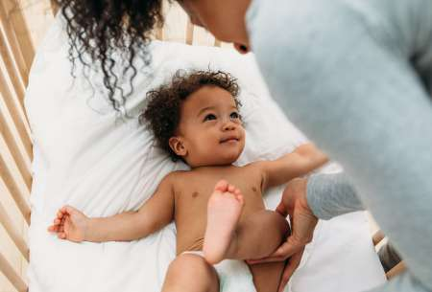

Institute of Food and Agricultural Sciences (UF/IFAS)

https://ifas.ufl.edu/

The University of Florida’s Institute of Food and Agricultural Sciences (UF/IFAS) is a federal- state-county partnership dedicated to education, research, and Extension. The mission of UF/IFAS is to develop knowledge relevant to agricultural, human and natural resources; and to make that knowledge accessible to sustain and enhance the quality of human life. UF/IFAS can trace its roots to the Morrill Act of 1862 which established the Land Grant university system.

UF/IFAS is the largest and most comprehensive agriculture and natural resources enterprise found among Florida’s public universities. This emphasis comes about because UF is one of the state’s two land-grant institutions, along with Florida A&M University. As a land-grant institution, UF receives federal support and operates with a federal mandate to improve the state’s agricultural and natural resources industries.

The full history of UF/IFAS dates to the 1880s, but the name “Institute of Food and Agricultural Sciences” only dates to 1964 — it was created to inaugurate a new administrative structure established that year, and is still in place today. The UF/IFAS enterprise is based in Gainesville on the UF main campus, and encompasses 14 academic departments and 2 schools. The entire enterprise is led by the UF senior vice president for agriculture and natural resources.

As the agriculture and natural resources enterprise in a land-grant institution, UF/IFAS has three main units, focused on teaching, research and Extension. These are respectively, the UF/IFAS College of Agricultural and Life Sciences (UF/IFAS CALS), UF/IFAS Research, conducted
under the auspices of the Florida Agricultural Experiment Station, and UF/IFAS Extension.

UF/IFAS CALS offers undergraduate and graduate degree programs in more than 20 disciplines. Nationwide, UF/IFAS CALS is one of the largest and most comprehensive colleges of its type.

UF/IFAS Research facilitates all research activities conducted by UF/IFAS faculty and students, on the UF main campus and at 17 off-campus locations.

UF/IFAS Extension operates offices and other facilities statewide and includes faculty at the state, regional and county levels. UF/IFAS has Extension offices in each of Florida’s 67 counties. That includes 12 Research and Education Centers (RECs), Research and Demonstration Sites (RDSs), and several other offices located throughout the state. UF/IFAS Extension also administers the Florida 4-H Youth Development Program and other statewide programs open to the public.

In addition, UF/IFAS supports the Florida Sea Grant program, facilitates international collaborations, and, along with UF Health, administers the UF College of Veterinary Medicine.

UF/IFAS facilities used for teaching, research and demonstration are:

  - 14 on-campus academic departments and 2 schools
  - 12 Research and Education Centers (RECs) located throughout the state
  - 5 Research and Demonstration Sites (that include two biological stations), a research forest, and an 850-acre dairy farm.
  - UF/IFAS Extension offices in all 67 counties (counties operate and maintain)

Institute on Aging

https://aging .ufl.edu/

The mission of the Institute on Aging is to promote the health, independence, and quality of life of older adults by means of interdisciplinary teams in the areas of research, education, and health care. The Institute on Aging is the home of faculty members from diverse disciplines who wish to pursue a career primarily focused on health care, research, and education on aging.

The institute is dedicated to high-quality interdisciplinary and translational research and training focused on the health and independence of older adults. The goal is to be at the forefront of research, education, and career development in the area of aging, and make significant contributions to the preservation of independence and prevention and rehabilitation of disabilities affecting senior citizens.

The overarching goals of the Institute are:
- To conduct dynamic interdisciplinary research that spans public health, social, health services, behavioral, clinical, and basic sciences. Our research focuses on mechanisms, etiology, prevention, and rehabilitation of cognitive and physical disability. We strive to accelerate translation, dissemination, and implementation of research findings into clinical practice and healthcare policy.
- To educate undergraduate, graduate, professional and post-graduate trainees in an integrated model of care and research.
- To provide state-of-the-art comprehensive patient and community-centered care for older adults that is grounded in respect and understanding and fosters compassion and effective communication with patients, populations, and families.

The Institute on Aging is headquartered in the Clinical and Translational Research Building, a 120K-square-foot research complex. Research Facilities of the institute include:
- Clinical Research (RC1) Facilities
- Metabolism and Translational Science (RC2) Facilities
- Biostatistics (RC3) Facilities
- Data Science and Applied Technologies (RC4) Facilities
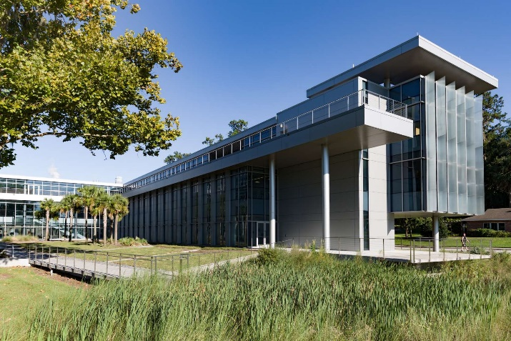

Interdisciplinary Center for Biotechnology Research (ICBR)

https://b iotech.ufl.edu/

The University of Florida’s Interdisciplinary Center for Biotechnology Research (UF | ICBR) provides extraordinary support services and facilitated access to advanced cutting-edge scientific technology for University of Florida faculty, staff, and graduate students, as well as research and commercial partners worldwide.

Founded in 1987, UF | ICBR has a rich history of enabling life science researchers by allowing scientists to focus on their research without the burden of developing and maintaining the infrastructure and expertise to support ever-changing technologies.

In addition to world-class services to a wide range of life science researchers, UF | ICBR also offers learning opportunities for scientists and their students through training to use equipment, seminar series and hosted workshops. Most of the core service laboratories are located centrally, in the Cancer and Genetics Research Complex – a space constructed with support from the National Institutes of Health (NIH.) There are, on average, 58 ICBR staff members, with 22% faculty, 45% full-time staff and 33% postdoctoral associates and temporary or part-time positions. Most UF | ICBR faculty report only to UF | ICBR and do not have competing demands of a home department or tenure and teaching.

UF | ICBR’s laboratories represent a diverse biotechnology landscape and are organized into seven cores:
- Bioinformatics
- Cytometry
- Electron Microscopy
- Gene Expression & Genotyping
- Monoclonal Antibody
- NextGen DNA Sequencing
- Proteomics & Mass Spectrometry

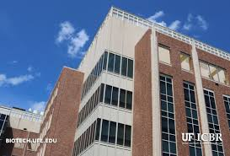
UF | ICBR provides more than 400 different services ranging from custom and high-throughput DNA sequencing to electron microscopy and antibody development and production.

Interdisciplinary Center for Musculoskeletal Training and Research (ICMTR)

https://www.ortho.ufl.edu/icmtr

The mission of the Interdisciplinary Center for Musculoskeletal Training and Research (ICMTR) is to promote education and research in the orthopaedic sciences. The goal of the ICMTR is to encourage the interaction of scientists and clinicians regardless of department or college.

The ICMTR currently is involved with research and education with the Colleges of Medicine, Dentistry, Health and Human Performance, Health Professions, Veterinary Medicine and Engineering. Additionally, Departments within the College of Medicine that are actively involved with this Center include: Orthopaedics and Rehabilitation, Molecular Genetics and Microbiology, Neuroscience, OB-Gyn, Radiology, Anesthesiology, Radiation Therapy, Pediatrics, Surgery, Pathology and Medicine.

The ICMTR Core Faculty are involved with education of faculty, residents and fellows of these Departments as well as undergraduate and graduate students in the areas of Rheumatology, Pediatrics, Radiation Therapy, Family Medicine, Physical Therapy, Nursing, Athletic Training, and Physician Assistants. Core Faculty in the Center are actively involved with introducing biomedical engineering students to clinical orthopaedic issues. On the community level the Center has promoted education including:
  - Physicians in the field covering local athletic events,
  - Faculty involved with the Gainesville Sports Organization Committee
  - Talks given to the Alachua Medical Society

The ICMTR has also initiated an Orthopaedic Grand Rounds series entitled “Clinical Problems - Basic Science Solutions” in an effort to promote interaction between clinicians and basic scientists. Core Faculty and staff host an internationally attended biannual course held locally on musculoskeletal pathology. This course draws physicians, residents and fellows from across North America. ICMTR Core Faculty and staff put on an annual Hand Camp for children with congenital hand problems.
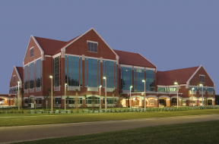

Interdisciplinary Program in Biomedical Sciences (IDP)

https://catalog.ufl.edu/graduate/colleges-departments/medicine/interdisciplinary-departments/medical/

The goal of the IDP is to prepare students for a diversity of careers in research and teaching in academic and commercial settings, after completion of the Ph.D. in Medical Sciences. The program provides a modern, comprehensive graduate education in biomedical sciences while providing both maximum program flexibility and appropriate specialization for advanced training. The IDP represents a cooperative effort of six interdisciplinary advanced concentrations with participation of over 250 faculty members.

During the first semester of study, students undertake a common, comprehensive interdisciplinary core curriculum of classroom study and a responsible conduct of research course. During the second semester, students begin to focus their coursework in one or two concentrations. Throughout the first two semesters, students participate in at least three laboratory rotations in any of the laboratories of the IDP faculty members. The advanced concentration and the supervisory committee chair are chosen no later than the end of the spring semester to maximize flexibility and facilitate an informed decision. Students entering the advanced concentrations take more specialized courses that strengthen their knowledge of these disciplines. The advanced concentration curricula are flexible enough to allow students to integrate course work offered in other advanced concentrations. In addition, journal clubs and seminars associated with their research interests allow students to further augment their scientific development.

Prospective students should have strong backgrounds in biology including genetics, chemistry (organic, quantitative, and biochemistry), physics, and calculus. Demonstrated high motivation and a serious intention to pursue research-related careers are also important considerations. This is best accomplished by performing independent study in a research laboratory for at least a semester, with a year or more being preferred.

JDRF Network for Pancreatic Organ Donors with Diabetes (NPOD)

https://diabetes.ufl.edu/research/programs/npod/

The Network for Pancreatic Organ Donors with Diabetes (nPOD) program, supported by JDRF at the University of Florida, is the world’s largest open research consortium dedicated to the study of the human pancreas.

Founded in 2007, the JDRF nPOD biorepository housed at the University of Florida supports the collection of pancreata and related tissues from organ donors with type 1 diabetes (T1D) which are made available to scientific investigators around the world including in the U.S., England, Finland, Canada and Australia.

With nearly $3 million in annual program funding, nPOD researchers are conducting more than 150 studies that seek to unlock the mysteries of type 1 diabetes. Investigators hope to address the most pressing questions related to how the disease develops and progresses including, but not limited to the immunopathology of T1D, beta cell physiology and dysfunction, pancreas development, beta cell regeneration, environmental factors and medical imaging.
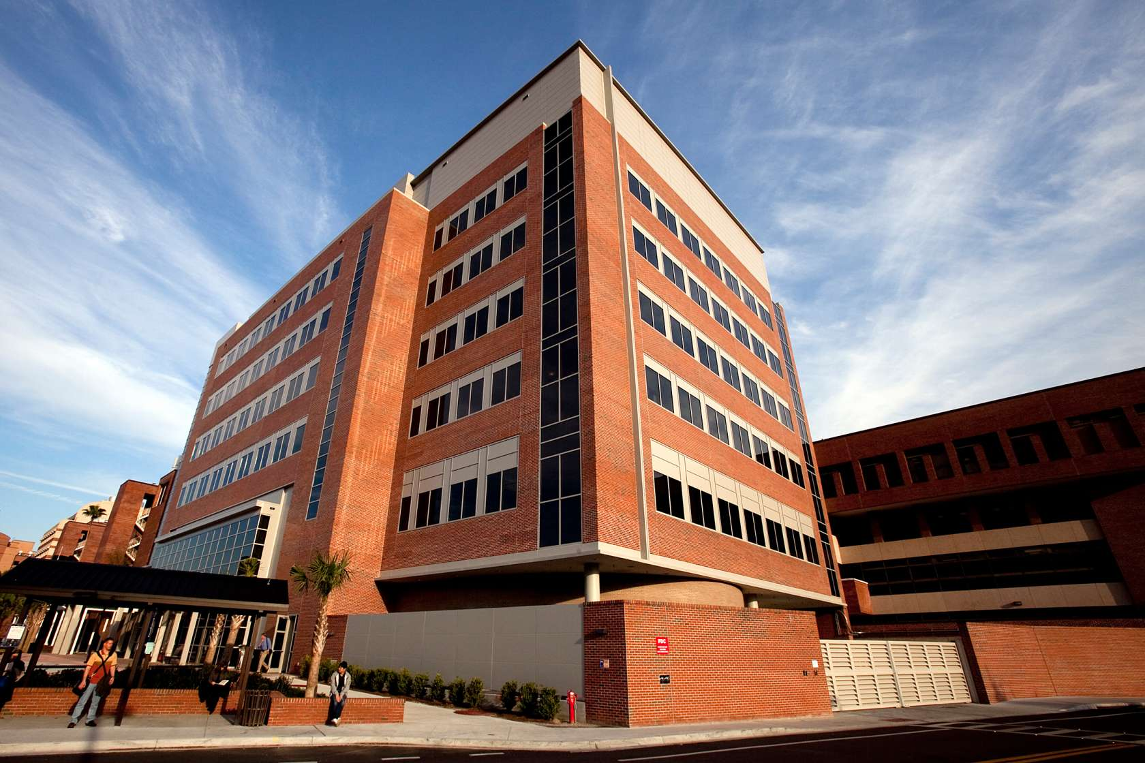

UF Diabetic Institute

McKnight Brain Institute (MBI)

https://mbi.ufl.edu/about/about-us/

The McKnight Brain Institute of the University of Florida is one of the nation’s most comprehensive and technologically advanced centers devoted to discovering how the normal brain operates, and how we can repair the brain following injury, disease, or aging. Collectively, our investigators hope their research will make a difference for those who suffer from disorders of the brain including neurodegenerative diseases, brain cancers, addictive and psychiatric diseases, stroke, acute spinal cord injuries and brain injuries as well as memory loss associated with normal aging.

The MBI is a nexus for neuroscience at the University of Florida. Across the UF campus, more than 300 faculty members work in multidisciplinary teams to better understand how the brain works and how various diseases alter brain function. Ultimately these researchers and physician-scientists hope to help broaden the understanding of many neurological and psychiatric disorders and change them from untreatable to treatable, incurable to curable and inevitable to preventable.

The MBI building houses the four “neuro” departments of the UF College of Medicine: neurology, neurosurgery, neuroscience and psychiatry. All four of these departments have major investments and research in the neurosciences and neuromedicine. However, the mission of the MBI extends well beyond the walls of this building. Other departments and centers with concentrations of neuroscience research are spread across the campus. The MBI supports our affiliated departments, centers and numerous neuroscience research programs on the UF campus — one of few campuses in the United States that boasts all six health professional schools: medicine, dentistry, nursing, veterinary medicine, public health and pharmacy.

In December 2017, the UF Health Neuromedicine hospital opened its doors, and we are working hard to create more synergy within our translational research programs. By investing in programmatic team science, we hope to continue our growth, furthering our connections between research at the lab bench and care at the bedside.

Research Facilities
AMRIS: a state-of-the-art facility for high-resolution solution NMR, solid-state NMR, microimaging, animal imaging, and human imaging. There are currently twelve spectrometer systems, including an 800 MHz medium bore, a 750 MHz wide bore, an 11 T/40 cm bore horizontal animal imaging magnet, and two 3T human systems. All of our systems are available to internal University of Florida and external academic and industrial scientists.

AMRIS is an NMR/MRI auxiliary located at the McKnight Brain Institute of the University of Florida that supports UF research groups and operates an international user facility for the NSF-funded National High Magnetic Field Laboratory (NHMFL). Equipment in the facility was acquired through support from the NIH, NSF, and Department of Defense.

Stereotactic Radiosurgery Lab: The Stereotactic Radiosurgery/Biology (RSB) Lab within the MBI-UF building contains a computer-controlled six Mev linear accelerator for use in cerebrovascular, cancer and fundamental cell and molecular research. To the best of our knowledge, this is still only full-time radiosurgery-biology research laboratory of its kind in the world.

CTAC: The Cell and Tissue Analysis Core (CTAC) maintains high-end instrumentation as well as standard microscopy systems for the acquisition and analysis of bright field, ultrasonic, intravital, fluorescent, and bioluminescent data from both in vitro and in vivo experimental models.

Preston A. Wells, Jr. Center for Brain Tumor Therapy: The Preston A. Wells, Jr. Center for Brain Tumor Therapy at the University of Florida, directed by William A. Friedman, MD, neurosurgeon, has a number of active clinical trials as well as on-going basic and translational research.

Vector Core Lab: The primary role of the Vector Core Laboratory is to provide the service of generating gene therapy vectors. The Vector Core currently services 5 NIH program project grants worth over $25M and produces over 400 preps per year. In addition, the Vector Core serves a training role for students associated with those programs.

MBI-UF Shared Equipment Resources: Please visit https://mbi.ufl.edu/research/facilities/shared-equipment/ for details.

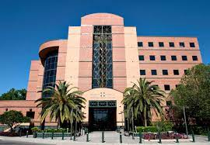

Medical Doctor/Doctor of Philosophy (MD/PhD) Program

https://mdphd.med.ufl.edu/

Prior to 1986, there was no formal MD-PhD Training Program at the University of Florida (UF). The program initially consisted of an accommodation of MD students who wanted to pursue PhD training. It remained small until 2007, when new College of Medicine leadership made a commitment to the funding of tuition and stipends. The number of Scholars matriculating since 2007 has been 4-6 Scholars per year, with a recent increase to 8 new Scholars per year under the leadership of our current Directorate.

The UF MD-PhD Training Program will recruit, rigorously train, and promote the retention of diverse physician-scientists for impactful roles in careers which integrate biomedical science and clinical medicine. The current MD-PhD program was established in its present form in 2007. The proposed program plan expands and integrates ongoing research training opportunities and develops new ones at the University of Florida Health Science Center (UFHSC). The UF MD-PhD Program is a collaborative effort between the UF College of Medicine and the UF Clinical and Translational Science Institute.

The development of the UF MD-PhD Training Program is based on eight core concepts (shown in the figure below) and a “Community of Practice” educational model that will facilitate the achievement of its primary goal – the preparation and retention of physician-scientists in impactful careers in biomedical science. 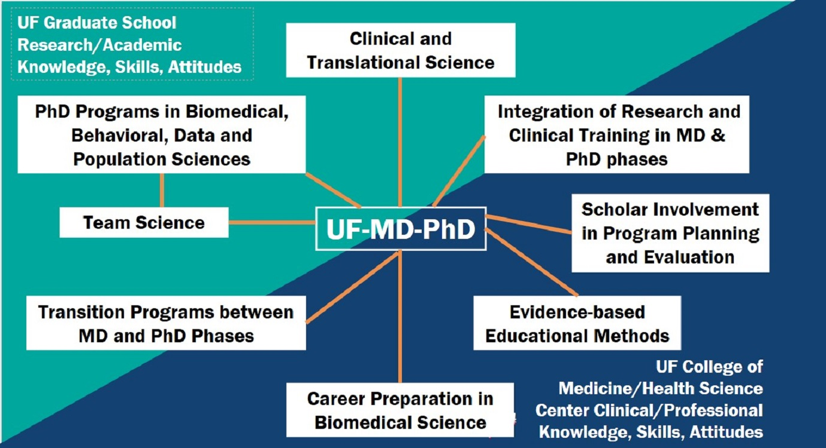

Medical Honors Program

https://mhp.med.ufl.edu/application/

The Medical Honors Program is a combined 7-year BS/MD program designed for students who are in their second year of enrollment (post secondary education) at a 4-year accredited science degree granting institution (University of Florida or equivalent institution). Eligible applicants must be United States citizens or United States permanent residents (in possession of the USCIS assigned ‘Green Card’). This program is open to students who are both Florida and non-Florida residents. Students apply for admission to the MHP through the University of Florida College of Medicine Admissions Office.

Applicants are responsible for understanding the application requirements. The link for the electronic application will be posted above once the cycle opens. The application is designed to resemble both the AMCAS application and the UF College of Medicine application.The information requested for the application includes biographical data, college coursework, personal statement, extracurricular activities (including research), medical and non-medical volunteer activity, physician shadowing, interests/hobbies, employment (if any), and letters of recommendation.

Metabolism and Translational Science Core

https://aging.ufl.edu/research/oaic-cores/metabolism-and-biomarkers/
and
https://aging.ufl.edu/wordpress/files/2021/08/RC2-Services-OAIC-Services.pdf

The UF Older Americans Independence Center’s Metabolism and Translational Science Core provides the infrastructure, laboratory space, trained personnel, consultative and collaborative scientific expertise to investigate aspects of the biology of aging and metabolism. A wide spectrum of established methodologies of biochemistry and molecular biology and selected measures of metabolism address a set of genetic and biological themes focused on biological mechanisms underlying aging in general, and sarcopenia and disability in particular.

Metabolism and Translational Science (RC2) Facilities: The Biochemistry of Aging and Metabolism and Translational Science Core Laboratory occupies approximately 1,500 sq. ft. of laboratory space. The Core supports biological analyses for a variety of clinical and pre-clinical projects related to the field of aging. The core includes a lab manager as well as several full-time technical staff capable of performing a variety of biologic techniques including western blotting, real-time PCR, immunosorbent assays, and a variety of procedures related to inflammation, oxidative stress, mitochondrial function, and apoptosis. Both facilities are under the direction of Dr. Leeuwenburgh and are located in the Medical Science Building.

Molecular Pathology Core

https://molecular.pathology.ufl.edu/

The UF Molecular Pathology Core (MPC) aims to improve human and animal health by accelerating basic and clinical research based on histological procedures.

The Molecular Pathology Core (MPC) is based in the Experimental Pathology Division of the Department of Pathology, Immunology, and Laboratory Medicine and opened January 1, 2001. We can be referenced using RRID:SCR_016601.

MPC is a comprehensive histology and light microscopy facility for paraffin and frozen blocks and for all aspects of specimen collection, preparation, fixation, processing, staining, and analysis. Technical assistance, training, and consultation are also provided. Standard operating procedures compliant with good laboratory processes are in place for all procedures.

As a shared histology core, we strive to help all researchers so they can concentrate on the science.

Services:
- Processing and sectioning of frozen or fixed samples of tissues, cells, and plants by cryostat, microtome and vibratome
- Staining methods including routine and special histology stains or immunolocalization of proteins/RNA/DNA (IHC/IF/ISH/FISH)
- Additional specialized services include whole slide images (brightfield), tissue microarray construction, laser microdissection, and Nanostring GeoMX digital spatial profiling.
- Rental equipment include cryostat, microtomes, vibratome, microscopes (brightfield and fluorescent) and image analysis workstations.

Nanoscience Institute for Medical and Engineering Technology (NIMET)

https://www.eng.ufl.edu/nimet/

The Nanoscience Institute for Medical and Engineering Technology (NIMET) is a university-wide institute administered by the Herbert Wertheim College of Engineering. NIMET serves to enable and support research and educational activities at the University of Florida in all fields of nanoscale science, engineering, and technology. In addition, NIMET facilitates the collaborative engagement needed to develop and adapt nanotechnologies for novel medical, engineering, scientific, and agricultural applications.

NIMET consists of a diverse group of faculty, students, and staff who are engaged at various levels in a common mission to advance fundamental knowledge and develop cutting-edge technologies related to nanoscale science, engineering, technology, and their applications. Successfully bridging disciplines is vital for achieving multidisciplinary discoveries in the laboratory and translating them into socially and economically impactful outcomes. Over 200 faculty from 6 colleges and 25 departments, are actively engaged in research on nanoscale science, engineering, technology, and their applications.

Research activities within the Nanoscience Institute for Medical and Engineering Technology (NIMET) span many fields of nanoscale science, engineering, and technology. Specific focus areas for NIMET research include: Nano-Materials, Nano-Electronics, Nano-Mechanical, Nano-Chemical, Nano-Fluidics, Nano-Physics, Nano-Biomedical, and Nano-Agriculture.

NIMET works with the Research Service Centers (RSC) to support and enhance the research, education, and public-service missions of the University of Florida by providing access to advanced micro/nano-scale fabrication tools and processes as well as characterization instrumentation. Expert staff provides the assistance and guidance necessary so that students, faculty, and industry get the most effective and appropriate use of the center’s facilities.
The RSC consists of the collective capabilities of three formerly distinct service centers:
- Nanoscale Research Facility (NRF)
- Major Analytical Instrumentation Center (MAIC)
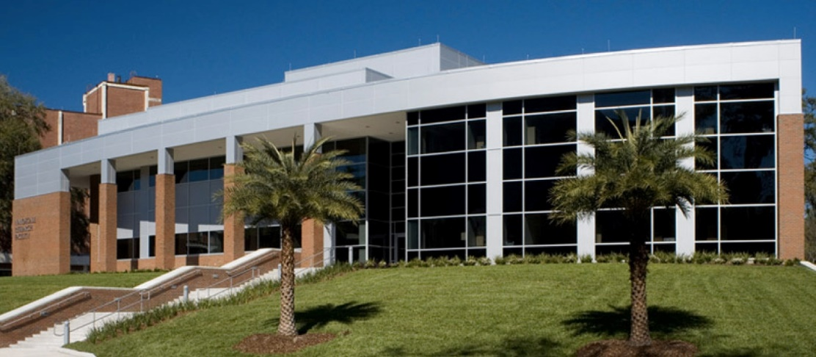
- Particle Analysis Instru mentation Center (PAIC)

Neuro ICU Research Lab

https://anest.ufl.edu/research/labs-and-research-groups/neuro-icu-research-lab/

The goal of the laboratory of Dr. Sylvain Doré is to discover new mechanisms that limit neuronal dysfunction associated with stroke (e.g. IS, ICH, SAH), traumatic brain injury (TBI), Alzheimer disease (AD), aging and other neurological disorders.

The overall goal is to slow down the progression of the disease, and ultimately stop it. To do so, the aim is to limit cell death resulting from either acute and/or chronic neurodegenerative conditions, re-establish normal cerebral blood flow, limit inflammation, and restore regular cellular functions. Using a variety of in vitro and in vivo protocols, using preclinical and human specimens, several new hypotheses and potential therapies are being investigated and developed.

One objective is focused on understanding the unique properties of hemoglobin, heme and iron in the brain using cellular/molecular techniques and various models of stroke, traumatic brain injury/concussion, Alzheimer disease and aging.

New knowledge is gained specifically, by investigating the action and the role of activity of the heme oxygenase enzyme and its unique bioactive metabolites, namely, carbon monoxide, iron, biliverdin, and bilirubin.

Thirdly our lab provides molecular evidence for the potential therapeutic applications of complementary and alternative medicines (CAM).

Using cultures of neurons and brain tissues, Dr. Doré has observed that pre-treatment with a standardized extract of Ginkgo biloba or Ginseng could alter the presence of specific genes/proteins important in neuronal function. Individual components of the extract are ineffective, supporting the synergistic principals of Chinese medicine. Similar experiments and results have been obtained using resveratrol, which appears to be an active ingredient concentrated in red wines, and which has been proposed to explain some of the beneficial effects associated with the so called “French Paradox.” These alternative medicines could provide resistance against damage induced by free radicals, the toxins that are generated with aging and are the hallmark of many neurodegenerative processes.

Ultimately, the aim is to perform basic research using innovative tools to test original hypotheses and find new treatments that could have clinical applications for the population.

OneFlorida Clinical Research Consortium

OneFlorida Data Trust

https://www.ctsi.ufl.edu/ctsa-consortium-projects/oneflorida/

The OneFlorida Clinical Research Consortium, a statewide clinical research network and database, aims to unite researchers, clinicians, patients and stakeholders to address some of the nation’s biggest health challenges and serve as a resource for the state in facilitating health care research and improving health, health care and health policy.

Led by Elizabeth Shenkman, Ph.D., and David R. Nelson, M.D., through the UF CTSI, dozens of individuals spanning numerous institutions have collaborated to develop a framework for research infrastructure that can serve the entire state — including health system, state agency and community leaders, researchers, clinicians, human-subject protection experts, informatics experts, patients and caregivers. Formed in 2013, the OneFlorida Clinical Research Consortium collaboratively integrates and expands programs developed by the UF CTSI and its partners.

Together, OneFlorida partners provide health care to more than 40 percent of Floridians in the nation’s third-largest state. OneFlorida partners encompass hospitals, practice/clinic settings and physicians, which provide care for 15 million patients across all of Florida’s 67 counties.

The OneFlorida Clinical Research Consortium was recently designated as one of the nation’s 13 clinical data research networks, or CDRNs, by the Patient-Centered Outcomes Research Institute (PCORI) to accelerate the translation of promising research findings into improved patient care. The PCORI Board of Governors approved more than $7.5 million to support the ongoing development and expansion of the OneFlorida Data Trust and its involvement in PCORnet, the National Patient-Centered Clinical Research Network. The funds included support to add seven health data networks to this large, collaborative initiative, which is designed to link researchers, patients, communities, clinicians, and health systems in productive research partnerships that leverage the power of big data.

The strength of the consortium is in its diversity. Research is conducted in real-world settings and results can be implemented in the consortium’s practices to promote the uptake and sustainability of evidence-based health-care practices.

Pain Research and Intervention Center of Excellence (PRICE)

https://price.ctsi.ufl.edu/about-the-center-2/

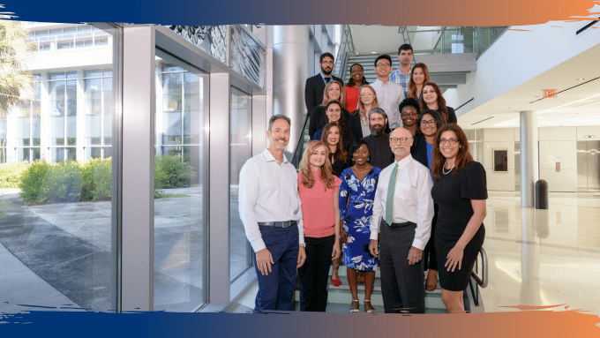
PRICE is a multi-college Center of Excellence that serves as the professional home for UF scientists, clinicians, and trainees dedicated to improved understanding and treatment of pain. PRICE is affiliated with and supported by the UF Clinical and Translational Science Institute (CTSI) and receives strong support from the UF Institute on Aging and the UF Health Cancer Center. PRICE provides member investigators with several resources and services in order to facilitate clinical and translational pain research at UF, including assistance with protocol development and assistance with recruitment of research participants. Also, PRICE offers facilities and services to assist investigators with collection of pain assessment data in their research protocols, via the Pain Clinical Research Unit (see below). Investigators can conduct their own studies in the PainCRU, or they can request that the PainCRU staff collect the data for their protocol.

Regulatory Support: Through its affiliation with the CTSI, PRICE offers investigators assistance with protocol development, preparation of IRB and other regulatory documents in order to ensure rapid regulatory approval and full compliance with all appropriate standards.

Assistance with Recruitment of Research Participants: PRICE maintains a registry of more than 1,000 potential research participants who have expressed interest in research participation and have provided permission for future contact. This registry includes individuals from several different patient populations as well as those who are generally healthy and can serve as control subjects. The registry is comprised of an ethnically diverse group of individuals between 18 and 85 years of age who were recruited via multiple methods, including print, radio, and electronic advertisements, clinic-based recruitment, and word of mouth.

Facilities and Resources for Data Collection: PRICE offers facilities and services to assist investigators with collection of pain assessment data in their research protocols, via the Pain Clinical Research Unit (see below). Investigators can conduct their own studies in the PainCRU, or they can request that the PainCRU staff collect the data for their protocol.

In addition, PRICE endeavors to enhance the intellectual and professional work environment for the UF pain research community by and coordinating training activities related to pain, including T32 training grant in translational pain research, as well as journal clubs, seminar series, and a monthly Pain Interest Group.

In early 2013, PRICE occupied its physical home in the new Clinical and Translational Research Building (CTRB), and state-of-the-art research building that serves as the home for clinical and translational research at the University of Florida. The CTRB provides offices for the PRICE Director, multiple PRICE research coordinators, and staff, as well as the Director of the Pain Clinical Research Unit.

Training Resources: PRICE hosts a monthly journal club for review and discussion of current topics and findings in pain research. The journal club is attended by a wide variety of faculty and trainees, and emphasis is on presentation of topics by trainees and early career investigators. PRICE also hosts a monthly Responsible Conduct of Research (RCR) Discussion group, which is led by Dr. Fillingim and attended by faculty and trainees. Each session focuses on a specific RCR topic, such as conflict of interest, authorship issues, mentor and mentee responsibilities, reproducibility, research misconduct, and data management. The format includes brief presentation with emphasis on active discussion of real-world examples and case scenarios.

Travel Awards: PRICE offers travel awards to trainees and early career scholars to support attendance of national and international conferences at which they will present their research findings.

Pain Clinical Research Unit (PainCRU)
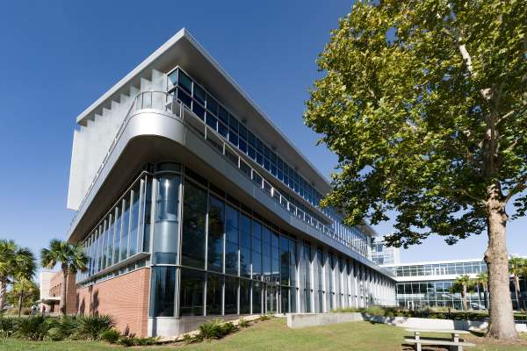
The PainCRU is a component of PRICE, which provides a patient-oriented research venue designed to facilitate and foster clinical and translational pain research at UF. The PainCRU currently occupies more than 2,000 square feet of space, which includes two CTRB locations: the Clinical Research Center and the Institute on Aging’s Aging Rehabilitation Research Center (ARRC) and the second floor of the Dental Tower at the University of Florida Health Sciences Center.

Altogether, the PainCRU includes six fully equipped psychophysical testing units, each approximately 150 square feet. The laboratory space also includes multiple clinical examination and interview rooms. Each of the six sensory testing units is equipped for assessing thermal pain and pressure pain, and four of the laboratories are also equipped for assessing cold pressor pain. All units include equipment for measuring cardiovascular responses. The PainCRU facilities in the CTRB are contiguous with the greatly expanded UF Clinical Research Center (CRC), which has multiple general use examination rooms, laboratory and sample processing facilities, as well as several infusion and procedure rooms. The UF CRC offers nursing support for PainCRU studies that involve repeated blood draws and/or administration of medications.

The Pain CRU provides the following services:
- Consultation on design and implementation of pain assessment protocols into research studies
- Collection of psychophysical pain assessment data

Pediatrics – Jacksonville

https://ufhealthjax.org/location/217/uf-health-pediatrics-north/

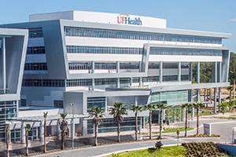
UF Health Pediatrics - North offers pediatric primary care services for newborns to adolescents and young adults (to age 18), including well-child care, school and sports physicals, immunizations, and preventive health assessments with nutritional and developmental screenings.

Starting at birth, the Division of Neonatology is ready with the latest technologies to care for newborns, especially those babies who are born too early or have a medical problem. Before newborns leave the hospital, they are screened for hearing problems and other medical or genetic conditions so that they may receive early care and treatment. For the infant, toddler and school-aged child, the Division of Community and Societal Pediatrics provides well-baby checkups, immunizations, school physical examinations, management and care for allergies, asthma and childhood dermatological or skin conditions, and routine primary care for common childhood ailments, such as colds, flu, earaches, fevers, nutritional issues, bumps and bruises.

Powell Gene Therapy Center (PGTC)

https://research.phhp.ufl.edu/research-core-office/grantsfunding-support/boilerplate-language-for-proposal-resources-sections/powell-gene-therapy-center-pgtc/

The PGTC Center was founded in 1996. Its primary mission is to merge molecular genetics research and health care delivery by developing new therapeutic strategies for the treatment of human diseases that involve gene transfer. The PGTC was recently named one of only two National Gene Vector Laboratory (NGVL) Toxicology Centers by the NCRR and was also selected by the NCRR as the site for production of the National Reference Standard Stock of AAV, to set the standard for the potency and purity of these key gene transfer reagents and to allow for greater sharing of data among various centers. The PGTC has been awarded 4 NIH program project grants totaling approximately $25 M to pursue gene therapy for diseases of the heart, lungs, and liver and has been designated as a Diabetes Gene Therapy Center by the Juvenile Diabetes Research Foundation. The PGTC has pioneered several advances relevant to gene delivery including discovery of the unique life cycle of AAV; first use of AAV to deliver genes to cells in culture; first use of AAV in animals and humans; first use of AAV in models of muscle and heart disease; first use of AAV to reverse blindness in dogs with a genetic disease; active clinical trials in CF patients since 1996. Several of the Lead mentors (Krista Vandenborne. Glenn Walter, Paul Reier, Dave Fuller) have ongoing collaborations with the Powell Gene Therapy Center and are combining gene transfer and rehabilitation strategies to improve function. Areas of particular expertise are Duchenne Muscular Dystrophy, Glycogen Storage Disease and Spinal Cord Injury.

Prostate Disease Center

https://ufpdc.urology.ufl.edu/

The University of Florida Prostate Disease Center is an interdisciplinary research and educational effort to facilitate the development of new and better diagnostic tools and treatment methods for prostate diseases, including prostate cancer, benign prostate hyperplasia, inflammatory prostate disorders, and other urogenital diseases.

The Center’s mission strictly follows the University’s strategic plan to become a national leader in translational research and teaching institute that ultimately means better overall patient care. The Center focuses on four principal areas of investigation:

- study of immune mediators and their interactions with benign and malignant prostate cells;
- identification of cancer genes or gene products that can be exploited for molecular diagnosis and therapy;
- investigation of the prostate microenvironment including the initiation of a vascular and immunosuppressive network; and
- exploration of the role of prostate stem cells in the development and progression of prostate disease. New areas of research from potential collaborators are also welcome.

The UF Prostate Disease Center is designed as a highly interactive research initiative that unites basic, translational and clinical researchers with an interest in the investigation of benign and malignant prostate and urogenital diseases. The Center has already established several scientific and clinical collaborations across various departments and centers at UF Gainesville and Jacksonville campuses. These scientific interactions and programmatic exchanges have successfully created a vibrant intellectual climate and collaborative atmosphere that result in a unique scientific resource that pushes scientific insights from the discovery phase into human applications for cure.

Proton Therapy Institute

https://ufhealth.org/uf-health- proton-therapy-institute

and

https://www.floridaproton.org/

The UF Health Proton Therapy Institute located on the campus of UF Health Jacksonville is a state-of-the-art radiation oncology facility offering proton therapy, stereotactic radiosurgery and conventional IMRT radiation therapy for the treatment of cancer.

Currently, UF Health Proton Therapy Institute is one of only several proton therapy facilities operating in the nation, and the only proton therapy facility in the Southeast U.S.

Since opening in August 2006, it has earned the distinction of being among the top 10 proton therapy treatment centers in the world, and the pediatric proton therapy program is one of the most active. The facility treats an average of 110 proton therapy patients daily and a total of 150 radiation oncology patients daily.

- Proton therapy offers patients a way to treat tumors with an optimal dose of radiation that provides the best chance for cure with reduced risk of treatment side effects.
- Types of cancer currently being treated include cancers of the eye, head and neck, pancreas, pituitary, prostate, breast, lung, central nervous system, base of skull as well as sarcoma, Hodgkin lymphoma and cancer in children.

UF Health Proton Therapy Institute has 15+ years of experience and expertise treating many types of cancer, including the most complex and rare. This is more than any other center in the southeastern United States.
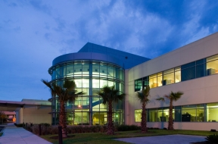

Research Computing, High Performance Computing (HPC)

https://it.ufl.edu/new-faculty/research-computing/

The University of Florida 2020-2025 Strategic Plan for IT outlines UFIT’s support of the university’s mission as it transforms to a national leader in the application of AI, including an expansive plan to elevate research, teaching, and economic development.

The mission of research computing is to support research-oriented computing activity as needed by UF faculty. UF has created a world-class research computing environment. At its core is HiPerGator, a state-of-the-art artificial intelligence supercomputer created in partnership with NVDIA. HiPerGator supports more than half of the projects in UF’s $942 million research portfolio. It is the central element of the university’s artificial intelligence initiative to educate the AI workforce of the future -- an initiative that is unique in higher education.

Increasingly research must be done on data that is restricted by laws, regulations, or contract terms. The University of Florida operates a compliant computing environment to store and process such data. This includes export controlled data, electronic protected health information, student data, intellectual property data, and more.

All users need to apply for an account to access UF high-performance computing resources. UF Faculty accounts will be created upon verification of employment status. All other users require a faculty sponsor – a faculty member who will support and sponsor the applicant’s use of resources and services.

The cost for the new NVIDIA Ampere A100 GPUs that power the DGX A100 nodes in HiPerGator AI will be measured as a multiple of the Normalized GPU Unit (NGU), which can be purchased as hardware or leased at the rates published at https://www.rc.ufl.edu/services/rates/.

Although the NVIDIA Ampere A100 GPU is significantly more powerful, the average application performance ratio between the new A100 and the RTX 2080ti and RTX 6000 GPUs is not yet known. As a result, until December 31, 2021, the HiPerGator scheduler will treat the A100 as equivalent to the other GPUs. This means that an investment in 1 NGU will give access to 1 A100 GPU or 1 RTX 2080ti GPU or 1 RTX 6000 GPU.

In partnership with UFIT’s Infrastructure and Communication Technology Services (ICT), UFIT’s Research Computing department established the Campus Research Network (CRN) as a high-bandwidth, low-latency Ethernet network linking major research labs and data centers within the University. The CRN is separate from the main campus network, dedicated to the movement of research data, and serves as a research DMZ.

The CRN backbone consists of dual 10 GbE links among primary endpoints with single 10 GbE links to several smaller laboratories. The CRN connects to the Florida Lambda Rail, from which Internet2 is accessible.

Southeast Center for Research to Reduce Disparities in Oral Health (SCRRDOH)

https://hobi.med.ufl.edu/2011/11/17/southeast-center-for-research-to-reduce-disparities-in-oral-health/

The mission of the Southeast Center for Research to Reduce Disparities in Oral Health (SCRRDOH) is to:

- Promote early detection and prevention of head and neck cancer among low-income rural and minority individuals in Florida

- Provide new resources for conducting targeted community-based interventions by multi- disciplinary teams from five colleges within the University of Florida as well as other highly regarded research universities such as the University of Chicago and the University of North Carolina.

- Strengthen the partnerships among researchers, clinicians, and the community to speed translation of research into practice.

The purpose of the Center’s first community-based intervention project is to apply scientific health promotion models to increase the likelihood that African American men obtain oral cancer screenings.

Applications will be sought from new and established scientists for studies addressing health disparities that will lead to community-based interventions. Working with health economists, we anticipate building an evidence base about the cost-effectiveness of new interventions that hold promise for reducing oral health disparities, including cost-effectiveness studies of early versus late stage detection of head and neck cancer.

The research conducted by the Center will affect public policy and result in long-term benefits among our most disadvantaged citizens.

Southeastern National Tuberculosis Center (SNTC)

https://sntc.medicine.ufl.edu/home/index#/

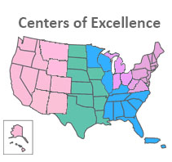
Connecting TB healthcare professionals with information, training and expertise.

The Southeastern National Tuberculosis Center (SNTC) is one of four TB Centers of Excellence (COE) in the United States. The COEs are funded by the Centers for Disease Control and Prevention (CDC), Division of Tuberculosis Elimination. The four centers are:

- Southeastern National Tuberculosis Center, based in Florida
- Global Tuberculosis Institute, based in New Jersey
- Heartland National Tuberculosis Center, based in Texas
- Curry International Tuberculosis Center, based in California

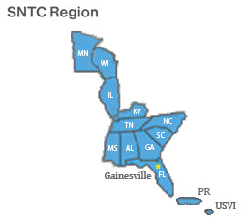
The SNTC supports the education and training missions of TB programs throughout the SNTC region and provides a source of expert medical consultation for healthcare providers caring for TB patients. SNTC serves 11 states, Puerto Rico and the U.S. Virgin Islands.

The SNTC is located on the campus of the University of Florida in Gainesville, FL. The University of Florida is one of the nation's largest health center complexes and includes:

- College of Dentistry
- College of Medicine
- College of Nursing
- College of Public Health and Health Professions
- College of Pharmacy
- College of Veterinary Medicine

All efforts of the SNTC are guided by these principles:
- To control and eventually eliminate tuberculosis;
- To include, communicate with and provide accountability to our stakeholders;
- To provide state-of-the-art treatment and training methodologies;
- To appreciate the diversity, history and technical expertise of the TB providers in SNTC region;

Stereotactic RadioSurgery Lab (RSB)

https://neurosurgery.ufl.edu/research/laboratories/radiosurgery-lab/

The RadioSurgery/Biology (RSB) Lab within the MBI-UF building contains a computer-controlled six Mev linear accelerator for use in cerebrovascular, cancer and fundamental cell and molecular research. To the best of our knowledge, this is still only full-time radiosurgery-biology research laboratory of its kind in the world. The research linear accelerator is capable of providing full dynamic therapy and was donated by Varian Associates, Inc. In addition, the lab is also equipped with high-end work station computers, assorted stereotactic equipment, a three-dimensional ultrasound imaging instrument, and other equipment such that, together with a technical support staff, this facility can support a variety of types of studies including: i) experiments to develop and evaluate techniques and equipment to be used in (CT, MRI and ultrasound) image-guided radiation therapy, intensity-modulated radiation therapy, image-guided radiosurgery, image-guided surgery and stereotactic surgery; ii) experiments to deliver single and multi-fraction radiation schedules to various radiobiological models (both cell and animal), including those designed to investigate the possible concomitant use of gene delivery and radiation therapy; and iii) experiments to validate models used to predict dose distributions and dose models.

In order to perform much of this research, and in order for investigators to plan clinical treatment protocols (to be performed elsewhere), the RSB lab is linked via the MBI-UF.s gigabit network to the Shands at UF Hospital computer system wherefrom they can access the Picture Archival and Communications System (PACS) to download the digital image data sets (e.g., MRI and CT images) of prospective patients to the MBI-UF.s web-accessible image server. In addition to fundamental research on and planning treatment paradigms for human clinical cases, the RSB lab and core faculty also participate in veterinary clinical cases with faculty from the College of Veterinary Medicine, and in doing so expedites the translation of discoveries to human patients.

Recently, the lab has received an NIH R01 grant to support research into an entirely new method of stereotactic guidance for surgery. This method involves the use of “rapid prototyping equipment.” Preoperative cranial or spinal scans are transferred to the lab’s computer systems. Special software is used to select a surgical pathway for brain or spine operations. The rapid prototyping machine then manufactures a special guide which, after sterilization, can be used in surgery to precisely identify the correct location of skin, bone, brain, and spine incisions and pathways through such structures during surgery.

Currently, this lab is the center of research activity for many postdoctoral assistants, doctoral students, masters students, medical students, and neurosurgical residents.

Structure Based Drug Design Lab

https://cancer.ufl.edu/research/shared-resources/ufhcc-supported-shared-resources/drug-design-core/

The mission of the lab is to facilitate drug development by combining structure-based methods with strengths of University of Florida researchers with applied goals. The lab assists medical researchers with novel drug discovery and development.

Drug development resources available for the following:

- X-Ray Crystallography
- Protein
- Small Molecule
- Lead Discovery (Computational Chemistry)
- Molecular Docking (Large Chemical Libraries, Single Molecule Docking, Lead Optimization)

The lab offers structure-based screening services to researchers using multiple chemical libraries.

- UF College of Pharmacy library consisting of 145 new chemical entities
- 1,217 FDA approved drugs
- 139,735 National Cancer Institute developmental therapeutics program small molecule library

UF Research

https://research.ufl.edu/

Research at UF plays a significant role in advancing our fundamental understanding of the universe, generating creative breakthroughs that lead to technologies with positive benefit, creating opportunities for economic growth in the state, and changing the trajectory of young people through education.

UF Research is committed to facilitating the research and scholarship successes of our faculty and students by creating effective collisions between researchers and funding opportunities, marketing our research capabilities to collaborators and funding agencies, and forging institutional relationships with external stakeholders.

UF Research supports UF faculty and staff in their research efforts, providing many services, from identifying grant opportunities to managing proposals and awards and protecting and promoting intellectual property. We also work to strengthen ties among researchers and between our research enterprise and other interested parties, such as potential business and industry partners and funding agencies. From proposal development assistance to technology transfer, our various units and offices assist investigators at every stage of the research process. Dr. David Norton, Vice President for Research, leads the many efforts of UF Research to stimulate and support competitive research at the University of Florida.

The University of Florida strives to be the internationally recognized leader among research universities in creating new knowledge and technologies, performing research with impact, spawning new economic opportunities, and educating the next generation of leaders. UF Research provides the institutional leadership and infrastructure necessary for the research enterprise to achieve excellence in creating new fundamental knowledge and technological breakthroughs, in translating research to relevance, and in contributing to the educational mission of the institution.

UF Center for Experiential Learning and Simulation (UFCELS)

https://simulation.med.ufl.edu/

UFCELS will improve health care in Florida, our nation and the world through excellence in health care simulation, integrating training, innovation and discovery. The mission of the UFCELS is to deliver experiential training that develops and enhances health care students’ and professionals’ clinical expertise, competence and teamwork skills that facilitates high quality patient care, safety and advances the field.

UFCELS is comprised of the UF Health Shands Experiential Learning Center (Fourth Floor) and the Anaclerio Learning and Assessment Center (Third Floor). UF Health Shands Experiential Learning center focuses on task training and mannequin-based simulation as well as in situ simulation. The Anaclerio Learning and Assessment Center encompasses the standardized patient program. The Center for Safety, Simulation & Advanced Learning Technologies (CSSALT) utilizes space on the 4th floor and focuses on innovation and development of new training modalities. Together, CELS occupies the third and fourth floors of the Harrell Medical Education Bldg.

UF Center for HIV/AIDS Research, Education & Service (UF CARES) – Jacksonville

https://ufhealthjax.org/location/28/uf-center-hiv-aids-research-education-service-uf-cares-jacksonville/

The University of Florida Center for HIV/AIDS Research, Education and Service (UF CARES) is the only comprehensive pediatric and family-focused HIV and AIDS program in Northeast Florida and South Georgia. UF CARES provides primary, secondary and tertiary care for HIV-exposed and infected individuals and families. In addition to basic medical care, the center provides medical case management, pharmacy services, health education, nutrition and mental health counseling. UF CARES doctors are trained in general pediatrics and internal medicine with additional specialization in infectious diseases and women’s health. UF CARES also have a full-time psychologist and part-time psychiatrist and gynecologist who provide specialty services.

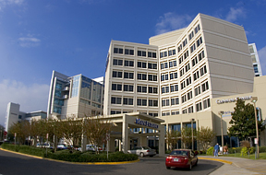
UF CARES also works to provide services through collaborations and partnerships with Children's Medical Services, a state sponsored program to provide health care to low-income children with special needs.

UF CARES began providing medical care for children in 1988. Over the next two years, the growing need for additional HIV/AIDS research became apparent. In 1990, the center established a four-year partnership with the National Cancer Institute in order to participate in clinical research trials. During this partnership, the center explored the barriers children face in finding, receiving and maintaining health care. This led to the center’s current comprehensive approach to care, providing complete care for patients.

In 1993, UF CARES became a National Institute of Child Health and Human Development’s Pediatric AIDS Clinical Trial Unit. The center continued to grow and in 1997 moved to the clinic space it currently resides in at UF Health Jacksonville. In this same year, the center expanded its scope to a family-centered, comprehensive health care provider for HIV-infected or exposed infants, children, adolescents, women and their families. UF CARES remains Northeast Florida’s only comprehensive, multidisciplinary HIV program.

This program is supported by Program Income generated from the Health Resources and Services Administration (HRSA) of the U.S. Department of Health and Human Services.

UF Center for Smell & Taste (UFCST)

http://cst.ufl.edu/

The University of Florida Center for Smell and Taste has devoted over 20 years to revolutionizing scientific collaboration and academic advancements in chemical senses. The University of Florida’s large, welcoming faculty and staff provide the UFCST with a wonderfully diverse range of expertise throughout the science of smell and taste.

Established in October 1998, the UFCST was organized as a University-wide center to promote research and education that thrived outside the box. We proudly call ourselves the home to a unique, dynamic center dedicated to advances in chemical senses research.

Over 50 faculty members, along with their postdoctoral associates, graduate students, and staff enhance our unique, academic team. We gain expertise from numerous colleges within the University, including the Colleges of Engineering, Medicine, Dentistry, Pharmacy, Health and Human Performance, Agriculture, and Liberal Arts and Sciences. All of those fields and each member of our team sheds another light on smell and taste disorders. Research, application, and education keeps us busy in the hopes to share our wealth of knowledge with those afflicted with smell and taste disorders.

Many members affiliate with other interdisciplinary units, such as the Institute for Food and Agricultural Sciences, the Genetics Institute, the Brain Institute, the Institute on Aging, the Whitney Laboratory for Marine Bioscience, and the Emerging Pathogens Institute. Additionally, the UFCST partners with chemosensory scientists at several other Florida institutions, thus pushing above and beyond new advances in smell and taste science across the State.

The center’s mission not only involves UF’s admired team of academics but the center’s valued community, as well. UFCST holds events and guest lecturers to educate and serve its community. Engagement and advocacy are critical to making advances for the chemosensory disorders community.

The UFCST is committed to education and training in the chemical senses to help assure the next generation of chemosensory scientists as well as to increase the awareness of chemosensory disorders among clinicians. UFCST members participate in the education of undergraduate, graduate and professional students across the campus through lectures, small group and mentoring activities. Additionally, the UFCST offers a regular seminar series during the academic year that brings in leading chemosensory scientists from around the world to discuss their research and meet with faculty, postdoctoral and student trainees. Semiweekly discussion groups allow members to explore new ideas emerging from the literature. Finally, annual colloquia at UF and in conjunction with chemosensory researchers at Florida State University offer the opportunity to explore current research and establish new mentoring relationships.

UF Health

https://ufhealth.org/about-us

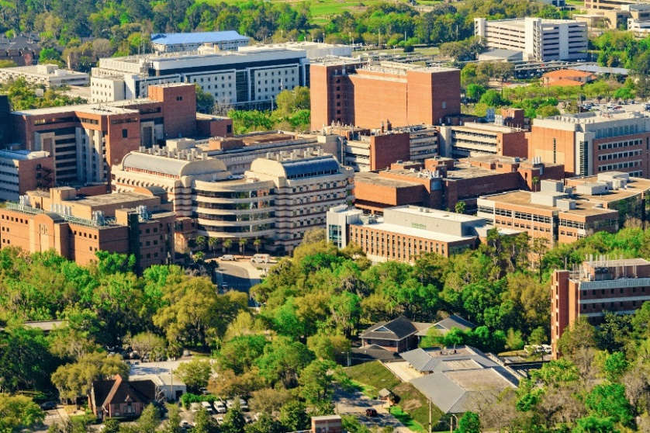
UF Health represents the commitment of more than 26,500 employees to reach higher and farther, both translating scientific discoveries into patient care advances and implementing them to help people get back to living their best possible life. UF Health encompasses the colleges of Dentistry, Medicine, Nursing, Pharmacy, Public Health and Health Professions and Veterinary Medicine; the UF Health Shands family of hospitals; UF Health Jacksonville medical center; UF Health North; and an academic campus in Jacksonville that is home to the UF College of Medicine – Jacksonville and includes degree programs offered by the colleges of Nursing and Pharmacy. It also includes primary care and specialty practices throughout North Central and Northeast Florida, as well as Southeast Georgia.

UF and UF Health attract skilled health professionals and staff from across the country. The dynamic university environment encourages business, career, and community growth and development. The UF Health network of hospitals and physician practices manages more than 3 million inpatient and outpatient visits each year and serves patients from all 67 Florida counties, from around the nation and from more than 30 countries. UF Health Shands, UF Health’s private, not-for-profit hospital system based in Gainesville, includes seven hospitals:
- UF Health Shands Hospital
- UF Health Shands Cancer Hospital
- UF Health Shands Children’s Hospital
- UF Health Heart & Vascular Hospital
- UF Health Neuromedicine Hospital
- UF Health Shands Rehab Hospital
- UF Health Psychiatric Hospital
UF Health is unique for its diverse constellation of health colleges, centers and institutes and our hospitals, faculty practices and patient care programs. Academic health centers make discoveries that lead to breakthroughs in patient care. UF Health offers compassionate care with a focus on world-class outcomes for all, no matter how simple or complex their illness, and we offer hope — and results — for those who have been told elsewhere they have run out of options.

The mission of UF Health is to promote health through outstanding and high-quality patient care; innovative and rigorous education in the health professions and biomedical sciences; and high-impact research across the spectrum of basic, translational and clinical investigation.

UF Health Cancer Center (UFHCC)

https://cancer.ufl.edu/

UFHCC is dedicated to provide the residents of Florida with leading-edge cancer care and conducting original research for the prevention, early diagnosis and treatment of cancer.

Cancer is the leading cause of death for Floridians. FL has the second highest cancer mortality rate in the nation, and the age group at the highest risk of developing cancer — 65 and older — is projected to grow by 25% over the next two decades. Therefore, serving Florida with innovative research and leading cancer care have never been more critical.

By leveraging all the resources of the University of Florida campus, the UF Health Cancer Center stands alone in the state in our unique ability to blend comprehensive patient care and innovative research in a collaborative, multidisciplinary environment. We participate in research that has a direct impact on improved patient outcomes, allowing patients access to the very latest cancer fighting technologies and drugs. Our clinical enterprise uses a comprehensive care model, with multidisciplinary cancer programs offering advanced treatment options such as minimally invasive and robotic surgery, proton and intensity-modulated radiotherapy, hematopoietic stem cell transplantation, chemotherapy, targeted therapy and immunotherapy in conjunction with the precision medicine, as well as access to clinical trials.

Additionally our membership consists of more than 280 researchers, clinicians and educators throughout the University of Florida and UF Health, the Southeast’s most comprehensive academic health center — boasting six health colleges, nine research centers/institutes, 10 hospitals, two veterinary hospitals and a host of physician medical practices and outpatient services throughout North Central and Northeast Florida. Additionally, more than 90% of the center’s members also serve as faculty; the Cancer Center boasts members from 11 UF colleges. Members may also hold affiliations with other institutes and centers across the university or serve as physicians for the UF Health Shands family of hospitals and clinical programs.

This multidisciplinary membership allows for exciting collaborations and encourages the translation of basic laboratory findings to novel curative and preventive therapies.

One of the great benefits of receiving cancer care at an academic health center like UF Health is unique patient access to the most advanced medical research, treatments and technologies. Our clinician-scientists participate in research that has a direct impact on improved patient outcomes, and allows patients access to the very latest cancer-fighting technologies and drugs.

UF Health Communications

https://ufhealth.org/uf-health-communications

UF Health Communications serves the Health Science Center at the University of Florida, its six professional colleges and a number of health-related research centers and institutes, UF Physicians – Gainesville, UF physicians – Jacksonville, and the Shands system of hospitals and programs throughout north central and northeast Florida.

We publicize the research, clinical and academic accomplishments of current faculty, staff and students. We create and distribute news releases and news publications about these institutions, provide support to the news media, assist with and promote internal communication through various mechanisms and provide other communication services to clients within and beyond UF Health, the Academic Health Center (such as faculty media training). We handle crisis communications and issues management. We produce a national consumer health radio program that airs on public radio affiliates in 18 states and in Washington, D.C. We also craft broadcast and multimedia packages for TV and the Web. In addition, we support the advancement communications needs of UF Health through a team dedicated to alumni and development efforts.

UF Health Hospitals

https://ufhealth.org/locations

The Gainesville campus is home to UF Health Gainesville (Shands Teaching Hospital and Clinics Inc.). UF Health Gainesville has ~1000 licensed beds and is staffed by over 900 fulltime faculty members of the UF College of Medicine. The campus is also home to over 700 medical residents and fellows, pharmacy residents and more than 500 students from the UF colleges of Medicine, Pharmacy and Nursing. It features a teaching hospital, UF Health Shands Hospital, which also includes UF Health Cancer Hospital and UF Health Children’s Hospital; two specialty hospitals, UF Health Rehab Hospital and UF Health Psychiatric Hospital; a network of outpatient rehabilitation centers; and a home health agency. Two additional specialty hospitals, the UF Health Heart & Vascular Hospital and UF Health Neuromedicine Hospital, opened in December 2017 with an additional 216 rooms.

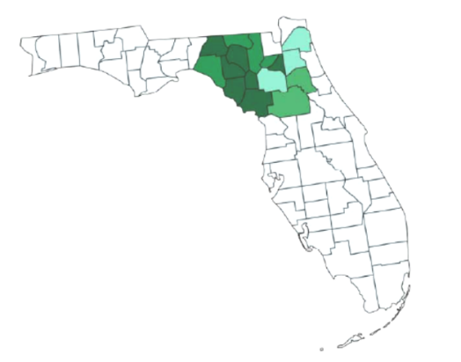
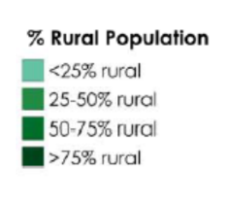
The Jacksonville campus is home to UF Health Jacksonville, which includes the UF College of Medicine- Jacksonville. UF Health Jacksonville has ~700 licensed beds, is staffed by over 400 fulltime College of Medicine faculty members, and ~40 accredited residency and fellowship programs with over 350 residents and fellows. UF Health North expanded the Jacksonville campus in 2015 to include advanced specialty services, an additional emergency department, an outpatient surgery center, and birth center. The latest expansion in 2017 includes a new 92-bed hospital in North Jacksonville, which is the only hospital in the north Jacksonville area.

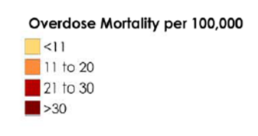
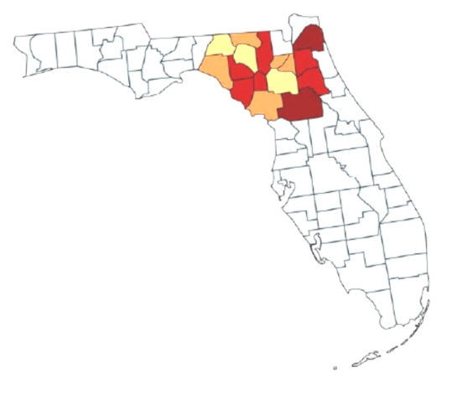
Each year, patients come to UF Health Gainesville and Jacksonville from all 67 Florida counties, throughout the nation and from more than a dozen countries. The direct catchment area for UF Health Hospitals includes a 15-county radius in North and Central Florida with a wide variation in population demographics, including a mix of counties with majority rural and majority urban population concentrations (Figure, left). Additionally, UF Health Hospitals and clinics provide services to counties that have substantial variation in opioid utilization and opioid overdose mortality. In 2017, Florida Department of Vital Statistics reported that the mean rate of overdose mortality for all Florida counties was 23.9 per 100,000, which is significantly higher than the 2016 nationwide 19.8 per 100,000 overdose mortality rate reported by the Centers for Disease Control and Prevention (CDC). The counties in the study catchment area, which are serviced by UF Health, have substantial variation in overdose mortality as reported in 2017. More than half of the counties included in the study catchment area, including the county with the largest population, have overdose mortality figures significantly above the most recent national-level overdose mortality rates reported by the CDC (Figure, above right).

UF Health Integrated Data Repository (IDR)

https://www.ctsi.ufl.edu/about/research-initiatives/integrated-data-repository/

The Integrated Data Repository (IDR) for Research Services offers assistance and resources to support research data needs at UF Health. Resources include websites, data guides, videos, and training tools created by the IDR and our partners.

The IDR consists of a secure, clinical data warehouse that aggregates figures from the UF Health various clinical and administrative information systems, including the Epic electronic health record system. The IDR contains more than 1 billion observational facts pertaining to more than 1 million patients, and it now includes data on every patient who has presented at UF Health with COVID-19-like symptoms and/or who has been tested for this coronavirus since January 2020. The IDR also contains data on biospecimen availability through the CTSI Biorepository and patient consent for research contact through UF Consent2Share. IDR data is continually updated.

Through the IDR’s research data request process, research teams partner with an IDR Honest Broker analyst who is approved by the UF Privacy Office and IRB to release detailed patient data for research purposes. This process begins with a consultation and then submission of a research data request. Often, by consulting with an IDR team member BEFORE obtaining IRB approval, research teams can avoid IRB amendments.

UF Health Pathology Laboratories Genetic Laboratories, Molecular Pathology

https://pathlabs.ufl.edu/about-us/overview/

University of Florida Health Pathology Laboratories is a pathology services resource for physicians throughout the Southeast United States. We offer a broad range of modern diagnostic and prognostic tests that include applications of advanced technology and the latest research findings.
UF Health Pathology Laboratories’ expert diagnostic services include but are not limited to:

- Anatomical/Surgical pathology  - Clinical pathology  - Cytopathology  - Cytogenetics  - Flow cytometry  - Quantitative pathology (for tumor analysis)  - Clinical toxicology/Special chemistry | - Molecular pathology  - Forensic toxicology  - Hematopathology  - Endocrinology  - Immunology  - Pharmacogenetics  - Metabolics

UF Health Pathology Laboratories is committed to improving diagnostic laboratory testing through research and technological development. We continually seek to grow the science of pathology while practicing state-of-the-art laboratory medicine. Research is the catalyst for the refinement of the assays performed at UF Health Pathology Laboratories. Our knowledgeable staff professionally provides accurate test result interpretation and assistance in the technical aspects of assays.

The faculty and staff at UF Health Pathology Laboratories are committed to providing you with high-quality, efficient and reliable service, and meaningful interpretation of test results. Consultative help is provided by UF College of Medicine faculty members, whose daily involvement in clinical research and teaching helps keep them abreast of new tests and technologies. Our service commitment is backed by a staff of qualified technologists who receive ongoing training and continuing education.

UF Health Pathology Laboratories maintains both state and federal licensure and certification. These laboratory services have been consolidated, since 1988, within the UF College of Medicine’s Department of Pathology, Immunology and Laboratory Medicine. Our laboratories participate in a variety of programs for proficiency evaluation, comprehensive quality control and continued quality improvement.

The University of Florida Health Pathology Laboratories’ Molecular Diagnostic Laboratory is a CLIA-certified clinical diagnostic facility responsible for the development and performance of molecular diagnostic tests for nucleic acid targets found in a variety of settings in medicine.

UF Health—Jacksonville

https://ufhealthjax.org/

UF Health Jacksonville is the region’s premier academic health center, a leader in the education of health professionals, a hub for clinical research and a unique provider of high-quality patient care.
With more than 6,200 faculty and staff, the academic health center in Jacksonville is the largest UF campus outside of Gainesville. UF Health physicians offer primary care and specialty services in practices throughout Northeast Florida and Southeast Georgia, tallying more than 650,000 outpatient visits and more than 40,000 inpatient admissions annually.
UF Health in Jacksonville, Florida, is comprised of:
- UF Health Jacksonville, an academic health center near Downtown Jacksonville and home to the area's only adult and pediatric Level I trauma program
- UF Health North, a 92-bed hospital and outpatient medical campus in North Jacksonville
- UF Health Science Center Jacksonville, which encompasses three UF colleges in Jacksonville: Medicine, Nursing and Pharmacy
- UF Jacksonville Physicians, Inc., a network of primary and specialty care centers offering exceptional patient care throughout Northeast Florida and Southeast Georgia

UF Innovate

https://innovate.research.ufl.edu/about/

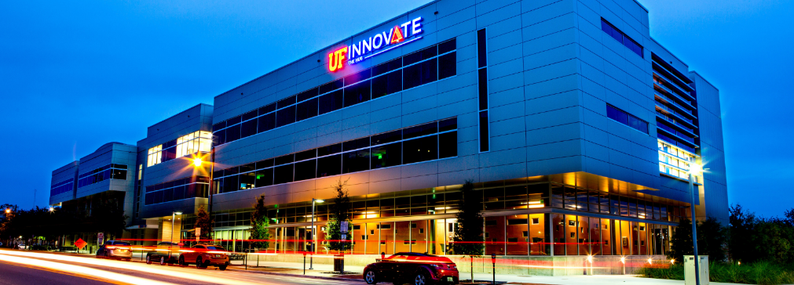
UF Innovate supports an innovation ecosystem at UF that moves research discoveries from the laboratory to the market, fostering a resilient economy and making the world a better place. Based at one of the nation’s leading research institutions, UF Innovate comprises four organizations: Tech Licensing, Ventures, and two business incubators, the Hub and Sid Martin Biotech.

Tech Licensing has earned its reputation as a leader in commercializing discoveries that cure diseases, create efficiencies, improve quality of life and create jobs.

The Hub and Sid Martin Biotech both nurture startups with the resources and expertise they need to thrive, thereby creating jobs and economic prosperity.

Ventures will source new venture investments, prepare in-depth financial and data analyses for potential investments, work closely with angel groups and other investment funds, and develop entrepreneurs.

Organized under the UF Research umbrella, this quartet forms a comprehensive commercialization system that brings together five critical elements: facilities, capital management, talent, intellectual property, and technology-transfer expertise.

Tech Licensing: UF Innovate | Tech Licensing works with innovators, entrepreneurs, investors and industry partners to maximize the potential of University of Florida innovations through commercialization for the global good. Founded in 1985, Tech Licensing receives more than 300 invention disclosures, executes more than 100 commercial transactions and launches nearly 20 companies each year. In 2017, the Milken Institute ranked the University of Florida third in the nation for its tech commercialization efforts.

Ventures: Seeks to fuel consistent growth in the number and quality of UF technology-based startup companies. Ventures will serve as a liaison between public and private sectors as it implements an investment program intended to support UF startups. The goal is to link new venture investments with companies, work closely with angel groups and other investment funds, and to develop entrepreneurs. Since 1985, more than 200 companies have formed by licensing technologies from the University of Florida. UF Innovate | Ventures seeks to fuel consistent growth in the number and quality of technology-based startup companies. These startups move UF inventions out of the lab and into the marketplace for the global good. Ventures supports startups by developing entrepreneurs, connecting companies to potential investors, and making equity investments.

UF Innovate | Ventures has a $1 million venture fund available to support startups during each fiscal year. Ventures will assist UF startups in preparing for a financing round and may participate in financings after review and approval by the Investment Committee. Ventures will act as a co-investor with an accredited third-party investor acting as the lead investor of a financing round.

In addition, Ventures oversees an Entrepreneurs in Residence (EIR) program throughout the state of Florida. With EIRs strategically located throughout Florida in major urban centers, these seasoned entrepreneurial experts will connect UF startups with experienced executives in various industry sectors across the state. Also, the EIR program will connect UF startups to private capital, elevating the probability of success for these new enterprises.

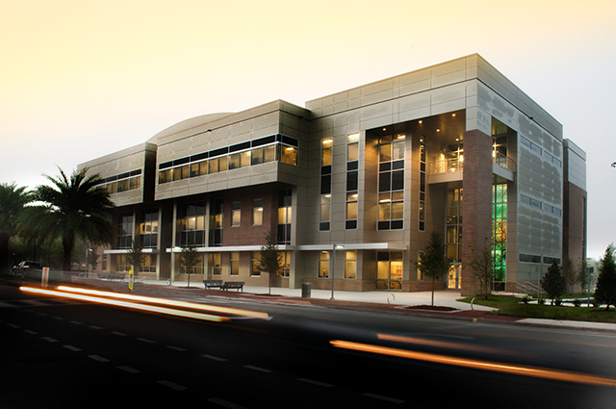
The Hub: Formerly known as the Innovation Hub, located in UF's Innovation Square between campus and downtown Gainesville. The Hub, recently completed a second phase that doubled its size, providing even more space for technology startups. Both the Hub and Sid Martin Biotech foster an innovation ecosystem that nurtures startups with the resources and expertise they need to thrive, thereby creating jobs and economic prosperity. Its mission is to provide an innovation ecosystem for connecting all the elements critical to creating and supporting technology-based companies.

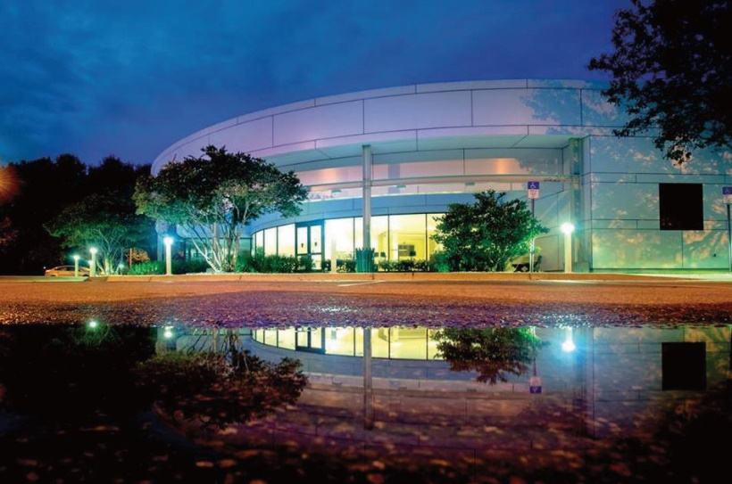
Sid Martin Biotech: Named the world’s top incubator in 2017, incubates biotech startups at its location in Alachua. Expedites research and commercial development of promising biotechnologies in the context of viable, well-managed startup companies. The incubator, a specialized complex, with BSL II labs, offices, vivariums, greenhouses, and shared scientific equipment, is twenty minutes from the UF campus in Progress Park, in the city of Alachua, which is home to many of UF’s bioscience startups. Companies in this 204-acre private park may apply for Foreign Trade Zone status. The incubator’s relationships, services, and programs include introductions to investors, early recruitment of experienced leadership, networking opportunities, and seminars. By bringing together a critical mass of university and private sector specialists, the program is a magnet for scientific expertise, novel problem solving, and successful commercial ventures. The program is particularly interested in supporting companies, which have established research relationships with the UF, or which have an interest in and potential for initiating such relationships. The Sid Martin Advisory Committee and program management grant companies that successfully apply for admission one-year terms with the chance of renewal subject to successful reviews.

In 2009, Sid Martin developed the Florida BioDatabase, an online searchable database of all Florida bioscience companies, available to the public. The site provides address, website, founding date, a summary of a company’s technology, sector, research focus, whether they have products on the market, and publicly disclosed investors.

Sid Martin Biotech has a biotechnology focus and has served more than 100 startup companies in biotechnology, biomedicine and bioagriculture. The Institute has created more than 2,200 high-tech jobs since its inception, and SMBI resident companies have accumulated over $1.62B in capital and M&A activity. There is a 93% survival rate for companies that entered the SMBI program since March of 2003, and 78% of companies are still in business five years post-graduation

UF’s two incubators provide a place and a program, coaching and connections for young companies to give them the best chance for ongoing success. Startups that have resided at the incubators have generated more than $10 billion in investments and created nearly 8,000 jobs, most in the local economy. The incubators play a crucial role in Alachua’s and Gainesville’s innovation landscapes, and the director is integral to their success.

UF Innovate’s Pathways

https://innovate.research.ufl.edu/pathways/

UF Innovate | Pathways serves to empower innovators with training and resources to support innovation and commercialization at UF. Whether you are a faculty member, postdoctoral associate, staff, or student, take advantage of these programs to enhance your knowledge and advance your ideas to market.

Pathways provides an exhaustive list of educational sources and events for UF faculty, staff, and students interested in the commercialization process. UF Innovate has collaborated with AUTM, the leading organization supporting academic technology transfer, to bring you over 200 hours of technology transfer webinars addressing technology evaluation, protection, marketing, licensing, and more.

UF IT Training

https://training.it.ufl.edu/

The UF IT Training Team provides a robust and extensive learning environment for the University of Florida community, enabling them to seize the power of technology and to fully utilize resources to enrich teaching and learning, expand research, and enhance service.

The UF IT Training Team demonstrates the Academic Best Practice for the use of technology in teaching. IT workshops follow a standard structure; utilize learning objectives, gauge participant understanding, assess retention, provide further resources, and evaluate participants’ feedback.
Learning opportunities address various learning styles and are accessible in multiple formats.

IT Training Team develops learning opportunities based on the needs of the UF community. Using multiple information streams, IT Team determines the highest priorities of faculty, students and staff to develop learning opportunities to meet those needs. IT Team actively promote and publicize the benefits of participation in learning opportunities to encourage participation throughout the entire UF community.

UF IT Services include:

- UF computing help desk
- E-Learning Tools and Services vai Training Service Requests

UFIT Training can offer special sessions on topics including (but not limited to): Accessibility, Ally, Cybersecurity, Qualtrics, VoiceThread, Zoom.

UF Research and Academic Center at Lake Nona

https://lakenona.ufhealth.org/

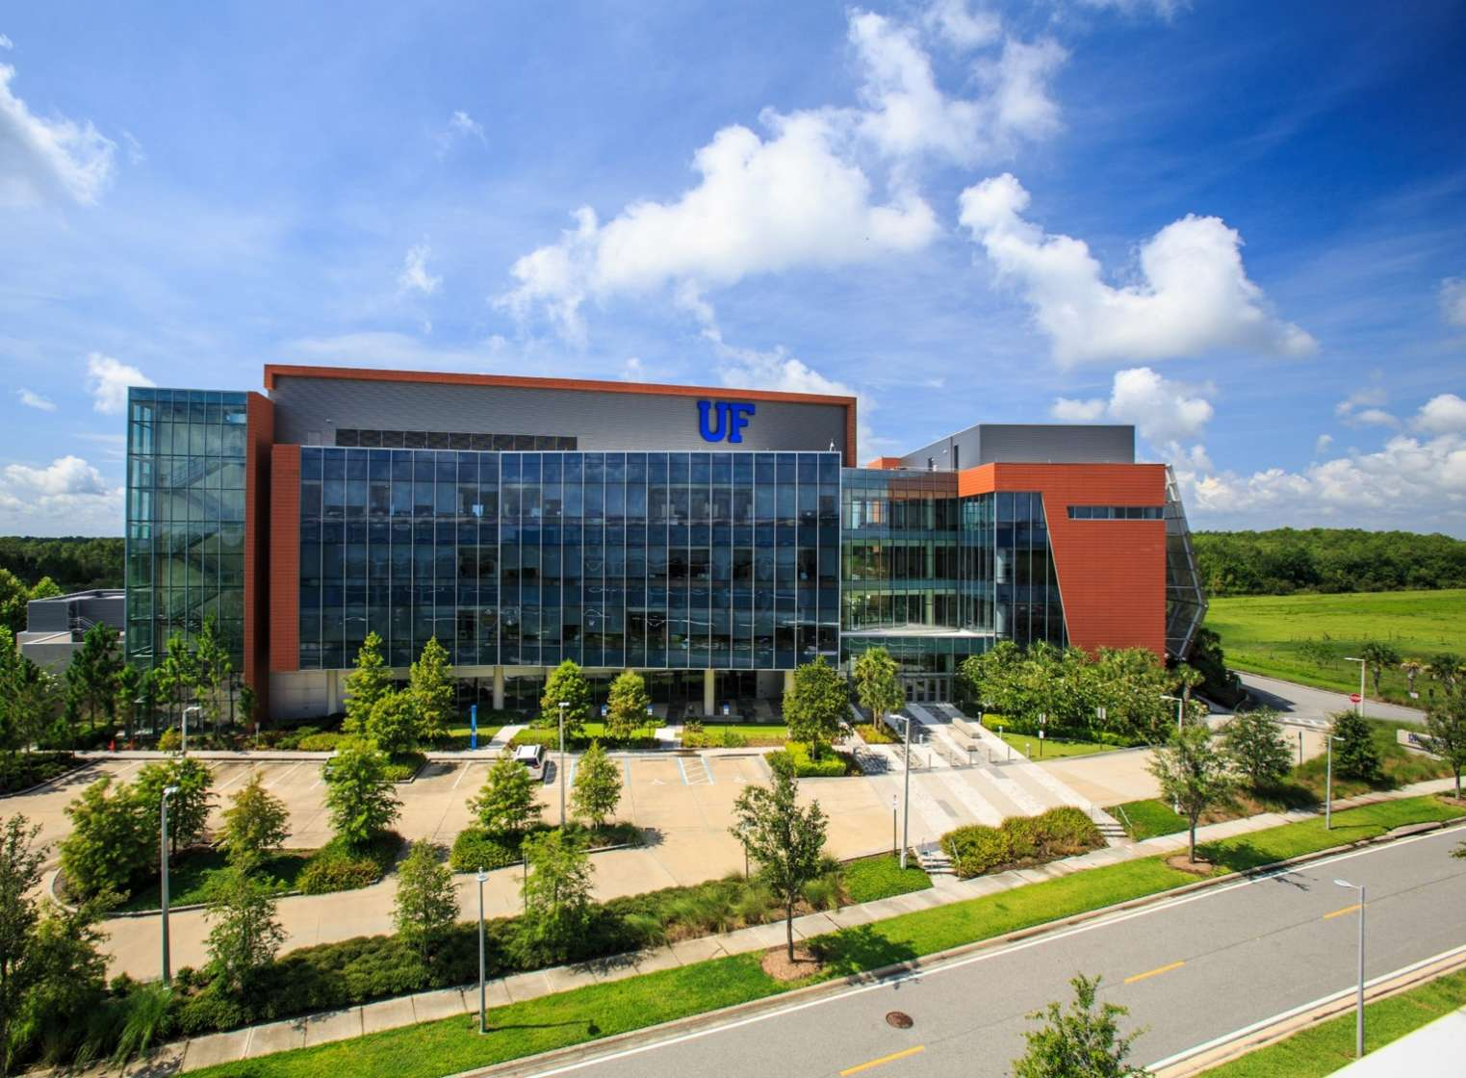
Located in Orlando Florida’s Lake Nona Medical City, the University of Florida Research and Academic Center was founded in 2012 to serve as a bridge between research, education and community service programs of the university’s other campuses with partnering organizations in central Florida. The UF Research and Academic Center is a $62 million, 110,000 square foot LEED platinum certified building carrying out basic, clinical and translational research in drug discovery and development.

This facility houses multidisciplinary teams of researchers, clinicians, teachers, and students with the goal of providing effective therapies and improving health for patients. The facility has two functions: academic study and research. More than 450 UF faculty members, students, administrators and staff work in the center within the Colleges of Medicine and Pharmacy, carrying out basic, clinical and translational research in drug discovery and development. The center offers a wide range of highly regarded programs including a Doctorate of Pharmacy Degree (Pharm.D.) program, internships, world‐renowned research and successful clinical services.

The facility became the permanent home of the UF College of Pharmacy Orlando Campus. Ranked by U.S. News & World Report as the No. 1 pharmacy college in Florida and in the Top 5 nationally, the University of Florida College of Pharmacy is training the next generation of pharmacists and pharmaceutical scientists at its Orlando campus. Students enrolled in the Doctor of Pharmacy program benefit from an innovative curriculum which prepares them to be leaders in the pharmacy profession, while graduate students and trainees contribute to scientific advances by performing cutting-edge research. Award-winning faculty in Orlando work personally with students and trainees to help them achieve their professional and academic goals.

Institute for Therapeutic Innovation: College of Medicine The Lake Nona campus is home to a division of the College of Medicine that focuses on infections disease research. A team of faculty, researchers and staff work together on continued advancements and grant funded research in their fields.

UF Undergraduate Research

https://cur.aa.ufl.edu/

The University of Florida has a long tradition of discovery through the deep and broad research enterprise housed in all of its varied Colleges and Institutes. This research-rich environment offers undergraduates extensive opportunities to become engaged in their fields in ways that go beyond traditional classroom settings. Scholarly work mentored by research faculty is a form of active learning that fosters critical and independent thinking, creativity, and understanding of the research process, preparing students to continue their education beyond the undergraduate level. UF believes in fostering undergraduate research in all colleges and majors across campus. Students have conducted faculty mentored research on campus and presented their research at the annual Undergraduate Research Symposium for over 20 years.

The Center for Undergraduate Research (CUR) was founded by Dr. Anne Donnelly in 2010 and it continues to be led under her guidance. CUR is committed to fostering a culture of research that encourages all students to include a research component as a critical part of their undergraduate experience. CUR provides guidance to students and faculty interested in pursuing research and creative work opportunities and the coordination of campus research activities. CUR also works to expand research opportunities across campus.

VA Geriatric, Research, Education, Clinical Center (GRECC)

https://www.va.gov/GRECC/pages/Gainesville_GRECC.asp

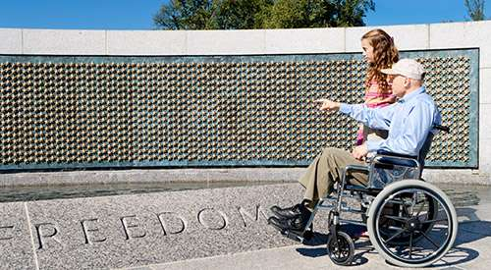
One of the main GRECC missions is to ensure that VA staff are prepared to work with older Veterans. The GRECCs provide training to VA staff, community health care providers, Veterans, and caregivers across many settings.

The Geriatric Research, Education, and Clinical Centers (GRECCs) are Veterans Health Administration’s (VHA) centers of excellence focused on aging. They were established by Congress in 1975 in order to improve the health and health care of older Veterans. They have three main missions:

- To build new knowledge in geriatric care through research
- To improve health care for older Veterans by developing innovative clinical models of care
- To provide training and education on best practices in caring for older adults for students in healthcare disciplines and VA staff

All GRECCs are connected with a major research university and are located at 20 medical centers across the country.

Values: Discovery, education, and clinical innovation are foundational to VHA achieving and sustaining excellence in Veteran-centered health care delivery and health outcomes for older and frail Veterans.

Vision: GRECCs propel VHA toward continuous advancement and application of evidence-based patient-centered preventive, therapeutic and restorative care to achieve best possible health outcomes, including optimal function and quality of life, for older Veterans and all older Americans.

Mission: GRECCs are interdisciplinary Centers of Excellence for discovery and innovation that:

- Conduct geriatrics and gerontological research
- Educate and develop current and future geriatrics and gerontology investigators, educators, clinicians and leaders
- Develop, implement, evaluate and disseminate models of clinical services that improve care and health outcomes for older Veterans

VA Medical Center

https://residency.medicine.ufl.edu/tag/gainesville-va-hospital/

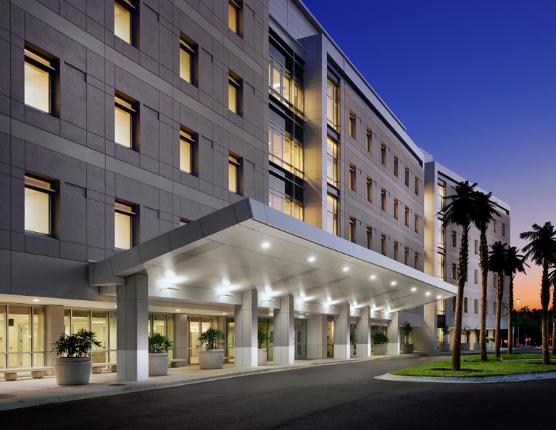
The VA Medical Center (VAMC) is located across the street from Shands Hospital. It is a 239 bed VA hospital that serves veterans throughout North Florida and South Georgia. It is the second largest VA system in the country. The VA patient population provides residents the opportunity to treat the “core” disease states in Internal Medicine. These include COPD, coronary artery disease, cancer, and more. More importantly, the VA patient population is very willing and grateful to have their care provided by residents in training.

At the VAMC, patients are cared for by medical housestaff under the supervision of Department of Medicine faculty that include Hospitalists. There are four general medicine teams at the VAMC: Blue, Green, Orange, and Red. One attending, one upper-level resident (PGY 2 or 3), two-three interns, and medical students are assigned to each of the medicine services.

Research at the VAMC is separated into four main divisions: Biomedical Laboratory, Clinical Science, Health Services, and Rehabilitation.

The Biomedical Laboratory division supports basic science and preclinical research. The Clinical Science division is oriented toward therapeutics and clinical trials for medical conditions relevant to veterans. The Health Services division is dedicated to issues in quality and improvement of health care, again focusing on issues relevant to veterans. The Rehabilitation division is responsible for developing research strategies for coping with serious illness and injury. All research at the VAMC must include participation by a VA-supported investigator. Researchers are required to obtain approval from the VA Research & Development (R&D) Committee and its appropriate subcommittees reviews for all research studies that (1) utilize VA resources or facilities, (2) involve VA patients (including their medical information or PHI), (3) involve VA staff, including part-time staff, without compensation employees (WOC), and/or fee-basis, contract and consultants.

Vector Core Laboratory

https://pgtc.med.ufl.edu/vector-core-lab/

The Vector Core Laboratory was established in March of 1995 when the first of two laboratory modules targeted for the Vector Core became available in the Academic Research Building (ARB). In September of 1995, the Vector Core Laboratory occupied a second laboratory module in the ARB to reach its current size of approximately 1500 sq.ft. In its first year of operation, Sergei Zolotukhin, Ph.D., the previous Director, had equipped the first module for wet lab DNA manipulation and cloning and the second module as a tissue culture facility for producing preclinical vectors and for training staff from other laboratories. The current facility director is Sanford Boye.

The primary role of the Vector Core Laboratory is to provide the service of generating gene therapy vectors. This service is comprehensive, starting with consultation on construct design and AAV capsid selection, molecular cloning of AAV plasmids, and finally packaging and purification of the virus. The Vector Core has served this role for a number of NIH program project grants worth over $25M and produces over 400 preps per year for both academic and industry sponsors. In addition, the Vector Core serves a training role for students associated with those programs.

Vector Core assists with developing new vector technology in collaboration with Powel Gene Therapy Center faculty. As such Vector Core has access to many of the new AAV capsids developed at the University of Florida. In addition, Vector Core staff works directly with the GMP manufacturing to facilitate the transfer of projects to clinical-stage manufacturing.

The Vector Core laboratory manufactures research-grade gene transfer vectors for use in pre-clinical investigations, while the Human Applications Lab manufactures gene transfer vectors under cGMP for use in human clinical trials. The Human Applications Laboratory is a state of the art GMP manufacturing facility that occupies 2200 sq ft in the Mc Knight Brain Institute. The unit includes an 1800 sq ft BL2/BL3 GMP facility, a 300 sq ft Quality Control laboratory and storage facilities for receipt and control of incoming materials. The GMP manufacturing facility has two suites with 2 production modules in each module which operate on a campaign basis. The first suite deals with Cell Processing and the other is used for Viral Vector Production.

Water Institute

https://waterinstitute.ufl.edu/

The University of Florida Water Institute brings together talent from throughout the University and builds internal and external partnerships to address urgent water research challenges; implement innovative interdisciplinary academic programs to train excellent students; and provide state-of-the-art expert assistance and educational programs for external stakeholders. Water Institute faculty represent a breadth of water specialties from geophysical, chemical, biological and social sciences, engineering, law and humanities.

The Water Institute builds partnerships to

- Identify, understand and solve complex interdisciplinary water issues
- Develop intellectually stimulating environments to address important water resource problems
- Prepare a pool of well-trained water-related scientists, engineers, planners and policy-makers
- Ensure sustainable water resources for Florida and beyond

The water institute has 311 affiliated UF faculty, 65 affiliated UF departments and centers. The active research projects totals $180 million. The sponsored research awards totals ~$44 million.

Please visit https://waterinstitute.ufl.edu/wp-content/uploads/strategicplan2016-2021.pdf for the institute’s strategic plan.

Whitney Laboratory for Marine Bioscience

https://www.whitney.ufl.edu/

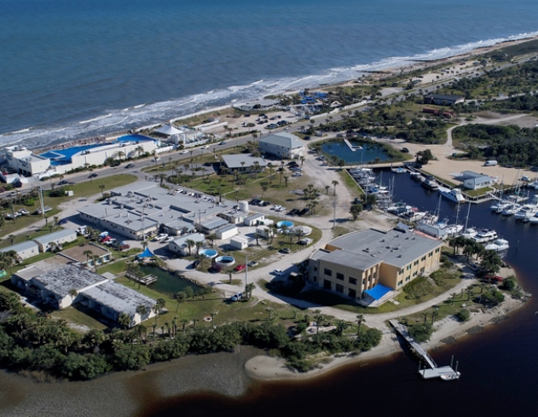
Whitney Laboratory for Marine Bioscience is a full-time University of Florida research center for biomedical research and biotechnology located in St. Augustine, Florida. Founded in 1974, the Whitney Lab is dedicated to using marine model animals for studying fundamental problems in biology and applying that knowledge to issues of human health, natural resources, and the environment. Researchers at the lab are on the front lines of a variety of scientific areas including biodiversity, ocean health, marine chemistry, neuroscience, sensory biology, evolutionary genomics, embryology, and cell regeneration.

The Laboratory is continuing operations under UF and CDC advised guidelines and pursuing important basic research and training.

An important part of the lab’s mission is to train future experimental biologists through its graduate, postdoctoral and summer National Science Foundation sponsored undergraduate internship program. The laboratory provides a marine animal focused K-12 STEM outreach program and a public lecture series, with the goal of increasing community engagement in lifelong learning and marine science.

