Beginning January 25, 2023, all NIH applications will require the use of new Form-H application forms. These forms implement the new data management and sharing plan requirements. Please review the following for further details on the new policies and updates:

- Forms-H Grant Application Forms & Instructions must be used for Due Dates on or after January 25, 2023.
Applicants applying to National Institutes of Health (NIH), Agency for Healthcare Research and Quality (AHRQ), and Food and Drug Administration (FDA) funding opportunities with due dates on or after January 25, 2023, must use updated FORMS-H application packages as detailed in NIH Notice (NOT-OD-23-012). Applications with due dates on or before January 24, 2023 should continue to use FORMS-G application packages. Applications submitted using an incorrect form package for their intended due date will be withdrawn and removed from funding consideration.

In UFIRST, the forms version being used can be found in the General Information Section 1.1 Federal Program Information in the Competition ID area:
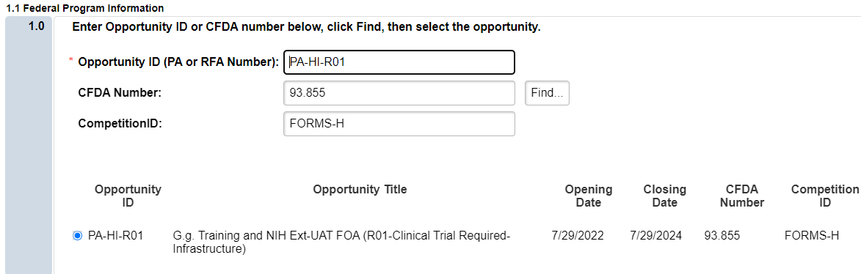

If using grants.gov, the forms version being used can be found by searching for your RFA in grants.gov, click on the opportunity number, and then click on “package.”

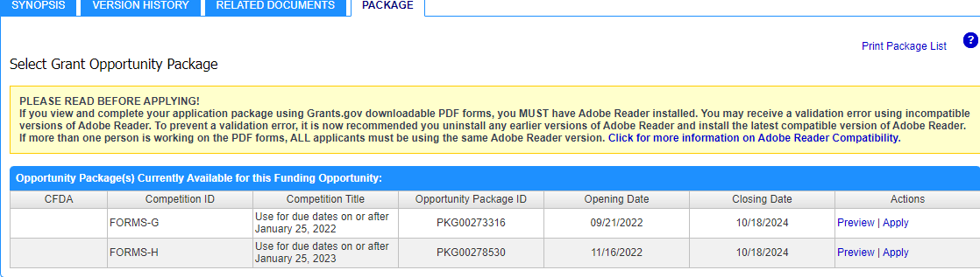

High-level Summary of Form Changes in FORMS-H Application Packages
Forms-H: Instructions, Forms, and a Handy Checklist

- Forms-H Key Changes: Data Management and Sharing Policy.
To promote the sharing of scientific data, the NIH Data Management and Sharing (DMS) policy goes into effect on January 25, 2023. A new “Other Plan(s)” attachment field has been added to the PHS 398 Research Plan Form and the PHS 398 Career Development Award Supplemental Form where applicants must attach the required DMS Plan.

The DMS Policy applies to all NIH funded research which results in the generation of scientific data, including: Research Projects (R), Some Career Development Awards (K), Small Business SBIR/STTR, and Research Centers. The DMS Policy does not apply to research and other activities that do not generate scientific data, including: Training (T), Fellowships (F), Constructions (C06), Conference Grants (R13), Resource (G), and Research-Related Infrastructure Programs (e.g., S06).
For proposals requiring the DMS plan, budgets should include estimated funds needed for data management and sharing activities. These should include all allowable costs for DMS for all data types including planned storage costs beyond the project period of performance. Since UFIRST currently does not have a category labeled “Data Management and Sharing Costs,” these costs should be budgeted under “Other Expenses” in UFIRST and then in Section F Other Direct Costs in the SF424 manually make the name change to “Data Management and Sharing Costs.” You must word the SF424 section exactly “Data Management and Sharing Costs” or your application will be rejected.

From the SF424 Other Direct Costs Section:

There is a free DMP Tool available at https://dmptool.org/ that can be used to assist in the development of data management plans. Sample plans area also available at that website for reference.

For additional information, please review UF’s NIH Data Management and Sharing Policy website: https://research.ufl.edu/dsp/award-management/nih-data-management-and-sharing.html.

