**We are sharing these mentoring plans with PI’s permission.**

**Please note that materials are confidential and not available for further distribution or publication in any shape or form.**

**Mentoring Plans**

**From Dr. Alina Zare’s 2019 CPS Frontier**

**Postdoctoral Researcher Mentoring Plan**

This project includes funding for five post-doctoral researchers (post-docs). Two post-docs in remote sensing will be advised jointly by Dr. Alina Zare and Diane Rowland. One post-doc in IoT and machine learning will be advised by Dr. Janise McNair. Two post-docs in data science for health informatics will be advised jointly by Ilaria Capua and Daniela Paolotti. All post-docs will meet weekly with their primary advisor(s) and monthly with another PI from the team. The goal of meeting with an alternate PI is to provide the post-doc with the dedicated time to get and ask career advice from other investigators on the team.

**Professional Development:**

At the start of their position, each post-doc will be asked to complete and individual development plan using one of the several worksheets provided by the post-doctoral affairs office at the University of Florida (http://postdoc.aa.ufl.edu/resources/mentoring-resources/). The goal of the development plan is to encourage each post-doc to consider their goals and scope out training needs to be able to reach these goals. PI Zare will discuss the Individual Development Plans with them and identify training opportunities. Each post-doc will be encouraged to revise their development plans as needed. Each post-doc will also be incorporated into the day-to-day project administration and management to provide them with these skills (which are not commonly taught during graduate programs). We will have post-doctoral researchers on the effort to participate in the University of Florida’s A2i Symposium which features workshops, panel discussions, presentations and networking events - all led by industry leaders and focused on helping participants build key professional skills that will give students a competitive edge.

**Transdisciplinary Training:**

The post-doctoral researchers (and all graduate students) on the effort will be expected to fully participate in full team meetings across disciplines. The goal of this is to ensure the post-docs are effective communicators with those from other disciplines. The post-docs will also be expected to participate in PIs Zare and Rowland’s bi-weekly journal club which includes faculty, students and post-doctoral researchers from both computer engineering and agronomy. In each meeting of the journal club, one computer engineer is paired with an agronomist to jointly present and lead a discussion on a scientific publication to the group. This not only allows the group to stay up to date on the current literature at the intersection of computer engineering/science and agriculture but also further improves our cross-discipline communication skills.

During bi-weekly team meetings, the team will discuss research projects bridging the post-doctoral researcher’s primary research interests to those of the rest of the group. These meetings will include time to provide feedback on research progress and discussion of data analysis. These meetings will be in addition to weekly (at least, more frequently as needed) one-on-one meetings with PI Rowland. Finally, the post-docs will be expected to be the lead author on at least two p apers that cross disciplinary boundaries.

**From Dr. Jack Judy’s 2020 Proposal**

**Postdoctoral Mentoring Plan**

NESSI postdoctoral associates will be working in, and consequently funded by center institutions. Because the of the encompassing nature and interconnectedness of the center, work on NESSI related projects will serve as an outstanding training vehicle for uniquely qualified individuals. These individuals will be exposed to a vastly richer variety of training opportunities than are available to most postdoctoral associates who join a single lab to work on an isolated project.

These individuals will be primarily mentored by their project lead; however, they will be co-mentored by the Directors of Engineering Workforce Development (EWD) and Diversity-and-Culture-of-Inclusion (DCI). The involvement of a postdoctoral associate in the proposed project will include mentoring training and activities designed to enhance the postdoc’s career trajectory and ability to handle logistics and manage personnel and students. The multidisciplinary team assembled for this project will provide ample opportunity for the postdoc to learn best-practices for maintaining effective cross-disciplinary collaboration. Furthermore, interactions among the postdoc, PIs, and student participants will strengthen the postdoc’s skills in mentoring students, time management, and prioritization of responsibilities and activities. The associate will assist with planning and implementing NESSI activities, assist with mentoring NESSI students, implement the Undergraduate International Course, and help identify future directions for meeting NESSI goals. Inspired by the National Postdoctoral Association core competencies, the Postdoctoral Training and Mentoring Plan will be tailored to the specific needs and interests of qualified candidates. The training program will be developed as a collaborative effort between the postdoctoral fellow, primary mentor, and the mentoring team. Prior to even starting on a project, candidates will develop a career development plan with their mentoring committee and will meet with the committee every six months to evaluate progress and develop alternative strategies. Taking advantage to the move to virtual teaching platforms following the pandemic, candidates will be able to participate in training opportunities available at any of the participating institutions. This mentoring plan is designed to prepare the postdoctoral associate for a successful career in higher education through a combination of formal and informal training, career planning assistance, and hands-on experience. The plan will consist of the following:

Research and Program Management

* Postdoctoral associates will complete their home institution’s mandatory Responsible Conduct of Research (RCR) training.
* Postdoctoral associates will complete Institutional Review Board (IRB) training and learn about the preparation and submission of new research protocols.
* Postdoctoral associates will develop expertise in educational research by reading and discussing science and engineering education literature with the directors, partners, and pertinent members of the university community.
* Postdoctoral associates will conduct research on the impact of the international program.
* Postdoctoral associates will be given responsibility for managing many of the day-to-day activities and communications of the EWD and DCI offices with oversight from the Directors.
* Postdoctoral associates will attend NSF ERC National Meetings.

Communication Skills

* The mentoring team will work with the postdoctoral associate to enhance her/his writing skills through preparation of reports, grants, and manuscripts.
* Postdoctoral associates will share program ideas and research findings with the appropriate center members, partners, and other pertinent members of the university community by oral and written presentations.
* Postdoctoral associates will develop and conduct workshops for NESSI student participants.
* Postdoctoral associates will be encouraged to present a poster or oral presentation annual meetings or conferences (e.g. Annual Association for Engineering Education, Society for Neuroscience, or the North American Neuromodulation Society).

Grant Writing and Management

* The mentoring team will provide training on proposal writing policies and procedures and teach strategies for writing competitive grants. These will include federal sponsors, private foundations, and local opportunities.
* Postdoctoral associates will assist with the preparation of new grant applications and/or renewals.

Career Planning and Professional Development

* The mentoring team will assist the postdoctoral associate with the creation of an Individual Development Plan. Progress will be reviewed on a regular basis and evaluated at the end of the program year.
* The mentoring team will hold bi-weekly meetings with the postdoctoral associate, provide regular feedback on performance, and identify areas for growth.
* Postdoctoral associates will participate in university-level NESSI meetings and attend other relevant meetings with the mentoring team.

In addition to the numerous training and mentoring opportunities within NESSI, it should be noted that each of the member institutions has an Office of Academic Career Development (or similar) which includes a Center for Doctoral and Postdoctoral Career Development (or similar). The resources within these Centers complement those of the NESSI Workforces Development team, with a variety of networking and training opportunities provided throughout the year with exposure to a variety of different career opportunities. For example, postdoctoral associates will be encouraged to participate in personal and professional development workshops/courses offered by the center institutions. Seminars and regularly scheduled workshops, mentoring and career resources, and intra-campus networking events are offered at all 4 center institutions. Previous workshops offered by center institutions include “Taking Leadership”, “Keys to Successful Grant Writing”, “Putting Yourself Out There: Critical Interview Skills for Postdocs”, and “Taking Care of Head and Heart: A Conversation about Mental Health and Well-being.” Opportunities for postdoc networking at other institutions nationwide are also available through the National Postdoctoral Association.

**From** **Dr. Bette Loiselle’s NSF NCODES**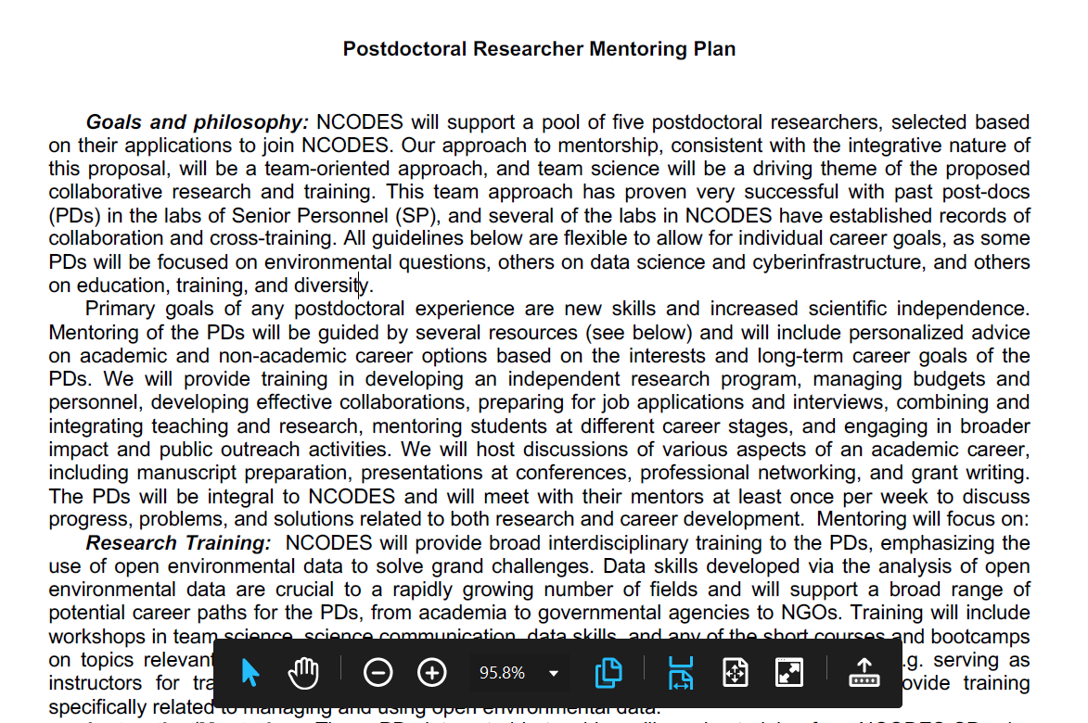

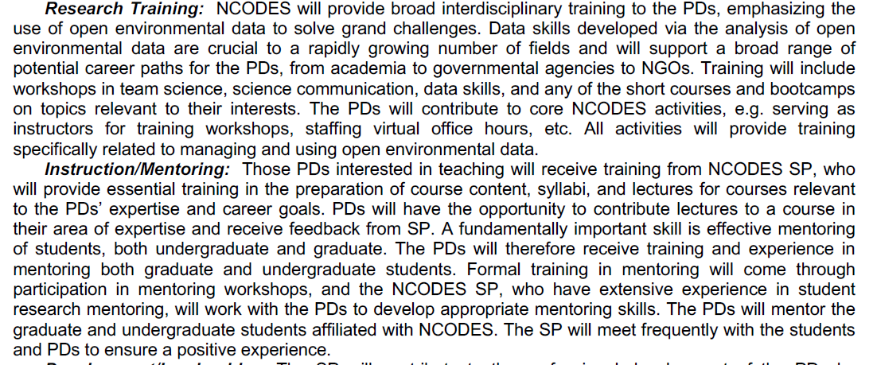

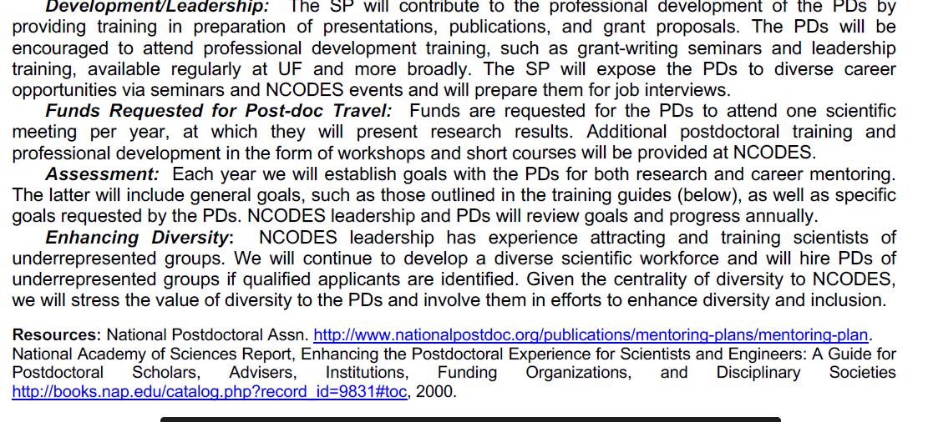

**From** **Dr. Jennifer Andrew’s 2022 MRSEC Preproposal**

**Postdoctoral Researcher Mentoring Plan**

The UF Materials Research Science and Engineering Center (MRSEC) postdoctoral mentoring plan seeks

to provide the skills, knowledge, and experiences necessary to prepare our postdoctoral researchers (PDRs) to excel in their chosen career path. The UF MRSEC will work with each PDR to create an individualized development plan (IDP). These plans will be developed and updated bi-annually with guidance and resources provided by the UF Office of Postdoctoral Affairs. Specific elements of the mentoring plan will include:

**Orientation.** All PDRs will be initially oriented to UF by an in-depth conversation with their PI, followed by an orientation to the UF MRSEC community with the Center Director, and a monthly orientation for all UF PDRs offered by the UF Office of Postdoctoral Affairs. We will utilize UF’s Postdoc Professional

Development Form to establish and discuss career goals, strategic goal making strategies, including the

development of SMART goals that are **S**pecific, **M**easurable, **A**ttainable, **R**elevant and **T**ime-based. The

PDR will work with their PI to establish a SMART IDP plan and a mentoring team that is unique for each PDR based on their research area and goals.

**Advising/Career Counseling**. All PDRs will be mentored and advised by their PI as well as their mentoring team. PDRs will also have access to individual career counseling appointments with the Director of the Office of Postdoctoral Affairs. This office offers a comprehensive workshop schedule that includes both career and professional development events to compliment the skills developed within the UF MRSEC.

**Research Skills.** The proposed Interdisciplinary Research Group. (IRG) research projects will provide

important training opportunities for the PDRs supported by this award. The PDRs will specifically develop expertise in soft matter experiments and simulations as well as data management. These skills will enable the PDR to develop creative and ambitious plans for future research as a PI or researcher at a national lab, in industry, or academia.

**Research Environment.** The UF MRSEC will provide a vibrant interdisciplinary community for the PDR to engage in collaborative efforts that include participants at all levels, from 2-year college students to world-class senior faculty. Leveraging their mentoring team, PDRs will develop the technical and scientific skills needed to execute this research program. PDRs will develop technical skills that cover the scientific IRGs of this proposal, including molecular simulation, machine learning and synthesis and characterization.

They will also learn to formulate and test scientific hypotheses, refine their writing, and grant development skills, and learn best practices for working on a diverse and inclusive multidisciplinary team. PDRs will regularly interface with the PIs, senior collaborators, and students through bi-weekly Center meetings. PDRs will be invited to participate in Center leadership as a member of the Student Advisory Committee (SAC).

**Professional Development.** The UF MRSEC will hold professional development training for PDRs,

including mentoring workshops, FAIR data management principles (See Data Management Plan), and our community of practice in action (CoPA) activities, including trainings on topics such as “*promoting*

*disagreement while containing conflict”* and setting clear expectations for sharing credit and authorship.

The PDRs will also participate in the grant-writing process, providing direct experience in research project ideation and design. These activities will be directly supervised by their direct research mentor, and mentorship team who will collaborate with the PDRs and provide ongoing constructive feedback. PDRs interested in faculty careers will be encouraged to participate in training and professional development programs offered by the National Center for Faculty Diversity and Development (NCFDD), a program that UF has an Institutional Membership with. PDRs with an interest in gaining teaching experience will be encouraged to work with a faculty member from the Dept. of Engineering Education for opportunities to prepare and present (with supervised guidance from the PIs) a small number of lectures within the context of an ongoing class, such as a core undergraduate course.

**Success of the Mentoring Plan.** The PDRs progress towards their Career goals will be assessed by tracking progress in their SMART research goals and trajectory with career goals.

Note: The mentoring plan here is specific for postdocs and not graduate students. However, it could be readily updated with inclusion of structures in existence at UF. For example, all graduate students already have an individual development plan (IDP) maintained in Canvas, and I believe administered by the Graduate School.

**From Juan E. Gilbert’s NSF Proposal: “BPC-AE: Collaborative: Evolution of the Institute for African Americans in Computing Sciences (IAAMCS)”**

**Postdoctoral Researcher Mentoring Plan**

One postdoctoral researcher will be supported at Morehouse College and one at the University

of Florida. Dr. Jeremy Waisome will be supported by this project in the laboratory of Dr. Gilbert at

UF to serve as the project manager for the Institute for African-American Mentoring in Computing

Sciences (iAAMCS) and to conduct research in Engineering Education, specifically CS Education.

On the project management side, Dr. Waisome will coordinate meetings, work on the annual

reports with the evaluation team, mentor undergraduate researchers with the graduate students

and serve as a liaison between the PI, Dr. Gilbert and all the Institute’s stakeholders. The **goal** of

the proposed mentoring plans is to provide a flexible framework for the postdocs’ professional

and career development that accommodates the needs of the individual. In accordance with the

National Academies of Science and Engineering 1 report on enhancing the postdoctoral

experience, the plan includes both structured and informal mentoring activities, career planning

assistance, and opportunities to learn valuable career skills such as grant writing, teaching,

networking and communication. These activities will broaden her research abilities and equip her

with the skills necessary for a successful research career in Engineering Education and Computer

Science.

• Upon joining the laboratory, the postdoc will perform a **self-assessment** to identify career and

professional goals that will guide the direction of the remainder of the mentoring plan.

• The PI will provide an orientation to **university policies**.

• The PI will provide an **orientation** to the laboratory that will include detailed discussion of

mutual expectations. Topics of discussion will include (a) level of independence, (b)

interaction with coworkers, (c) productivity and the importance of publications, (d) work habits

and laboratory safety and (e) documentation of experimental details and research

methodologies.

• The faculty mentor will meet individually with the postdoc on a weekly basis to discuss

research data and **project management**. The postdoc will be expected to participate in the

PI’s weekly research group meetings, in which lab members regularly present their ongoing

research. Feedback will be given to aid in the **development of communication and**

**presentation skills**.

• The postdoc will be encouraged to attend departmental research seminars and journal clubs.

These activities will also provide informal opportunities to discuss **presentation of scientific**

**data, writing, and submission of journal articles for publication**.

• The PI will facilitate travel to relevant scientific meetings of the postdoc’s choosing based on

publications, such as the annual *ACM SIGCSE and ASEE Annual Conference* to **foster**

**expansion of the postdoc’s scientific knowledge and professional network**.

• Postdocs will be encouraged to identify, with the PI’s assistance, additional resources and

colleagues to inform career decisions and form additional mentoring relationships.

Professional achievements and milestones will be monitored.

• The postdoc will complete online training in the **Responsible Conduct of Research** provided

through University of Florida’s membership in the Collaborative Institutional Training Initiative

(CITI). The online course meets NSF requirements. The PI will also take advantage of informal

opportunities to engage the postdoc in discussion regarding scientific ethics on an ongoing

basis.

The **success of the mentoring plan** will be assessed through semi-annual meetings with the

postdoc to discuss and monitor personal progress towards professional and career goals.

---------------

1National Academy of Science, National Academy of Engineering, Institute of Medicine, “Enhancing the

Postdoctoral Experience for Scientists and Engineers: A Guide for Postdoctoral Scholars, Advisers,

Institutions, Funding Organizations, and Disciplinary Societies,” National Academies Press. 2000