**The University of Florida**

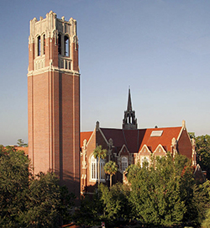 The University of Florida (UF), the state’s oldest, is a major, public, land-grant and sea-grant research university. UF traces its beginnings to a small seminary in 1853. It opened its doors in Gainesville in 1906 with 102 students. Today, it is one of the most comprehensive and academically diverse universities in the nation. As of fall 2023 UF has an enrollment of approximately 60,000 students (including undergraduate, graduate, and UF Online). UF is home to 16 colleges and more than 190 active research centers and institutes and UF offers over 100 undergraduate programs and over 200 graduate degree programs.

UF has a long history of established programs in international education, research and service. It is a member of the Association of American Universities, the higher-education organization comprising 71 of the top public and private research universities in North America. UF is consistently ranked among the nation’s top universities: No. 7 (tied) in U.S. News & World Report “Top Public Universities” (2024); No. 2 in Kiplinger’s “Best Values in Public Colleges” (2019); has a 5-star ranking in Money Magazine Best Colleges for Your Money (2024), and No. 4 on the Forbes list of best value public universities (2024). Additionally, UF ranked at No. 9 by the National Academy of Inventors (NAI) in its annual list of “the Top 100 worldwide university utility patent holders in the world to be granted U.S. utility patents” (142 awarded) in 2023.

UF graduate programs are among some of the top programs in the nation; 51 graduate programs in the top 50 nationally, 17 of which in the top 20 in U.S. News Best Graduate Schools (2025), 12 online graduate programs in the top 10 of U.S News Online Best Graduate Programs (2024). UF is also recognized among the top universities in the world; ranks 21 among U.S. Public Universities from the Shanghai Institute (2024), and 21 among U.S Publics from Times Higher Education World Universities (2025). UF ranks 20th among U.S. Public Universities in the QS World Ranking (2025).

UF has over 6,000 faculty members with distinguished records in teaching, research, and service, including 22 Eminent Scholar chairs and 38 faculty elections to the National Academy of Sciences, Engineering, and Medicine, 20 elections to the American Academy of Arts and Sciences. Awards include a Fields Medal, two Pulitzer Prizes, NASA’s top award for research, and Smithsonian Institution’s conservation award.

UF’s students are accomplished. Students admitted for the fall 2023 freshman class had an average weighted GPA of 4.51 and an average composite SAT score of 1378. The current freshman retention rate of 97 percent is among the highest in the country. UF’s current six-year graduation rate for bachelor’s stands at 91 percent. UF has a focus on a diverse student body.

UF is a leader in research and discoveries which improve the lives of individuals throughout the state, nation, and world. UF’s research expenditures totaled a record $1.25 Billion in fiscal year 2023. UF ranked No. 15 among all public universities in total R&D expenditures in 2022. UF is one of only about 30 public and private universities around the country with more than $1 billion in annual research spending, a list that includes Johns Hopkins, the University of Michigan, UCLA, Harvard, Stanford, Penn State and the University of California-Berkeley. In the most recent HERD report, based on 2022 fiscal year data, UF ranked 15th among public universities and 25th overall (<https://news.ufl.edu/2024/07/research-spending/#:~:text=UF%20accounts%20for%20about%2040,News>).

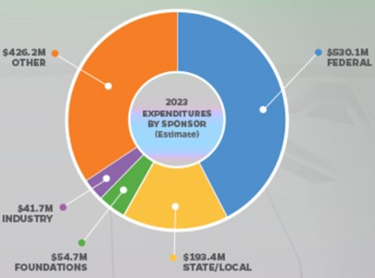UF conducts over $40 million of industrial/company-sponsored research annually. These research collaborations occur across the entire campus, in diverse fields that include engineering, life sciences, pharmaceuticals, and medicine, as well as the physical and social sciences. Research into improving education techniques and learning outcomes has also been sponsored by a variety of companies, particularly in areas pertaining to improving the education of students from under-represented and low-income demographic groups. Industrial funding for UF research comes from Global 1000 companies as well as local and regional start-ups and corporate entrepreneurs, all of which seek to leverage the expertise of UF’s world-class faculty to promote discoveries that will benefit the health and overall well-being of people worldwide.

The university is recognized as an international leader in technology commercialization. In 2023 researchers disclosed 300 new discoveries, and UF Innovation signed a record 282 licenses/ options and launched 15 startup companies.<https://research.ufl.edu/about/annual-reports.html> In 2022, Heartland Forward ranked UF No. 2 in the nation for tech transfer, No. 1 among public universities, for its tech transfer prowess. A 2019 economic impact report estimated that companies using technology licensed from UF contributed $2.4 billion and nearly 10,000 jobs to the state’s economy.

The university has a 2,000-acre campus and more than 900 buildings (including 26 Undergraduate residence halls, 7 libraries). The UF has over 7,900 students living in its residence halls. In addition, nearly 1,600 students and their families live in the 980 apartments of the Village Communities on campus. The university’s current facilities have a book value of more than $1 billion and a replacement value of $2 billion.

Overall, the total economic contributions of UF main campus in fiscal year 2017-18 were estimated at 93,764 jobs, $10.28 billion in industry output, and $6.46 billion in value added. These contributions represented 54 percent of total county employment, and 49 percent of county-level gross regional product (GRP) <https://fred.ifas.ufl.edu/extension/economic-impact-analysis-program/publications/2017-2018-university-of-florida-related-entities/#:~:text=The%20total%20industry%20output%20or,product%20(GRP)%20in%202017>.