FACILITIES AND RESOURCES
Health Science Center

Table of Contents
University of Florida 3
UF Health 4
UF Health - Education 5
Patient Care - UF Health Hospitals 5
UF Health Shands Hospital 5
College of Medicine 7
Norman Fixel Institute for Neurological Diseases at UF Health 8
UF Clinical and Translational Science Institute (CTSI) 8
CTSI REDCap 9
Pain Research and Intervention Center of Excellence (PRICE) 9
Pain Clinical Research Unit (PainCRU) 10
OneFlorida+ Clinical Research Network 11
The OneFlorida Data Trust 11
UF Health Integrated Data Repository (IDR) 12
Consent2Share 12
UF Diabetes Institute 12
UF Emerging Pathogens Institute 13
UF Genetics Institute (UFGI) 13
UF Health Cancer Center 13
UF Institute for Child Health Policy 15
UF Institute on Aging (IOA) 16
UF Research and Academic Center at Lake Nona 17
UF College of Medicine Quality & Patient Safety Initiative 17
Department of Health Outcomes and Biomedical Informatics 18
College of Dentistry (UFCD) 19
College of Nursing 20
College of Pharmacy 21
Department of Pharmaceutical Outcomes and Policy (POP) 22
Department of Pharmacotherapy and Translational Research 23
UF Center for Pharmacogenomics and Precision Medicine 23
College of Public Health & Health Professions (PHHP) 24
Department of Epidemiology 25
HealthStreet 25
College of Veterinary Medicine 27

University of Florida
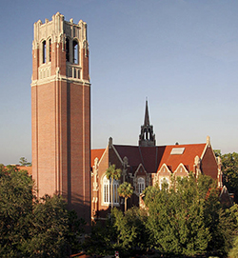
The University of Florida (UF), the state’s oldest, is a major, public, land-grant and sea-grant research university. UF is one of the most comprehensive and academically diverse universities in the nation. As of fall 2023 UF has an enrollment of approximately 60,000 students (including undergraduate, graduate, and UF Online). UF is home to 16 colleges and more than 190 active research centers and institutes and UF offers over 100 undergraduate programs and over 200 graduate degree programs.

UF has a long history of established programs in international education, research and service. It is a member of the Association of American Universities, the higher-education organization comprising 71 of the top public and private research universities in North America. UF is consistently ranked among the nation’s top universities: No. 7 (tied) in U.S. News & World Report “Top Public Universities” (2024); No. 2 in Kiplinger’s “Best Values in Public Colleges” (2019); has a 5-star ranking in Money Magazine Best Colleges for Your Money (2024), and No. 4 on the Forbes list of best value public universities (2024). Additionally, UF ranked at No. 9 by the National Academy of Inventors (NAI) in its annual list of “the Top 100 worldwide university utility patent holders in the world to be granted U.S. utility patents” (142 awarded) in 2023.

UF graduate programs are among some of the top programs in the nation; 51 graduate programs in the top 50 nationally, 17 of which in the top 20 in U.S. News Best Graduate Schools (2025), 12 online graduate programs in the top 10 of U.S News Online Best Graduate Programs (2024). UF is also recognized among the top universities in the world; ranks 21 among U.S. Public Universities from the Shanghai Institute (2024), and 21 among U.S Publics from Times Higher Education World Universities (2025). UF ranks 20th among U.S. Public Universities in the QS World Ranking (2025).

UF has over 6,000 faculty members with distinguished records in teaching, research, and service, including 22 Eminent Scholar chairs and 38 faculty elections to the National Academy of Sciences, Engineering, and Medicine, 20 elections to the American Academy of Arts and Sciences. Awards include a Fields Medal, two Pulitzer Prizes, NASA’s top award for research, and Smithsonian Institution’s conservation award.

UF conducts over $40 million of industrial/company-sponsored research annually. These research collaborations occur across the entire campus, in diverse fields that include engineering, life sciences, pharmaceuticals, and medicine, as well as the physical and social sciences.

The university is recognized as an international leader in technology commercialization. In 2023 researchers disclosed 300 new discoveries, and UF Innovation signed a record 282 licenses/ options and launched 15 startup companies.https://research.ufl.edu/about/annual-reports.html In 2022, Heartland Forward ranked UF No. 2 in the nation for tech transfer, No. 1 among public universities, for its tech transfer prowess. A 2019 economic impact report estimated that companies using technology licensed from UF contributed $2.4 billion and nearly 10,000 jobs to the state’s economy.

The university has a 2,000-acre campus and more than 900 buildings (including 26 Undergraduate residence halls, 7 libraries). The UF has over 7,900 students living in its residence halls. In addition, nearly 1,600 students and their families live in the 980 apartments of the Village Communities on campus. The university’s current facilities have a book value of more than $1 billion and a replacement value of $2 billion.

Overall, the total economic contributions of UF main campus in fiscal year 2017-18 were estimated at 93,764 jobs, $10.28 billion in industry output, and $6.46 billion in value added. These contributions represented 54 percent of total county employment, and 49 percent of county-level gross regional product (GRP) https://fred.ifas.ufl.edu/extension/economic-impact-analysis-program/publications/2017-2018-university-of-florida-related-entities/#:~:text=The%20total%20industry%20output%20or,product%20(GRP)%20in%202017

UF Health
https://ufhealth.org/assets/media/fact-sheets/172130134782_7.15.24-UFH_Overview_Fact_Sheet_Single_Page_Version_JUL24Version_F.pdf
University of Florida Health is part of the University of Florida. It is unique for its diverse constellation of
health colleges, research centers and institutes, hospitals, faculty practices, and patient care programs. With main campuses in Gainesville and Jacksonville, regional sites in Jupiter, Leesburg, The Villages, and St. Augustine, and more than 30,000 faculty and staff, UF Health includes six health colleges, 10 research institutes and centers, more than 115 physician practice locations, numerous outpatient services throughout Central, North Central, and Northeast Florida, and three veterinary hospitals.

UF Health is headquartered in Gainesville, where the colleges, several hospitals, and a majority of the research institutes and centers are located on UF’s main campus. UF Health also operates an academic health center in Jacksonville.

UF Health Colleges:
- Medicine
- Dentistry
- Nursing
- Pharmacy
- Public Health and Health Professions
- Veterinary Medicine

UF Research Institutes and Centers
- Evelyn F. and William L. McKnight Brain Institute of UF
- Norman Fixel Institute for Neurological Diseases at UF Health
- UF Clinical and Translational Science Institute
- UF Diabetes Institute
- UF Emerging Pathogens Institute
- UF Genetics Institute
- UF Health Cancer Center
- UF Institute for Child Health Policy
- UF Institute on Aging
- The Herbert Wertheim UF Scripps Institute for Biomedical Innovation & Technology

UF Health - Education
From the time of the health center’s founding in 1956, UF Health has operated as a single academic enterprise dedicated to training a variety of professionals. UF Health encompasses the Gainesville-based colleges of Dentistry, Medicine, Nursing, Pharmacy, Public Health and Health Professions, and Veterinary Medicine; the UF Health Shands family of hospitals; the UF Health Jacksonville hospitals; UF Health Flagler Hospital; the UF Health Central Florida hospitals; UF Health Ocala Neighborhood Hospital, and an academic campus in Jacksonville that is home to the UF College of Medicine – Jacksonville and includes degree programs offered by the colleges of Nursing and Pharmacy. The colleges offer the full continuum of higher education to undergraduates, professional students, and advanced postdoctoral students. Together with clinical programs and services across all six colleges, UF Health is helping to create Florida’s future health care workforce.

UF Health is home to 1680 medical residents and fellows, and more than 8,300 students, 2,700 faculty and 28,000 staff.

Patient Care - UF Health Hospitals
UF Health’s outstanding faculty physicians, nurses, and staff across the clinical enterprise serve patients from all 67 Florida counties, from throughout the nation and from more than 40 countries each year. The UF Health family encompasses two major teaching hospital systems, UF Health Shands Hospital in Gainesville and UF Health Jacksonville, each with a state-designated Level 1 trauma center, and an emergency air and ground transport program serving neonatal, pediatric, and adult patients, in
addition to regional sites in Central Florida — UF Health Leesburg Hospital and UF Health Spanish Plaines Hospital — and UF Health Flagler Hospital in St. Augustine.

UF Health Shands Hospital
https://ufhealth.org/assets/media/fact-sheets/2022-uf-health-shands-hospital-fact-sheet.pdf

UF Health Shands refers to Shands Teaching Hospital and Clinics Inc., a private, not-for-profit 501(c)(3) corporation affiliated with UF. It is part of UF Health, a world-class academic health center and part of one of the nation’s top 5 public research universities, with main campuses in Gainesville and Jacksonville
as well as satellite sites in Leesburg and The Villages®. UF Health Shands is based in Gainesville. It features a teaching hospital, UF Health Shands Hospital, five specialty hospitals — UF Health Shands Cancer Hospital, UF Health Shands Children’s Hospital, UF Health Psychiatric Hospital, UF Health Heart & Vascular Hospital and UF Health Neuromedicine Hospital — a network of outpatient rehabilitation centers, and a home health agency.

The Gainesville-based hospital system has a total of 1,111 licensed beds. At a glance (https://ufhealth.org/about-uf-health/uf-health-leadership):

- UF Health Shands Hospital
- UF Health Shands Cancer Hospital
- UF Health Shands Children's Hospital
- UF Health Heart & Vascular Hospital
- UF Health Neuromedicine Hospital
- UF Health Psychiatric Hospital
- A network of outpatient rehabilitation centers and a home-health agency

UF Health Shands is affiliated with 60 UF Health Physicians primary care and specialty medical practices located throughout North Central Florida. UF Health Shands Hospital is also home to a state-designated Level I trauma center, a Level IV neonatal intensive care unit, a regional burn center and an emergency air and ground transport program.

UF Health Shands has built relationships with affiliates throughout the state in services such as cancer, heart surgery, neurosurgery, pediatrics, pediatric cardiology, pediatric nephrology, vascular surgery and addiction medicine. The UF Health Rehab Hospital, a collaboration between UF Health and Select Medical, was recognized as one of the best physical rehabilitation centers in Florida by Newsweek magazine in 2021. UF Health Shands also is affiliated with urgent care centers in Gainesville and Ocala and collaborates with other hospitals and health care providers to expand clinical programs and research and education efforts.

More than 1,200 UF College of Medicine faculty and community physicians on the UF Health
Shands medical staff provide care in more than 100 specialty and subspecialty medical areas,
from primary care to highly specialized and complex care, including cancer, heart and vascular,
neuromedicine, pediatrics and transplantation services. Each year, patients come to UF Health
Shands from all 67 Florida counties, throughout the nation and 25 countries.

UF Health also has a network of outpatient rehabilitation centers, two home health agencies, and more than 115 physician practice locations throughout Central, North Central, and Northeast Florida, as well as Southeast Georgia. In addition, UF Health has a robust statewide presence, with satellite medical, dental, and nursing practices staffed by UF Health professionals and affiliations with community-based health care facilities stretching from Miami to the Florida Panhandle. UF Health also is home to UF Veterinary Hospitals, which includes a small animal hospital and a large animal hospital in Gainesville and a third hospital in Ocala.
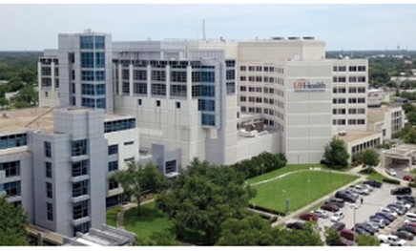
UF Health Jacksonville is a distinguished academic health center in Northeast Florida. Led by chief executive officer Patrick L. Green, Fellow of the American College of Healthcare Executives (FACHE), the hospital is well-positioned to be the region’s most valued health care asset. It is a private, not-for-profit hospital that has provided high-quality patient care for more than 150 years.

Affiliated with the University of Florida, UF Health Jacksonville is part of UF Health, the Southeast’s most comprehensive academic health center, with main campuses in Jacksonville and Gainesville.

UF Health Jacksonville has a range of medical offerings, with many specialty care options including cardiology, neurology and orthopedics. Combining its strengths with the UF College of Medicine – Jacksonville, it offers residents and fellows in Northeast Florida and Southeast Georgia all the research and cutting-edge diagnosis and treatment advantages of an academic health center.

In 2023, UF Health Jacksonville opened three innovative facilities, the first in the area to offer combined emergency and urgent care under one roof. UF Health North is expanding again, with a new six-story bed tower to be completed in 2024. UF Health East offers multispecialty services to the Southside and beaches communities of Jacksonville within a conveniently located state-of the-art medical facility (https://ufhealth.org/assets/media/fact-sheets/UF-Health-Jacksonville-Fact-Sheet.pdf).

College of Medicine
https://med.ufl.edu/

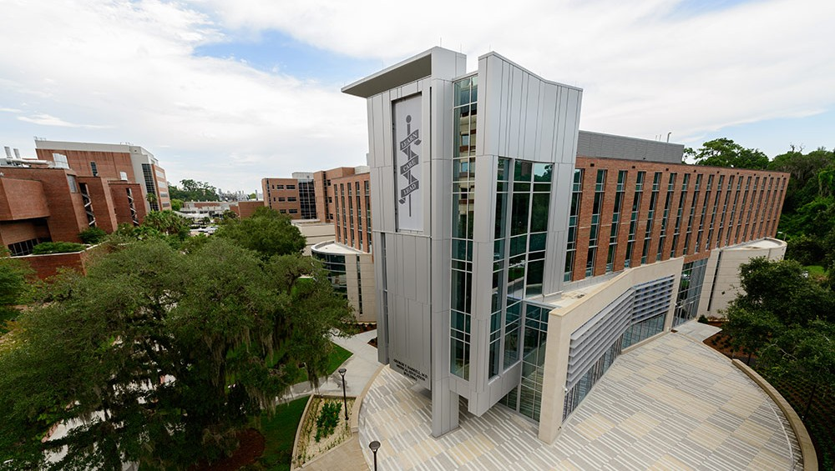
The College of Medicine, the largest of six colleges at the University of Florida Academic Health Center, opened in 1956 with a mission to increase Florida’s supply of highly qualified physicians, provide advanced health care services to the residents of Florida and foster discovery in health research.

Since graduating its first medical students in 1960, the College has graduated more than 5,000 physicians. The college also offers other graduate degree programs, including:
- Medical sciences
- Biomedical engineering
- Physician assistant studies
- Graduate Program in Biomedical Sciences

The college’s Gainesville campus is comprised of 28 clinical and foundational science departments and the UF School of Physician Assistant Studies and is staffed by more than 1,400 faculty members. The Jacksonville campus, located 75 miles to the northeast of UF main campus in Gainesville, is home to more than 450 physicians and scientists delivering medical care in an urban setting, performing research and educating medical students and residents.

A patient care setting is provided to College of Medicine faculty and students by the University of Florida Health Physicians Group Practice, a close collaboration with UF Health, the Malcom Randall Veterans Affairs Medical Center, as well as several community health care sites and other affiliated hospitals in Florida. First-rate medical facilities and well-trained physicians and physicians-in-training are partnered to provide the highest quality of patient care.

The college is an active partner in multidisciplinary campuswide programs that foster scientific synergy and collaboration and facilitate the “bench to bedside” transfer of therapies. Some of the centers and institutes that tap talent from the health sciences and many other disciplines include (https://med.ufl.edu/about/centers-institutes/):

Evelyn F. and William L. McKnight Brain Institute
The Evelyn F. and William L. McKnight Brain Institute of UF is one of the nation’s most comprehensive and diverse neuroscience research centers. Across campus, more than 200 faculty members work on multidisciplinary teams to better understand how the brain works and how various diseases alter brain function.

Norman Fixel Institute for Neurological Diseases at UF Health
The Norman Fixel Institute for Neurological Diseases is home to scientists and clinicians at UF Health who are working on neurological disorders that afflict millions of people across the globe. These conditions include Parkinson’s, dystonia and other movement disorders, Alzheimer’s disease and other dementias, concussion, traumatic brain injury, dystonia and amyotrophic lateral sclerosis, also known as ALS, or Lou Gehrig’s disease.

UF Clinical and Translational Science Institute (CTSI)
https://www.ctsi.ufl.edu/about-2/
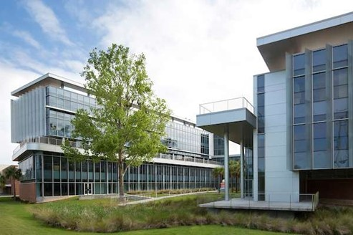
The University of Florida Clinical and Translational Science Institute (CTSI) was founded in 2008 to speed the translation of scientific discoveries into improved health by strengthening the university’s ability to conduct clinical and translational research.

As a catalytic hub connecting resources, people and ideas, the CTSI expands collaboration and advances translational research across UF’s 16 colleges, the state and the national Clinical and Translational Science Award consortium.

The CTSI performs three central functions: 1) transforms and continuously improves the research environment by developing new capabilities and providing novel infrastructure for research and translation to practice; 2) delivers high-quality and efficient research services and resources for translational research; and 3) cultivates a strong translational workforce.

The CTSI offers multidisciplinary training programs, undertakes transformational initiatives and provides services and resources to facilitate health research in any disease area and to advance knowledge across the translational spectrum.

As one of more than 50 such institutes supported by the National Institutes of Health at leading universities across the country, the UF CTSI creates new opportunities for translating basic research into clinically relevant knowledge and then further translating that knowledge into improved practice across the state and nation.

CTSI is geared to attract individual and team investigators to amplify their capabilities, and to help them more effectively and more quickly carry out their clinical and translational research. The UF CTSI is supported by multiple NIH grants, most notably a Clinical and Translational Science Award (CTSA) from the National Center for Advancing Translational Sciences, and by significant institutional support from UF. As part of its second CTSA awarded in 2015, the UF CTSI expanded its collaboration with Florida State University as a partner in community-based research.

UF CTSI’s pilot projects funded by UF CTSI and UF+FSU CTSA hub awards are designed to impact practice-based healthcare, hospital care, or the translational research process. They may also consist of transdisciplinary teams that conduct original research related to the design, dissemination, or evaluation of translational communication messages used to make research more accessible, understandable, and actionable.

The CTSI and its Clinical Research Center collaborate with teams that provide specialized services and expertise for clinical research in specific disease areas and populations, and with venues and partners across the state, including the OneFlorida Clinical Research Consortium – a statewide partnership led by the UF CTSI in collaboration with the University of Miami, Florida State University, health care systems, health plans, providers and patients throughout Florida – as well as UF clinical research facilities in Jacksonville, Orlando and the Malcom Randall VA Medical Center.

CTSI investigators collaborate with the UF-affiliated North Florida/ South Georgia Veterans Health System (NF/SGVHS) and the Malcom Randall VA Medical Center in Gainesville. NF/SGVHS research centers include the Brain Rehabilitation Research Center, Center of Innovation on Disability and Rehabilitation Research, Geriatric Research Education and Clinical Center, and the National Center for Occupational Health and Infection Control. Learn more about conducting research at the NF/SGVHS.

CTSI REDCap
https://www.ctsi.ufl.edu/research/study-design-and-analysis/redcap/

REDCap (Research Electronic Data Capture) is a secure, web-based application designed to support traditional case report form data capture for research studies.

Initial access to REDCap is offered at no cost, but annual maintenance fees will apply to projects that are not deleted from REDCap within one year of their creation date. If financial assistance is needed for REDCap project maintenance, the CTSI may be able to cover the REDCap annual project maintenance costs for research projects via its voucher program. For those with funding, fee-based configuration services are also available to jump-start a given project.

REDCap was originally developed at Vanderbilt University in 2004. The REDCap consortium was officially launched in 2006. The University of Florida and more than 2,000 other partners now comprise the REDCap Consortium that continues to develop and support the software. Using REDCap’s streamlined process for rapidly developing databases and/or surveys, users create a project, define and organize the data they wish to capture, build the related forms/surveys and associate them with study events. Other features include automated export procedures for seamless data downloads to Excel and common statistical packages (SPSS, SAS, Stata, R), as well as a built-in project calendar, a scheduling module, ad hoc reporting tools, and advanced features, such as branching logic, auto-validation, file uploading, survey stop actions, and calculated fields.

Pain Research and Intervention Center of Excellence (PRICE)
https://price.ctsi.ufl.edu/about-the-center-2/price-staff-2/
PRICE is a multi-college Center of Excellence that serves as the professional home for UF scientists, clinicians, and trainees dedicated to improved understanding and treatment of pain. PRICE is affiliated with and supported by the UF Clinical and Translational Science Institute (CTSI) and receives strong support from the UF Institute on Aging and the UF Health Cancer Center. PRICE provides member investigators with several resources and services to facilitate clinical and translational pain research at UF, including assistance with protocol development and assistance with recruitment of research participants. Also, PRICE offers facilities and services to assist investigators with collection of pain assessment data in their research protocols, via the Pain Clinical Research Unit. Investigators can conduct their own studies in the PainCRU, or they can request that the PainCRU staff collect the data for their protocol.

In addition, PRICE endeavors to enhance the intellectual and professional work environment for the UF pain research community by coordinating training activities related to pain, including our T32 training grant in translational pain research, as well as journal clubs, seminar series, and a monthly Pain Interest Group.

In 2013, PRICE occupied its physical home in the new Clinical and Translational Research Building (CTRB), a state-of-the-art research building that serves as the home for clinical and translational research at the University of Florida. The CTRB provides offices for the PRICE Director, multiple PRICE research coordinators, and staff, as well as the Director of the Pain Clinical Research Unit.

PRICE provides member investigators with several resources and services to foster clinical and translational pain research at UF. The Pain Clinical Research Unit, directed by Joseph Riley, Ph.D., is a component of PRICE that provides a patient-oriented research venue to facilitate clinical and translational pain research at UF.

Pain Clinical Research Unit (PainCRU)
https://price.ctsi.ufl.edu/services/
The PainCRU directed by Dr. Joseph Riley III, is a component of PRICE, which provides a patient-oriented research venue designed to facilitate and foster clinical and translational pain research at UF. The PainCRU currently occupies more than 2,000 square feet of space, which includes two CTRB locations: the Clinical Research Center and the Institute on Aging’s Aging Rehabilitation Research Center (ARRC) and the second floor of the Dental Tower at the University of Florida Health Sciences Center.

Altogether, the PainCRU includes six fully equipped psychophysical testing units, each approximately 150 square feet. The laboratory space also includes multiple clinical examination and interview rooms. Each of the six sensory testing units is equipped for assessing thermal pain and pressure pain, and four of the laboratories are also equipped for assessing cold pressor pain. All units include equipment for measuring cardiovascular responses. The PainCRU facilities in the CTRB are contiguous with the greatly expanded UF Clinical Research Center (CRC), which has multiple general use examination rooms, laboratory, and sample processing facilities, as well as several infusion and procedure rooms. The UF CRC offers nursing support for PainCRU studies that involve repeated blood draws and/or administration of medications.

The Pain CRU provides the following services:

Consultation on design and implementation of pain assessment protocols into research studies – Because pain is a nearly ubiquitous accompaniment to dental and medical conditions, pain assessment is an important component of many clinical research projects. Pain CRU can provide consultation to investigators on optimal pain assessment methods, ranging from basic pain scales to sophisticated laboratory-based pain measurement protocols.

Collection of psychophysical pain assessment data – If an investigator would like to include some pain testing but does not have the staff or facilities to do this, Pain CRU can be the “one-stop pain shop” that provides space, equipment, and trained personnel to assist investigators with the administration of laboratory pain assessment methods. Our staff has undergone considerable training and calibration in the conduct of pain testing methods. Pain CRU staff can train your research staff in the conduct of these procedures, or Pain CRU can arrange to have our staff conduct the testing ourselves in the Pain CRU facility.

OneFlorida+ Clinical Research Network
https://www.ctsi.ufl.edu/ctsa-consortium-projects/oneflorida-clinical-research-network/

UF Health and the UF CTSI serve as the coordinating center for the OneFlorida+ Clinical Research Network (formerly OneFlorida Clinical Research Consortium), which unites researchers, clinicians, patients and stakeholders across Florida and in select Georgia and Alabama cities to address some of today’s biggest health challenges.

The OneFlorida+ Clinical Research Network (https://onefloridaconsortium.org/) is a collaboration among researchers, clinicians and patients in Florida, Georgia and Alabama to create an enduring infrastructure for a wide range of health research, including pragmatic clinical trials, comparative effectiveness research, implementation science studies, observational research, and cohort discovery. Network partners include the University of Florida, Florida State University, the University of Miami, the University of South Florida, Emory University in Atlanta, and the University of Alabama at Birmingham, along with the six universities’ affiliated health systems and practices. Other partners include AdventHealth (Orlando), Tallahassee Memorial HealthCare, Tampa General Hospital, Bond Community Health (Tallahassee), Community Health IT (Kennedy Space Center), Nicklaus Children’s Hospital (Miami), Capital Health Plan (Tallahassee), Bendcare (Boca Raton, Florida) and the Florida Agency for Health Care Administration, which oversees the Florida Medicaid Program.

OneFlorida+ partners are committed to conducting stakeholder-engaged research in partnership with health systems, clinicians, patients, payers, policymakers and communities. OneFlorida+ network partners ensure that lessons from research conducted in the region’s diverse settings are systematically captured and translated back into improved health, health care and health policy for residents throughout the southeastern United States.

The OneFlorida Data Trust
https://onefloridaconsortium.org/pcori-approves-oneflorida-clinical-data-network-for-research/

The OneFlorida Data Trust, which serves as the statewide data repository for the OneFlorida Clinical Data Research Network (CDRN), currently includes the de-identified data of more than 8.2 million Floridians from UF Health in Gainesville and Jacksonville, Tallahassee Memorial Healthcare, Orlando Health, Health Choice Network, Florida Medicaid and Florida Hospital. The Data Trust will allow researchers nationwide to conduct studies on de-identified patient data to identify trends and procedures that improve individuals’ health as well as contact patients who have consented for engaging in research that could improve their health.

In order to be approved, the OneFlorida Data Trust completed multiple rounds of audits from PCORnet that examined how uniform the data is, its quality and any issues in procuring results from inquiries. The audit is essential for ensuring that research conducted with this data produces accurate results.

UF Health Integrated Data Repository (IDR)
https://idr.ufhealth.org/

The Integrated Data Repository is a large-scale database used to collect, store and report on information from across UF Health’s clinical and research enterprises. The IDR facilitates new research discoveries and enables patient care quality and safety.

IDR is a program of the UF Clinical and Translational Science Institute and UF Health Information Technology. The IDR consists of a secure, clinical data warehouse that aggregates figures from the UF Health various clinical and administrative information systems, including the Epic electronic health record system. The IDR contains more than 1 billion observational facts pertaining to more than 2 million patients, and it now includes data on every patient who has presented at UF Health with COVID-19-like symptoms and/or who has been tested for this coronavirus since January 2020. The IDR also contains data on biospecimen availability through the CTSI Biorepository and patient consent for research contact through UF Consent2Share. IDR data is continually updated.

In its simplest form, a data repository is a collection of disparate data organized in a manner that lends itself to understanding relationships between data elements to answer questions.

Consent2Share
https://www.ctsi.ufl.edu/research/participant-recruitment/uf-consent2share/
In several UF Health Physicians outpatient clinical practices, patients are asked to participate in the Consent2Share patient recruitment program.

Consent2Share asks patients at the point of care whether they would be willing to be re-contacted in the future about participating in research studies. To date, over 65,000 UF Health patients have agreed to participate. Because of this, the Health Integrated Data Repository (IDR) team can provide researchers with contact info for patients who meet their unique study criteria, and researchers can independently recruit patients via mail, phone, and email. In addition, the IDR team can provide regular patient lists to researchers looking to recruit patients in outpatient practices in coordination with the patients’ care teams. The IDR team has processes for securely sharing lists of eligible patients, such as those scheduled for an upcoming physician visit or those recently discharged. In some cases, these lists are deliverable on a daily basis. New sites for recruitment continue to be added to the program.

When patients agree to participate in the program, they are consenting to:
A periodic review of their medical information to determine if they might qualify for a future research study. If they do, then, they agree to be contacted sometime in the future to be asked if they are interested in participating in a UF Health research study. However, when they are contacted at a future date, the patient can decide whether they wish to participate.

UF Diabetes Institute
The UF Diabetes Institute serves as the umbrella organization under which diabetes education, research, prevention, and treatment are coordinated at UF and the UF academic health center. The Institute is committed to advancing patient care and ultimately finding a cure through innovative treatment, education, and pioneering research. The UF Diabetes Institute unites faculty members in the areas of endocrinology, education, epidemiology, patient and physician education, clinical care, health outcomes and policy, behavioral science, rural medicine, and more.

UF Emerging Pathogens Institute
The Emerging Pathogens Institute was created by fusing signature disciplines at UF and creating opportunities for novel scientific interaction. New and re-emerging diseases threaten Florida’s tourism, health and economy, which are particularly vulnerable due to the state’s mild climate and diverse agriculture. Weather patterns, commercial plant imports and annual global visitors all have the potential to unsuspectingly carry pathogens from other countries into our state. The Emerging Pathogens Institute fuses key disciplines to develop outreach, education, and research capabilities designed to preserve Florida’s health and economy, and to prevent or contain new and re-emerging diseases.

UF Genetics Institute (UFGI)
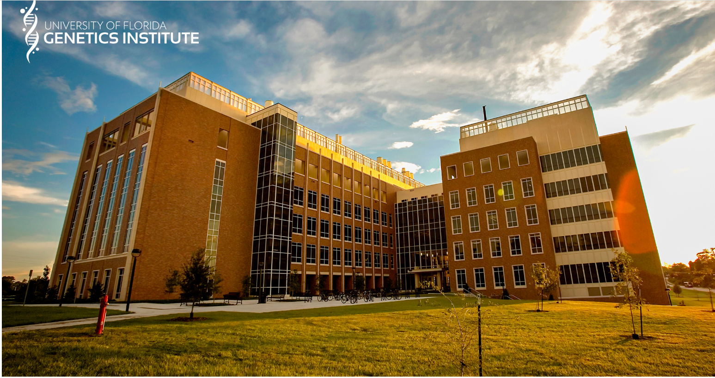
The University of Florida Genetics Institute is a multi-college, multi-faceted research center. Founded in 2007, the program provides interdisciplinary doctorate training with an emphasis on computational approaches. Students can train in any UFGI member’s laboratory, regardless of their college or departmental affiliation.

The UFGI is a research center that promotes collaborative research and includes more than 220 faculty members, representing eight colleges and 64 academic departments. Faculty members conduct an extensive range of genetics research, in fields such as gene therapy, plant genomics, neurogenetics, pharmacogenomics, evolution & development, bioinformatics, and the list goes on. Students are able to interact with these faculty during events, as well as collaborations and mentorship committees.
As part of the program, students attend a seminar course each week. This course focuses on enhancing students’ professional skills beyond lab work. Students will give presentations on their research, receive feedback from other students, and have opportunities to ask other students about their work. Program alumni and visiting faculty will also give talks.
Additionally, during National DNA Day in April, G&G students have the opportunity to visit local high schools to discuss their research, present the importance of genetics in a broad scope, and share their passion for research. These outreach events make a difference to budding scientists and many of our program’s students appreciate the opportunity to connect with local students.

Scientists united under the umbrella of the UF Genetics Institute have been delving into the genetic codes of a host of living things. UF researchers associated with the Powell Gene Therapy Center already are national leaders in studying how to use gene therapy — replacing or altering defective genes with healthy genes to treat diseases such as cystic fibrosis, high blood pressure and Parkinson’s disease.

UF Health Cancer Center
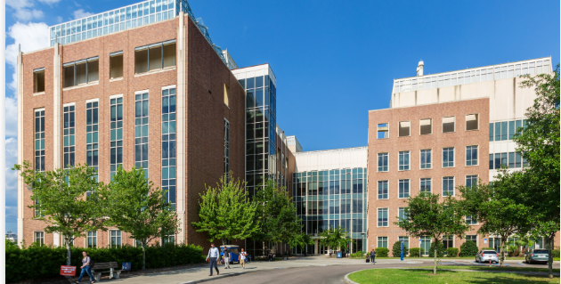
The University of Florida Health Cancer Center founded in 1992, blends comprehensive patient care and innovative research in a collaborative, multidisciplinary environment. In 2023, the center became the 72nd NCI-designated cancer center and the only one based at a public university in the state of Florida. The c enter will receive $2.1 million annually from the NCI to enhance its ability to attract more world-class researchers and clinical investigators and train the next generation of the cancer research workforce, while increasing its competitiveness for cancer research grants.
The UF Health Cancer Center serves North Central Florida, a geographically large region with the highest rates of cancer mortality in the state. The center is the only NCI-Designated Cancer Center based at a public university in the state of Florida. The geographic area from which the center attracts patients has high rates of poverty; rurality; and food, housing, and medical care insecurity. To address the cancer burden of the region, the center blends comprehensive patient care and innovative research in a collaborative, multidisciplinary environment, drawing members from 11 of the 16 colleges at the University of Florida (UF).
The Center boasts a membership of nearly 350 researchers and clinicians from across the University of Florida and UF Health, the Southeast’s most comprehensive academic health center. The Cancer Center and its members are dedicated to providing leading-edge cancer care and conducting original research for the prevention, early diagnosis and treatment of cancer.

UF researchers are known for improved diagnostic tests and therapies for cancers of the bone, breast, blood, colon, skin, prostate, bladder, the head and neck, and other malignancies, as well as for inventing the LINAC scalpel, which is used for targeting tightly focused beams of radiation to the site of brain tumors to destroy the malignant tissue.

The research priorities of the cancer center cut across and align with its four research programs: https://www.cancer.gov/research/infrastructure/cancer-centers/find/ufhealth

- Cancer Control and Population Sciences: The mission of this program is to reduce the cancer-related burden in the cancer center catchment area by conducting research to improve cancer prevention, treatment, symptom management, and palliative care. Distinctive contributions of this program include customized virtual health assistants to engage patients in screening and prevention behaviors, which were created through a partnership between population science researchers, communication specialists, and computer scientists.
- Cancer Targeting and Therapeutics: The mission of this program is to accelerate discovery, development, and clinical translation of targeted small molecule and bio-therapies. This program leverages leading-edge technology such as robot-assisted drug discovery at The Herbert Wertheim UF Scripps Institute for Biomedical Innovation & Technology to complement pharmacogenomics research at UF.
- Immuno-Oncology and Microbiome: The mission of this program is to improve cancer outcomes through innovative therapeutic research on microbiome-immunotherapy interactions influencing epithelial and immune cell function, engaging clinicians and basic scientists to partner on investigator-initiated trials. The program develops and translates immunotherapy modalities, such as RNA-based vaccines, adoptive cellular therapies, genetically modified T cells and microbiome-based therapy, into first-in-human studies.
- Mechanisms of Oncogenesis: The mission of this program is to identify and understand cellular pathways that are dysregulated during neoplastic transformation and to develop methodologies to target these cancer-specific signaling events. This program has a strong focus on abnormal chromatin and gene regulation in cancer, the biology of RNA processing in cancer, and tumor virology.

The UF Health Cancer Center is dedicated to providing leading-edge cancer care and conducting original research to prevent, detect, treat, and ultimately cure cancer while addressing the unique challenges of the cancer burden faced by the population it serves.

UF Institute for Child Health Policy
The Institute for Child Health Policy (ICHP) is dedicated to improving the health of children through innovative, interdisciplinary research. Drawing on the strengths of faculty in the College of Medicine and the expertise of affiliate faculty across the University of Florida, the Institute uses rigorous scientific methods to develop and test novel approaches to delivering better health care and preventing disease and injury among children and youth.

Institute’s methods include analyzing health data to assess the quality of children’s health care, evaluating the effects of health-related policies on population health and conducting clinical and community-based trials to test the effectiveness of new health care interventions and disease prevention strategies.

The Department of Health Outcomes and Biomedical Informatics in the College of Medicine serves as an important support infrastructure for the Institute for Child Health Policy and is the academic home for many of its faculty members.

Goals of the Institute for Child Health Policy are:
- Development and evaluation of community-wide programs and policies to promote child and adolescent health and positive health care outcomes.
- Multidisciplinary research on health care financing and delivery systems, health care quality, and outcomes of care for all children but especially those with cancer and other chronic conditions.
- Innovative evaluation research on public programs and policies.
- Training and mentoring of students and new scientists in child, adolescent, and youth health research.
- Leadership in interpreting and disseminating research results to policymakers and the public.
- Collaboration with state and federal agencies, non-profit organizations and foundations, and communities in research and policy change.

UF Institute on Aging (IOA)
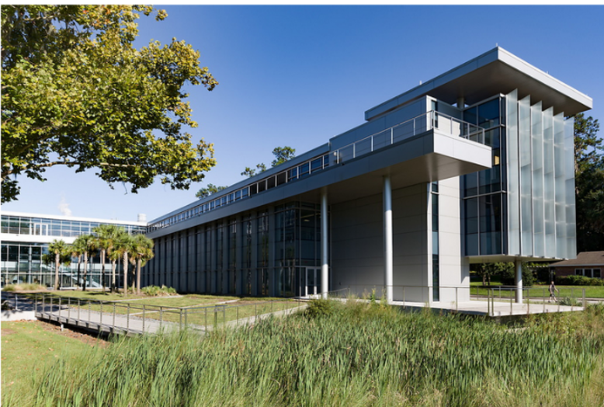
The mission of the UF Institute on Aging (IOA) to promote the health, independence and quality of life of older adults through multidisciplinary research, education and health care. Over the past two decades, the Institute on Aging and its affiliated faculty members have developed robust infrastructure and multidisciplinary teams focused on the full spectrum of aging research. UF’s Institute on Aging and Division of Geriatric Medicine in the Department of Medicine are recruiting an outstanding physician-scientist leader with a dynamic vision for bridging aging research and geriatric care to achieve even greater impact in the decade ahead.
Future Goals are:
- Grow multidisciplinary aging research and clinical trials aligned with issues that matter the most to older adults
- Facilitate an integrated clinical and research environment that provides experiential learning opportunities for UF students and trainees pursuing careers in geriatric care and aging research
- Promote comprehensive and community-centered care for older adults that is grounded in respect and understanding and fosters compassion and effective communication with patients and families

UF’s Institute on Aging is headquartered in the 39,000-square-foot south wing of the Clinical and Translational Research Building (CTRB), a LEED Platinum facility that opened in 2013. Construction of the three-story IOA-CTRB wing was funded by a 2010 NIH ARRA award of $14.7 million. Today, the IOA-CTRB functions as a collaborative hub with shared resources that have significantly enhanced capacity at UF for all stages of clinical and translational research focused on the needs of older adults.

The IOA-CTRB provides a welcoming environment with a good balance of individual and team spaces that can be adapted to meet the needs of research teams as well as students and trainees. The IOA-CTRB wing houses approximately 40 offices and 30 cubicles, plus additional student work spaces; three conference rooms with state-of-the-art audio and visual capabilities; and several employee lounges and treadmill workstations. The building’s environmentally friendly design ensures ample natural light and overlooks UF’s Wilmot Botanical Gardens, which provides a peaceful and verdant respite for faculty, staff, participants and the public.

Research participants have easy access to a dedicated parking lot in front of the building and a direct entrance to the IOA reception and waiting area. The IOA owns a van and golf cart to assist with transportation needs. IOA-CTRB clinical research facilities include a nursing station; lab processing, blood draw and physical evaluation rooms; DXA and Biodex equipment; eight exam and interview rooms; a conference room for group screenings and interviews; a screening and recruitment suite; and drug vault, data entry and secured file storage rooms.

UF Research and Academic Center at Lake Nona
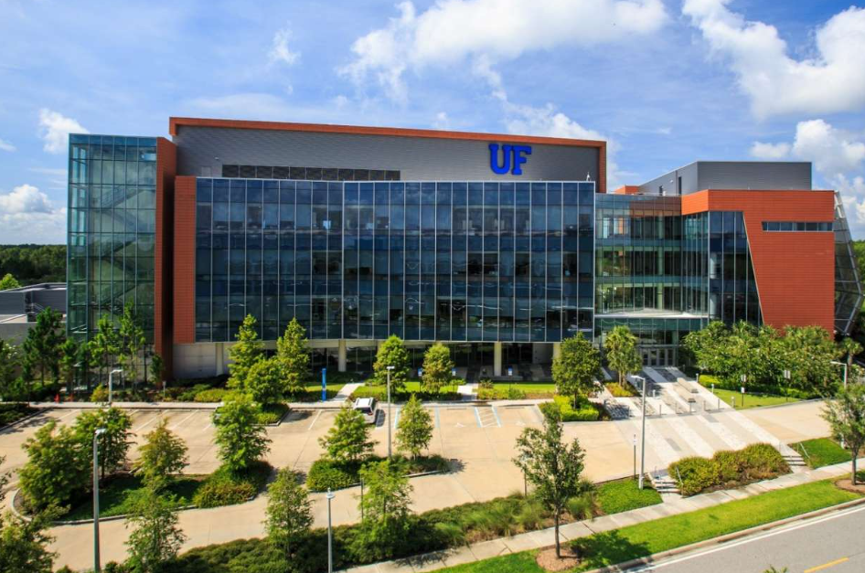
The UF Research and Academic Center at Lake Nona brings to the Orlando area vital research on new therapies and cures, increased opportunities for participation in clinical research and enhanced access to professional and graduate pharmacy education. The $53 million roughly 106,000-square-foot facility extends UF’s presence into the greater Orlando area through the following colleges, institutes and centers: the College of Pharmacy, College of Medicine, the Center for Pharmacometrics and Systems Pharmacology, the Institute for Therapeutic Innovation, the Institute on Aging, and the Clinical and Translational Science Institute.

More than 450 UF faculty members, students, administrators and staff work in the center within the Colleges of Medicine and Pharmacy, carrying out basic, clinical and translational research in drug discovery and development.

The Doctorate in Pharmacy (Pharm.D.) is the only academic program offered at the Orlando Campus and is a 4-year advanced degree program that can be completed entirely in the Central Florida/Orlando area. Ranked by U.S. News & World Report as the No. 1 pharmacy college in Florida and in the Top 5 nationally.

UF College of Medicine Quality & Patient Safety Initiative
The College of Medicine launched an AI-enhanced Quality and Patient Safety Initiative (QPSi) that will lead the nation in driving innovations to improve the quality of health care delivery, reduce preventable harm, advance knowledge regarding health systems operations and patient care and be a resource for workforce development for the state of Florida.

College of Medicine faculty are national leaders in fundamental, translational and clinical research in areas pertaining to diseases of the nervous system, human aging, cancer, diabetes, infectious disease, immunology and inflammation, genetics and gene therapy. College researchers are involved in collaborative research in several institutes and centers within the university, including the Evelyn F. and William L. McKnight Brain Institute, the Emerging Pathogens Institute, the Genetics Institute, the Institute on Aging, the UF Health Cancer Center, the Diabetes Institute, the Clinical and Translational Science Institute, the Institute for Child Health Policy and the Norman Fixel Institute for Neurological Diseases at UF Health.

College of Medicine faculty and collaborative research teams continue to receive awards and honors that reflect their exceptional distinctions and contributions. The College of Medicine’s annual grant awards from the National Institutes of Health consistently eclipse $100 million. The college’s steady increase in NIH funding over the past 10 years is reflected in the impressive rise in its national rankings in recent years and joining the upper third of U.S. colleges of medicine, according to U.S. News & World Report.

A hub for innovation, the college is leading medicine’s new frontier in artificial intelligence through a long-term initiative combining world-class infrastructure, leading-edge research and a transformational approach to curriculum. AI-enabled systems are being developed to guide perioperative and acute care decision-making, data scientists are working to spur data-driven medicine and foundational scientists are advancing AI-enhanced methods for analyzing molecular data — all to answer questions that will improve health outcomes and patient care. With lab spaces across UF in Gainesville and at the UF Research and Academic Center in Lake Nona, the college is home to more than 380,000 square feet of research space.

College faculty members practice at UF Health Shands Hospital, the UF Health Shands Children’s Hospital, the UF Health Shands Cancer Hospital, the UF Health Heart & Vascular Hospital, the UF Health Neuromedicine Hospital, the Malcom Randall Veterans Affairs Medical Center, the UF Health Shands Rehab Hospital and the UF Health Psychiatric Hospital. In addition, physicians practice throughout Central and North Central Florida at more than 50 UF Health Physicians locations. UF Health Physicians is the largest and most complete physician group practice in Florida, seeing patients from every county in Florida and every state in the U.S. Clinical strengths of UF physicians include cancer, heart and vascular, neuromedicine, aging, psychiatry and addiction medicine, diabetes, orthopaedics, children’s health services and transplant services.

Department of Health Outcomes and Biomedical Informatics
The Department of Health Outcomes and Biomedical Informatics (HOBI) is located within the UF Health Science Center and organizationally within the College of Medicine. The multidisciplinary faculty members include health services researchers, epidemiologists, biomedical informaticians, economists, epidemiologists, psychologists and social scientists. They provide leadership and expertise in prevention science, health promotion, policy evaluation research, quality of care, health disparities, data analytics and implementation science. The department also has the UF Institute for Child Health Policy, which conducts innovative studies and intervention trials to promote the health of children, adolescents and young adults.

HOBI researchers study many populations, ranging from the individual to big data sets with tens of millions of patients. The cross-fertilization of various fields and approaches enables HOBI teams to provide new answers to essential health care questions.

HOBI faculty work collaboratively across three divisions to achieve dynamic, data-driven research, knowledge integration, and the improvement of care and quality. By increasing the understanding of best methods and overall effectiveness of medical treatments and interventions, HOBI researchers are able to promote the successful integration of research findings into health care policy and practice. The divisions are:
- Biomedical Informatics
- Clinical and Population Health Integration
- Implementation Science and Health Interventions
HOBI faculty are recognized for their leadership and service in state and national organizations such as the Patient-Centered Outcomes Research Institute (PCORI), the Agency for Healthcare Research and Quality (AHRQ), the National Institutes of Health (NIH), and the American Medical Informatics Association (AMIA). HOBI faculty also hold major leadership roles in the UF Clinical and Translational Science Institute, the UF Institute for Child Health Policy, the UF Health Cancer Center, and the OneFlorida+ Clinical Research Network.

HOBI provides the project team with access to extensive medical expertise, including obstetricians and gynecologists, family practice physicians, psychiatrists, and pediatric specialists. The physicians in the College of Medicine frequently provide consultation services at no charge to HOBI.

HOBI is located in the Clinical and Translational Research Building (CTRB). The CTRB serves as the headquarters for the Clinical and Translational Science Institute (CTSI) at UF and in the state. The building houses patient-oriented research venues for the CTSI, as well as a range of clinical and health services research faculty, many of whom have extensive expertise in the areas of implementation science, quality of care and health outcomes. Adequate office space for study personnel and space for storage have been allocated.

HOBI has 37 faculty who provide leadership in implementation science, health promotion, health disparities, and health outcomes studies. Areas of focus include health care outcomes and preventive interventions for low-income children and adolescents, risk behavior reduction, biomedical informatics, community intervention trials, community-engaged research, and health care quality and outcomes for disadvantaged populations. There are more than 100 professional and support staff. The extramural funding portfolio in HOBI is diverse and includes current funding from the National Institutes of Health, Pfizer, the Robert Wood Johnson Foundation, Health Resources and Services Administration—Maternal and Child Health Bureau, State of Florida, State of Texas, and the Patient Centered Outcomes Research Institute. The current annual extramural funding is approximately $30M annually.

College of Dentistry (UFCD)
https://dental.ufl.edu/about/
Established in 1972, the University of Florida College of Dentistry is the only publicly funded dental school in the state and ranks as a national leader in dental education, research, patient care and community service. The college is housed in the Dental Sciences Building located on the UF Academic Health Center campus.

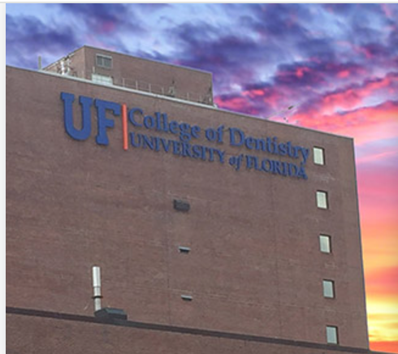
UFCD is continually expanding interdisciplinary educational opportunities in the predoctoral and the advanced education arenas and is a program of choice for applicants. During the 2021- 22 application cycle, the college received more than 3,050 applications for 93 dental student positions and 60 advanced education positions. The college offers advanced education programs in endodontics, operative and esthetic dentistry, oral and maxillofacial pathology, oral and maxillofacial radiology, oral and maxillofacial surgery, orthodontics, pediatric dentistry, periodontology and prosthodontics degree & certificate programs.

In October 2023, for the ninth consecutive year, UFCD received the Higher Education
Excellence in Diversity Award, or HEED Award for outstanding commitment to
diversity and inclusion. UFCD is one of only two UF colleges to ever receive the award.

UFCD Departments:
- Community Dentistry & Behavioral Science
- Endodontics
- Oral Biology
- Oral & Maxillofacial Diagnostic Sciences
- Oral & Maxillofacial Surgery
- Orthodontics
- Pediatric Dentistry
- Periodontology
- Restorative Dental Sciences

College of Nursing
https://nursing.ufl.edu/about/
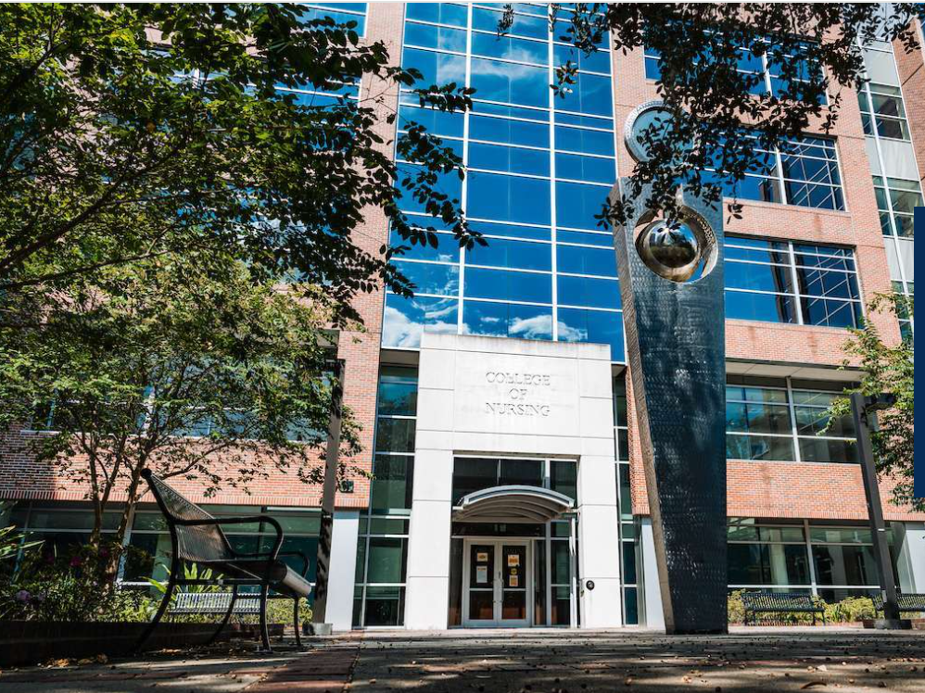
As part of the University of Florida, the College of Nursing has all the resources of the state’s flagship university at their fingertips, including a top-notch interdisciplinary Academic Health Center and centers and institutes like the Evelyn F. and William L. McKnight Brain Institute of UF, the UF Genetics Institute, th e UF Health Cancer Center and the UF Institute on Aging.

The nursing education programs offered at UF address gaps in the health care system, as do the college’s innovations in technological resources and initiatives linking students to diverse and international populations. The College of Nursing has a history of pioneering leadership in nursing education, having offered Florida’s first nurse practitioner programs and first PhD in Nursing Science program.

Health care delivery networks associated with UF provide access to an integrated system of community hospitals and clinics, including statewide home health care, a major veterans’ health system and the UF Health Shands Hospital system.

Faculty members set a standard for excellence when it comes to innovative education, dynamic research and quality patient care.

In recognition of their exceptional academic nursing partnership, the UF College of Nursing and UF Health Nursing have been selected to receive the New Era for Academic Nursing Award by the American Association of Colleges of Nursing, or AACN. The College of Nursing and UF Health were recognized for their innovative and sustained relationship that meets the AACN’s recommendation to “Embrace a New Vision of Academic Nursing.”

The UF College of Nursing is the recipient of the National League for Nursing’s 2022 Certification Star Award: Honoring the Pursuit of Excellence and Advancement of the Nurse Educator Certification. Half of the college’s clinical track faculty have obtained certification as National League for Nursing Certified Nurse Educators, or CNE, and this award recognizes the college’s integrated effort to create an academic environment to transform and advance nursing education.

College of Pharmacy
https://pharmacy.ufl.edu/research/

The University of Florida College of Pharmacy was established in 1923 and is the oldest of six health science colleges at UF. Ranked by U.S. News & World Report as the No. 4 pharmacy college nationally, the University of Florida College of Pharmacy excels at preparing graduates to practice in an evolving environment where the pharmacist is an interprofessional team member who collaborates to improve patient care. Doctor of Pharmacy graduates have the foundational knowledge and skills to improve medication therapy in an evidence- based manner. They are also prepared to assume leadership roles in the pharmacy profession and the U.S. health care system.

First- to third-year Pharm.D. students study at campuses in Gainesville, Orlando, and Jacksonville, and fourth-year students rotate throughout the state, nation and internationally for their clinical practice experiences. UF prepares graduates to practice in a variety of pharmacy settings, including community, hospital, ambulatory care, academia, the pharmaceutical industry, and more. In 2024, the UF College of Pharmacy ranked No. 1 nationally in the number of graduates securing highly competitive pharmacy residency positions.

Future pharmaceutical scientists receive training in one of the college’s comprehensive graduate programs. Under the mentorship of nearly 75 graduate faculty, UF College of Pharmacy Ph.D. students have the opportunity to participate in lifesaving research and take a lead role in advancing science. In 2024, the graduate program set a record enrollment with 159 students

Research activities in the UF College of Pharmacy span the entire life cycle of a drug and include broad interest areas such as medicinal chemistry, pharmaceutics, pharmacology, clinical and translational research, and pharmaceutical outcomes and policy. In 2023, the college secured a record $41 million in research funding and earned a No. 3 national ranking from the American Association of Colleges of Pharmacy and The Blue Ridge Institute for Medical Research for total grant funding. Researchers in the college are pioneering advancements in drug discovery, marine natural products, pharmacology, disease modeling, pharmacokinetics/pharmacometrics, pharmacogenomics, pharmacoepidemiology, and patient safety, while also advancing AI-driven solutions and exploring new frontiers in space to develop innovative drug therapies.
Five active centers support these diverse research programs:
- Center for Drug Evaluation and Safety
- Center for Integrative Cardiovascular and Metabolic Disease
- Center for Natural Products, Drug Discovery and Development
- Center for Pharmacogenomics and Precision Medicine
- Center for Pharmacometrics and Systems Pharmacology

Department of Pharmaceutical Outcomes and Policy (POP)
https://pop.pharmacy.ufl.edu/

The Department of Pharmaceutical Outcomes and Policy’s focus on research and graduate training is centered on the evaluation of drugs and related medical technology. This focus includes classic pharmacoepidemiologic work in drug safety and comparative effectiveness, pharmacoeconomics, as well as patient safety and program evaluation as related to medication use.

The department of pharmaceutical outcomes and policy excels in three areas of specialization in both research and training. Each area employs its own set of methodological approaches, but all utilize the vast array of big data sources available in the department.
1. Pharmacoepidemiology and Safety Sciences applies epidemiologic methods and knowledge to the study of uses and effects of drugs in populations after drug approval. Important research areas include
causal inference studies on post marketing drug safety and comparative effectiveness and predictive models of drug outcomes and use.
2. Pharmacoeconomics and Outcomes Research assesses the value (clinical and economic) of pharmaceutical products and related services in the delivery of health care. It aims to provide patients, providers and payers with evidence to inform decision-making. Important research areas include economic evaluations, budget impact analysis, multicriteria decision analysis and policy evaluations related to drug formulary, reimbursement and pricing.
3. Pharmaceutical Health Services Research examines the quality, accessibility and delivery
of pharmaceuticals and related services. The program places emphasis on vulnerable populations, such as children, elderly, minorities and persons with high-burden diseases and
disabilities. Examples of research include the development of quality measures or assessment of disparities and determinants of appropriate therapy.

In addition, the new focus area, Artificial Intelligence in Pharmaceutical Outcomes and Policy Research, supports the three specialization areas with the goal of employing and tailoring novel AI methodology on automated health care data to answer important questions about clinical outcomes of drug effects, other health care interventions, and the policies governing medication use.

In 2023, POP’s research funding grew by an impressive 20%, even while POP’s graduate and research faculty group remained relatively stable. This academic year marked seven years of year-on-year growth for the department with a nearly eight-fold increase in research funding between the academic years
2015-16 and 2022-23.

Training: The Department of Pharmaceutical Outcomes and Policy offers a broad spectrum of opportunities for training, including a residential Ph.D. and M.S. program, an online M.S. program, and internship programs for students in the health and related sciences. Students can choose from several specialty areas. The department offers a weekly seminar series and journal club as well as more than 20 graduate courses in the department specialty areas.

Research facilities: Research facilities include computer labs for students, a secure research computing environment (co-managed with the Center for Drug Evaluation and Safety, or CoDES), that houses several population-based data sets, including more than 350 million covered lives, and a variety of software packages.
POP’s Core Facilities Include:
- Multiple Zoom-enabled large conference-style and smaller collaborative rooms, dedicated to ongoing research studies with wall-mounted video cameras
- TV monitors in each conference room for wireless projection
- Omnidirectional microphones
- Ample graduate student working space (with >75 individual work spaces), as well as shared office space for post-docs and research staff
- The department also provides an array of hardware, software, and personnel, including Research Coordinators and Data Managers and Analysts, who provide computing infrastructure management and statistical consultation

POP’s Research Computing Infrastructure is managed in coordination with the Center for Drug Evaluation and Safety (CoDES), including the CoDES high speed research server and POP/CoDES-managed access to UF’s HiPerGator and ResVault. Additional information regarding specifics of this research computing infrastructure can be found on the CoDES website.

Department of Pharmacotherapy and Translational Research
https://ptr.pharmacy.ufl.edu/research/
Research in the department of pharmacotherapy and translational research primarily focuses on understanding genetic and nongenetic factors that contribute to variability in drug response. The department has nearly two dozen faculty leading research initiatives at all three UF College of Pharmacy campuses in Gainesville, Jacksonville and Orlando.

UF Center for Pharmacogenomics and Precision Medicine
https://precisionmedicine.ufhealth.org/research/center-for-pharmacogenomics-and-precision-medicine/
Established in 2001, research in the Center for Pharmacogenomics and Precision Medicine strives to identify genetic variations that affect drug response, with the goal of enabling safer and more effective drug therapy. Research in the center spans from single variant association studies to multi-omic approaches to elucidate genetic contributions to drug response. The center also supports the UF Health Precision Medicine Program through the translation of pharmacogenomic research findings into patient care and examining outcomes with genotype-guided therapies.

The mission is to facilitate the clinical implementation of precision medicine by improving patient outcomes through the optimization of efficacy and limiting toxicity of drug therapy. This is accomplished through research, teaching and service focused on genetically-guided therapeutic decision-making, drug discovery and drug development.

Pharmacogenomic laboratory and analytical services are provided for UF and non-UF investigators through the CPPM Core Laboratory. Services are provided either as a price per sample or price per project depending on the service type and specific needs of the researcher. Researchers interested in multiple services will be provided with an estimate of the charges for the entire project.

College of Public Health & Health Professions (PHHP)
https://phhp.ufl.edu/academics/
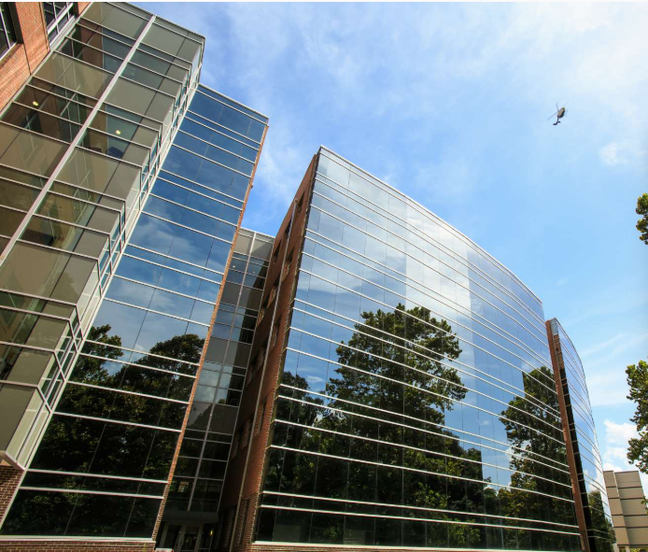
The UF College of Public Health and Health Professions is focused on advancing and integrating education, research, and service to meet ongoing and emerging local, regional and global health challenges. With over 2,500 students, PHHP is a national leader in the education of health professionals. It is one of more than 60 colleges and schools in the U.S. that has achieved accreditation as a school of public health from the Council on Education for Public Health.

The College is committed to the development of cutting-edge science and outreach in areas such as aging and disability, rehabilitation of central nervous system impairment, behavioral and environmental determinants of health for individuals and communities, disaster response, and health systems functioning. The College’s overall mission is to shape tomorrow’s public health and health professionals through dynamic and responsive educational programs, transformational research, groundbreaking discoveries, and equitable health-related service.

The college has eight departments: Biostatistics; Clinical and Health Psychology; Environmental and Global Health; Epidemiology; Health Services Research, Management and Policy; Occupational Therapy; Physical Therapy; and Speech, Language and Hearing Sciences. The college offers 20 degree programs, including two bachelor’s, seven master’s programs, eight doctoral, and three professional degree programs with over 150 faculty.

PHHP) received $54.8 million in research funding in 2023. This was a new milestone for the college, and was achieved through: More grants for early career faculty; Larger, more complex center level grants;
Improved faculty recruitment efforts; Increased investment in college infrastructure.

The PHHP offers the PHHP Research Innovation Fund, which provides up to $25,000 in funding for pilot testing and feasibility studies. The fund supports research in three themes: Artificial intelligence, Direct clinical impact, and General topics in public health and health professions.

The PHHP Research Innovation Fund is open to all PHHP faculty members, but priority is given to early career faculty. The fund aims to help faculty members get research funding from outside agencies.

The PHHP's home is in the Health Professions, Nursing, and Pharmacy (HPNP) building, completed in 2003, and includes 11 classrooms, four lecture halls, one auditorium, and a distance learning room for a total of 7,783 square feet. The college also includes the PHHP Research Complex, which is located in the Dental Wing (Ground Floor) of UF Health and totals 15,690 square feet of dedicated research space.

PHHP has 452 affiliation agreements that allow students to participate in site visits and to be placed at various organizations to complete internships, clinical rotations, supervised research, and other practical experiences. The agreements include 147 with health departments, hospitals, health centers, and Veteran’s Administration facilities, 275 with clinics and private practitioners, and 30 with other universities/educational institutions (https://nursing.ufl.edu/wordpress/files/2019/06/OAIC-Resources-Template_Updated-1_21_2016.pdf).

Department of Epidemiology
https://epidemiology.phhp.ufl.edu/
The Department of Epidemiology is situated within both the College of Public Health and Health Professions and the College of Medicine at the University of Florida. Faculty members hold joint appointments, fostering synergies that contribute to a robust and competitive research profile. This collaborative approach enhances the training of highly skilled students, providing them with exceptional exposure to diverse expertise.

The Department of Epidemiology uniquely encompasses a variety of multi-disciplinary research fields. Faculty members prioritize interdisciplinary research, teaching and mentoring students, and providing innovative and well-funded initiatives. The department faculty members haves successfully obtained numerous grants and contracts from local, state, and national entities.

The Department of Epidemiology provides four exceptional programs for individuals interested in pursuing a career in epidemiology. These programs include a Doctorate in Epidemiology, a Master of Science in Epidemiology, a Master in Public Health, Epidemiology Concentration, and a Certificate in Psychiatric Epidemiology.

HealthStreet
https://healthstreet.program.ufl.edu/
HealthStreet, community engagement initiative from the UF department of epidemiology, engages with the community to reduce disparities in access to services and research to improve health and well-being. HealthStreet community health workers help bridge the gap between community members and resources available to them, including medical and social services and opportunities to participate in research that is relevant to their health concerns and conditions.

Using four pillars— Listen, serve the community, educate/learn, and build trustworthiness— HealthStreet is able to provide community members opportunities to participate in research and the ability to take part in their community’s health.
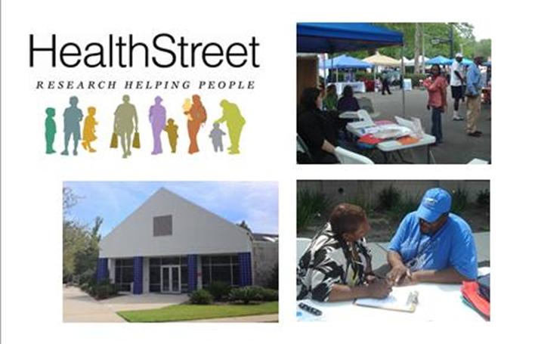
HealthStreet Gainesville is located in southwest Gainesville and includes about 10,000 square feet of space for community engagement and offices for faculty, staff, students and volunteers.

The HealthStreet suite also includes a lobby, a community center, a conference room, multiple meeting spaces, several interview rooms, four clinical rooms, and two kitchen facilities. In collaboration with the UF Libraries, a paper and electronic library of health information is provided. There are handicap-accessible restrooms and shower facilities. HealthStreet is easily accessible to the greater Gainesville student and non-student population with links to public transportation.

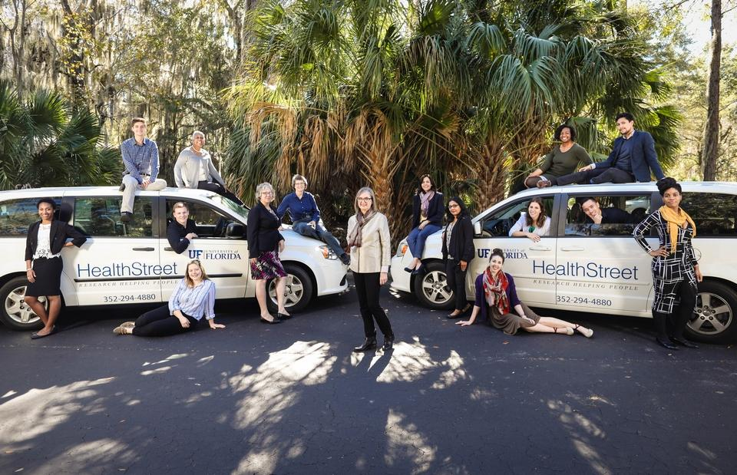
HealthStreet relies on Community Health Workers (CHWs) for engagement and is complementary to planned national self-guided participant registries. Through HealthStreet Gainesville and CHWs conducting outreach, HealthStreet is actively working in 46 of Florida’s 67 counties. Since opening in November 2011, HealthStreet has enrolled over 14,000 people from the community; more than 3,000 have been enrolled in health research studies across the University. HealthStreet expanded operations to Jacksonville beginning in 2015, where HealthStreet Jacksonville facilities are housed within the Edward Waters College Center for the Prevention of Health Disparities close to the urban core of downtown Jacksonville.

HealthStreet is a one-stop portal of entry for linking and navigating underrepresented populations to opportunities to collaborate with the research community through town halls, focus groups, individual interviews, library use, individual health assessment, and navigation to appropriate research through a CHW-delivered, person-centered, health-literate process. The one-stop portal also offers referrals to social (food pantry, housing, criminal justice, etc.), medical and psychiatric (MDs, nurse practitioners, drug treatment, other health professionals) services and, in-house, offers vision and mental health treatment services as well as HIV testing provided through local health agencies. CHWs provide regular screening for blood pressure and blood sugar along with health education, including navigation to research opportunities. Quarterly, HealthStreet produces a Community Health Needs Assessment (CHNA) report that describes all conditions and concerns and is distributed through many media to the community. In addition, HealthStreet offers many opportunities for dissemination of research findings and community consultations in early research phases. These opportunities include: facilitated focus groups; targeted town hall meetings; poster presentations to appropriate audiences; community dissemination of fliers and other printed health information; and our flagship monthly town hall meetings routinely watched in 29 states through livestreaming, Our Community Our Health. HealthStreet is a CTSI-sponsored community engagement and recruiting program; Principal Investigators can contract for specific services through the CTSI infrastructure. HealthStreet is University of Florida IRB approved to recruit participants for appropriate studies.

In June 2024, UF HealthStreet launched the HOPE Food Pantry in partnership with Bread of the Mighty Food Bank. The initiative addresses hunger needs in the community which has been identified by nearly half of the HealthStreet cohort.

College of Veterinary Medicine
https://www.vetmed.ufl.edu/
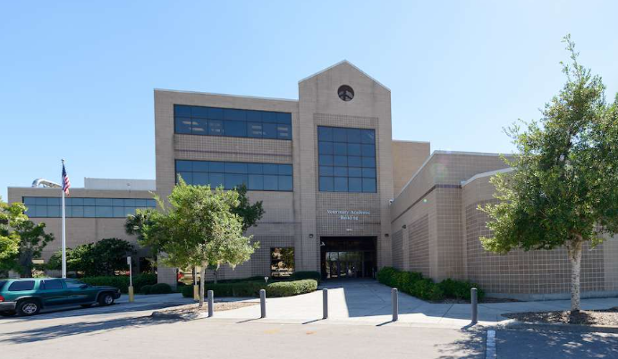The UF College of Veterinary Medicine, the state’s only veterinary medical college, is committed to advancing the health and welfare of animals, humans and the veterinary medical profession through world-class education, innovative research and state-of-the-art clinical services.

The UF College of Veterinary Medicine, one of six colleges at UF Health, is committed to excellence in teaching, research and patient care. From 2000 to 2023, College’s D.V.M. graduates have consistently ranked above the national average on the North American Veterinary Licensing Examination. The
number of seats currently offered continues to be 104 for state-funded and 46 for
self-funded applicants. The College offers special interest certificate programs in Aquatic Animal
Health, Veterinary Business Management, Food Animal Veterinary Medicine and Shelter Medicine. A state-of-the-art clinical skills laboratory provides dedicated space for students to enhance their training in clinical and technical skills. The College also offers a combined D.V.M.-M.P.H. degree, a master’s degree and a Ph.D. degree in Veterinary Medical Sciences, or V.M.S. Since 1993, nearly 400 students have completed the M.S. degree or Ph.D. degree in V.M.S. on campus. In addition, more than 600 students have completed Master’s online program in V.M.S., with a concentration in shelter
medicine, forensic toxicology or veterinary forensic sciences.

The UF College of Veterinary Medicine is a major leader in the neurophysiology of breathing, toxicology, immunology, infectious diseases and vaccine research. The College’s programs investigate emerging and exotic infectious diseases of livestock, pets, wildlife and humans. Our Aquatic Animal Health program remains one of the most broadly based of any veterinary college worldwide. In addition, College’s Center for Environmental and Human Toxicology is a leader in aquatic toxicology, with a major strength in nanotoxicology. The college is internationally recognized for its world-class basic science research in mucosal immunology, traumatic neural injury, vaccine development, malarial research, neurogenesis of airway defensive behaviors and cancer research, much of it conducted in collaboration with UF Health and the UF Institute of Food and Agricultural Sciences. College’s researchers are actively engaged in COVID-19 studies that target the efficacy of approved drugs in disease treatment and prevention, evaluate the effect of genetic variations in human leukocyte antigens in disease severity, and focus on harnessing genome editing for drug discovery. College leverages UF’s strengths in artificial intelligence to apply supercomputing and machine learning to solve today’s problems with tomorrow’s technology for animal and human health. Currently, most funding support is provided through competitive grants from the National Institutes of Health, the U.S. Department of Agriculture and the Centers for Disease Control and Prevention with total awards at $15.9 million in 2023.

Patient Care: UF Veterinary Hospitals are dedicated to transforming the field through innovation. Last year, exceptional treatment was provided to an impressive 47,062 animals at main hospitals, and an additional 19,568 animals received care at UF Pet Emergency Treatment Services in Ocala and the UF Veterinary Hospital at World Equestrian Center, which opened its doors in 2022. Equipped with worldclass facilities spanning 40,000 square feet, the UF Veterinary Hospital at WEC leads the way in cutting-edge patient care for equine athletes and companion animals on-site and locally. With one of the highest caseloads among academic veterinary hospitals nationwide, veterinarians throughout the Southeast rely on us to provide top-quality care for their patients. We actively lead groundbreaking clinical trials in cancer therapies, skin allergies, heart disease and more, with many of these trials
providing essential preclinical data for human research. The UF Veterinary Hospitals’ transformative mission to revolutionize veterinary medicine through innovation can significantly impact the health and well-being of animals everywhere.

Extension: The veterinary extension team plays a vital role in education, research and training with many important animal industry groups in Florida. Their primary mission is to support local animal industries, however the expertise and skill in animal health, disease, production and welfare are recognized nationally and internationally. The veterinarians directly support the cattle industry, both beef and dairy, small ruminant producers (goats and sheep), horse owners, poultry producers, deer farmers and states growing aquaculture sector, as well as provide outreach to pets in animal shelters. The Veterinary Community Outreach Program provides spay/ neuter and other veterinary services to local shelters.

