UF Scripps Biomedical Research
Conducting Human Research

Welcome to UF! While all of our staff within UF IRB Administration are ready and capable of assisting you with obtaining IRB approval, we have designated one of our top experts as a liaison for assisting our faculty at UF Scripps Biomedical Research. Please feel free to direct all inquiries and requests for assistance with the IRB to Renée Collins, Vice Chair and Asst. Director.
Designated liaison for assisting faculty at  UF Scripps Biomedical Research: | Renée Collins, Vice Chair and Asst. Director  (352) 273-9605  rbcollins@ufl.edu
General IRB Information: | Main line: (352) 273-9600  Email: irb@ufl.edu  Website: http://irb.ufl.edu  Asst. Director for IRB Administration:  Dr. Ivana Simic, PhD, CIP  (352) 273-9604  isimic@ufl.edu  Electronic submission system: https://my.irb.ufl.edu  myIRB researcher manual: https://irb.ufl.edu/wp-content/uploads/Researcher-Manual_FINAL.pdf

UF utilizes a web-based system for reviewing and approving human research called myIRB. First time users must self-register in the system. We highly encourage you to discuss your research with Mrs. Collins before using myIRB so she can help ensure the best experience.

Image 1: Login/Register in myIRB https://my.irb.ufl.edu
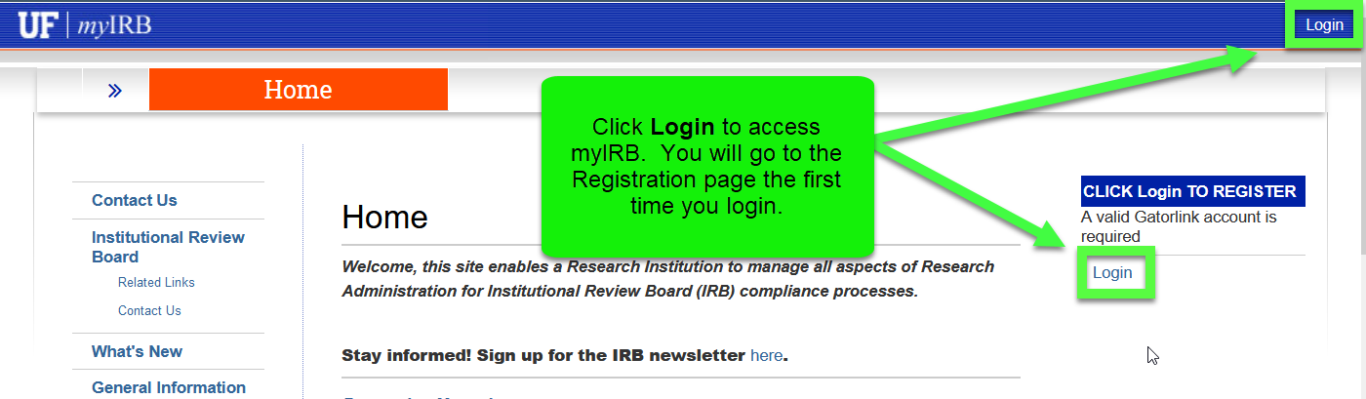

Image 2: Self Registration in myIRB
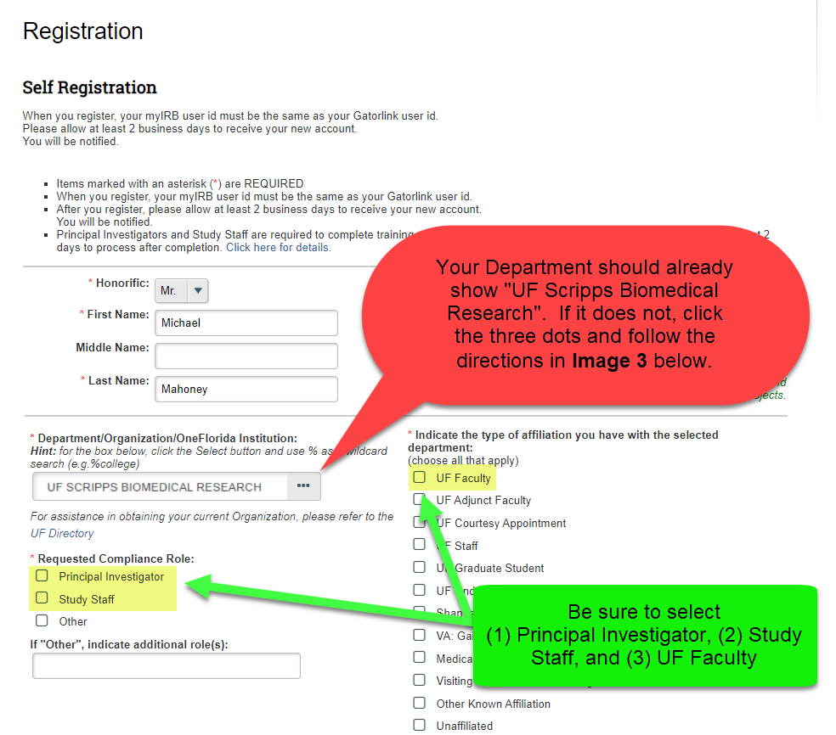

Image 3: if your department doesn’t automatically list UF Scripps Biomedical Research:
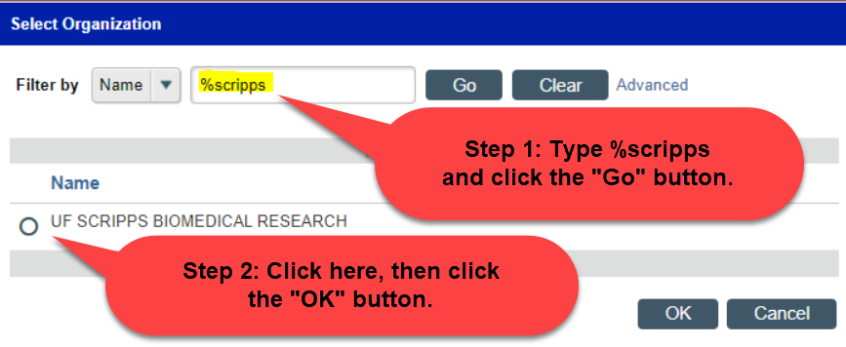
The myIRB Researcher Manual contains comprehensive directions with screenshots on how to navigate and use myIRB:
https://irb.ufl.edu/wp-content/uploads/Researcher-Manual_FINAL.pdf

Other inquiries or issues:
If you have any other research-related inquiries, please feel free to reach out to:
Michael Mahoney
Director, Research Operations & Services
mmahoney@ufl.edu
(352) 392-1587

This document is available for download at: https://research.ufl.edu/wp-content/uploads/UF-Scripps-Biomedical-Research-welcome.docx

